Hydra Hardware Design Notebook

|  |  |
| --- | --- |
| Rocket: | Gee-Force One |
| File Name: | DNS-2022-AV-Hydra-Hardware |
| Sub Team: | Avionics |
| Point of Contact: | Serban, Amanda, Liam |
| Purpose: | Document board-level design decisions for Hydra boards |

Revision History:

|  |  |  |
| --- | --- | --- |
| Revision | Description | Date |
| 0 | Baseline updated (Hydra V1) | Feb. 1, 2023 |
| 1 | Updated design following first design review | Feb. 11, 2023 |
| 2 | Included Hydra V2 boards post-competition | Sep. 10, 2023 |
| 3 | Added Hydra V3 SAME51 template project | Oct. 2, 2023 |

Table of Contents:

1 Hydra V1 1

1.1 Recovery Board (HYDRA_V1_RECOVERY) 1

1.1.1 Overview 1

1.1.2 Component List 1

1.1.3 Layout Considerations 1

1.1.4 Schematics 2

1.1.5 PCB 3

1.2 Communication Board (HYDRA_V1_COMMUNICATION) 4

1.2.1 Overview 4

1.3 Logic Board (HYDRA_V1_LOGIC) 5

1.3.1 Overview 5

1.3.1.1 SERCOM Pinouts 5

1.3.1.2 Parent Schematic Considerations (Connectors.SchDoc) 6

1.3.1.3 MCU Pinout Considerations (MCU_PINOUT.SchDoc) 6

1.3.1.4 SBG Considerations (SBG.SchDoc) 7

1.3.1.5 SD Card Considerations (SD.SchDoc) 7

1.3.2 Component List 9

1.3.3 Layout Considerations 12

1.3.4 Schematics 13

1.3.5 PCB 18

1.3.6 Reflection 20

1.4 Power Board (HYDRA_V1_POWER) 21

1.4.1 Overview 21

1.4.2 Component List 21

1.4.3 Layout Considerations 23

1.4.4 Schematics 24

1.4.5 PCB 25

1.4.6 Reflection 26

1.5 MCU Pinout (HYDRA_V1_MCU_PINOUT) 27

1.5.1 Overview 27

1.5.1.1 Power Requirements 27

1.5.1.2 CAN Requirements 27

1.5.2 Component List 27

1.5.3 Layout Considerations 28

1.5.4 Schematics 28

2 Hydra V2 30

2.1 Recovery Board (HYDRA_V2_RECOVERY) 30

2.2 Communication Board 31

2.3 Logic Board (HYDRA_V2_LOGIC) 32

2.4 Power Board (HYDRA_V2_POWER) 33

2.4.1 Overview 33

**2.4.1.1** **Power Protection Considerations (PWR_protection.SchDoc)** 34

**2.4.1.2** **Redundant Regulator Considerations (5V_regulators.SchDoc and 3V3_regulators.SchDoc)** 36

2.4.1.3 MCU Considerations (MCU_PINOUT.SchDoc) 40

3 References (force of habit) 41

List of Tables:

Table 1. Hydra V1 Recovery Board Component List 1

Table 2. Hydra V1 Power Board Component List 15

List of Figures:

Figure 1. Hydra V1 Recovery Board Schematic 2

Figure 2. Hydra V1 Recovery Board PCB Layout (traces are mirrored on both sides) 3

Figure 3. Connectors and reverse polarity protection schematic 17

Figure 4. 5V and 3V3 regulator schematic w/ LEDs 17

Figure 5. Hydra V1 Power Board PCB Layout (PWR and GND planes omitted) 18

# Hydra V1

## Recovery Board (HYDRA_V1_RECOVERY)

### Overview

The Hydra V1 recovery board uses two RRC3 COTS recovery devices in tandem with two independent 9V batteries for power. As such, its only purpose is to add safety power disconnect switches and locking connectors for the batteries as well as the ejection wiring.

### Component List

Table 1. Hydra V1 Recovery Board Component List

|  |  |  |  |
| --- | --- | --- | --- |
| Part # | QTY | Purpose | Comment |
| PRT-12790 | 2 | Inter-board header | Standard component for all Hydra Boards |
| 172298-1104 | 2 | Recovery wiring connector | Chosen for locking ability and excessive current rating. Vertical connectors are preferred to limit the amount of space required by the connector on the PCB. |
| 43045-0402 | 1 | Battery connector | Chosen for locking ability and high current capacity. Horizontal connectors are preferred here since the battery wiring will be coming from the bottom of the stack and this board is at the top. |
| RRC3 | 2 | Recovery device | Idk, I was told to use these by people with more *influence* than I. |
| SS-5GL2D | 2 | Safety switch | Chosen for high current capacity and rocket mechanism which functions well with rod protruding from rocket. |

### Layout Considerations

This board is relatively simple, the power comes in as two separate sets of wires through the 4-pin 43045-0402 connector (J3) at which point the positive terminal of each separate set of wires goes to its corresponding RRC3 and the ground terminal goes to a SS-5GL2D switch. Two SS-5GL2D switches (SW1 and SW2) are used, one per RRC3 (U1 and U2), to keep the devices entirely independent from each other. The RRC3s have their power switch terminals shorted (pins 7 and 8) as the external SS-5GL2D switch takes care of toggling power delivery. We are using low-current e-matches so the 9V batter will suffice to ignite them no secondary battery is required thus there are only two safety switches on the board.

The ejection signals are sent out from two 172298-1104 headers (J4 and J5) on either side of the top half of the recovery board. These connectors are vertical since the structural element holding the GPS and RFD900 antennas above the avionics stack in the rocket is shaped to allow components to protrude vertically in those locations. Furthermore, lateral clearance was limited on the PCB.

All traces on the PCB are 2mm wide. Considering a board thickness of 0.03566mm, they should allow 2A of throughput however the RRC3 can output a maximum of 3A before damaging itself[1] and so all traces are mirrored on both sides of the board for a total current capacity of 4A. Some traces are wider at 2.5 or 3mm however we will consider the current limit to be 4A.

### Schematics

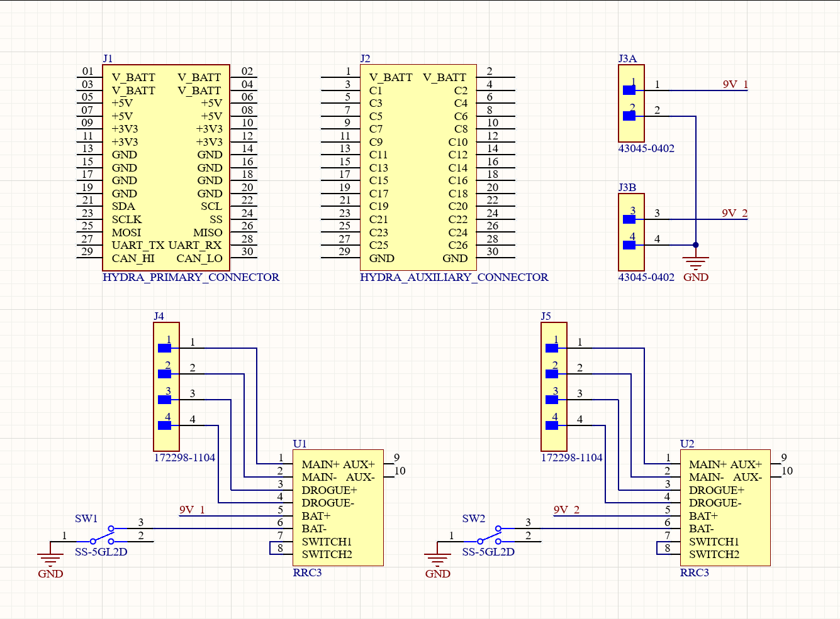

Figure 1‑1. Hydra V1 Recovery Board Schematic

### PCB

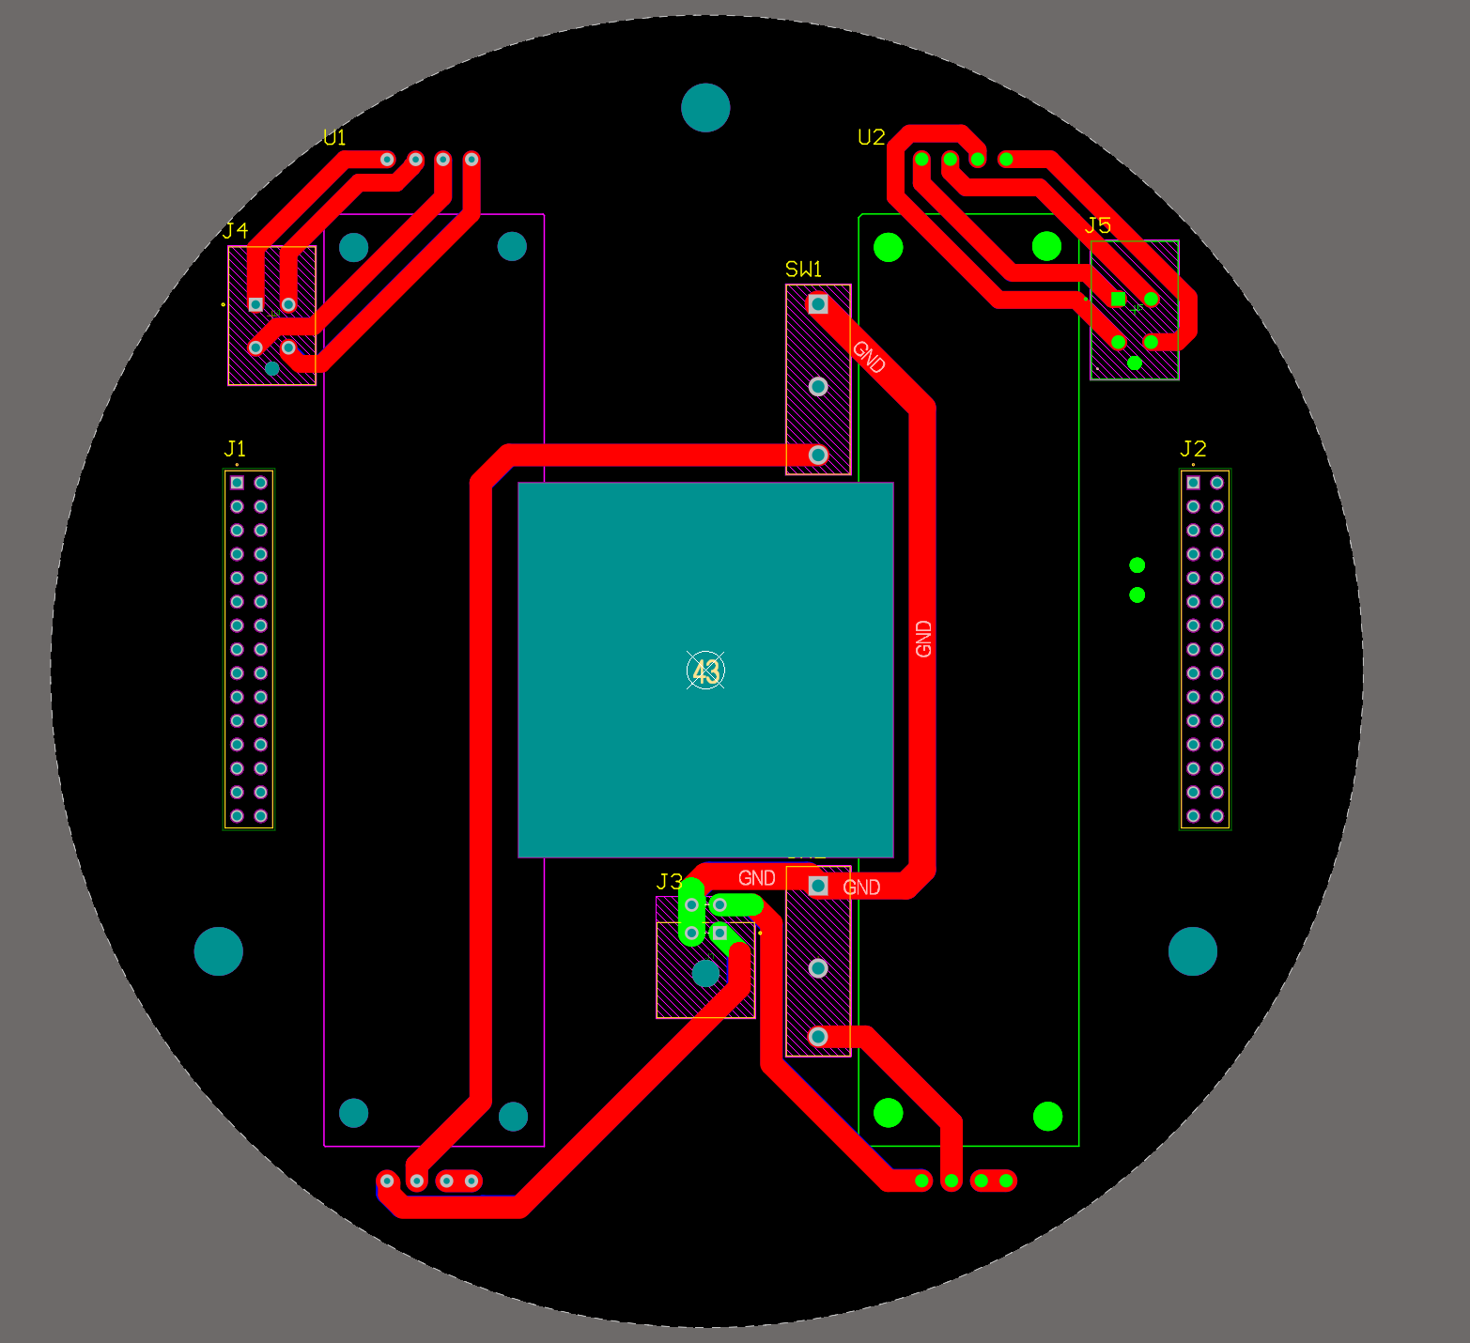

Figure 1‑2. Hydra V1 Recovery Board PCB Layout (traces are mirrored on both sides)

## Communication Board (HYDRA_V1_COMMUNICATION)

### Overview

V1/V2 communication board skipped for financial reasons. Team is shifting directly to V3 board which includes an MCU to input telemetry directly to the CAN bus. The V3 board will include ‘bypass’ traces to connect the RFD900’s UART to the left header’s UART bus which can be severed when we implement the V3 circuitry.

## Logic Board (HYDRA_V1_LOGIC)

### Overview

The logic board is the most complex board of the Hydra V1 stack as it houses the sole MCU within the system. Its purpose is to process data generated by the SBG and log it to the onboard SD card while simultaneously transmitting it through the left header’s UART bus which goes directly to the RFD900 on the communication board. Overall, the board consists of a SAM E51 MCU, the SBG, an SD card, a CAN transceiver, a buzzer, and a set of status LEDs.

We elected to interface the SD card through SPI on SERCOM 4 as opposed to using one of the SAM E51’s integrated SDHC controllers to alleviate some load on the software side since SDHC controllers are overly complex for our purposes. Future iterations of this board may utilize a SDHC controller or another form of data storage entirely however we are keeping things simple for the time being.

#### SERCOM Pinouts

SERCOM pinouts are determined as per datasheet specifications; the datasheet has a section for each protocol (SERCOM SPI, SERCOM I2C, and SERCOM USART) in which there are I/O tables under the “Register Description” section. For SPI, these are called “Data In Pinout” (DIPO) and “Data Out Pinout” (DOPO) whereas for UART they are called “Transmit Data Pinout” (TXPO) and “Receive Data Pinout” (RXPO). For I2C just go to section 36.4. These tables specify which SERCOM pads can serve which purposes for a given protocol. The purpose assigned to each SERCOM pad is tabulated below:

|  |  |  |  |  |  |
| --- | --- | --- | --- | --- | --- |
|  | Protocol[#] | SERCOM # | PAD # | MCU Pin | Function |
| SBG | UART[0] | 5 | 0 | PB02 | TX |
| 1 | PB03 | RX |
| SD Card | SPI[0] | 4 | 0 | PB12 | MOSI |
| 1 | PB13 | SCK |
| 2 | PB14 | CS |
| 3 | PB15 | MISO |
| General Purpose I/O | UART[1] | 2 | 0 | PA09 | TX |
| 1 | PA08 | RX |
| SPI[1] | 0 | 0 | PA04 | MISO |
| 1 | PA05 | SCK |
| 2 | PA06 | CS |
| 3 | PA07 | MOSI |
| I2C[0] | 1 | 0 | PA16 | SDA |
| 1 | PA17 | SCL |

#### Parent Schematic Considerations (Connectors.SchDoc)

This schematic offers a block-diagram view of how the logic board functions. The MCU, SBG, and SD card schematics are included as sub-schematic components. The CAN transceiver is included here as there was no room in the MCU_PINOUT.SchDoc schematic. It uses a voltage divider on the RxD line since the CAN transceiver operates at 5V whereas the MCU operates at 3.3V. **Important note: UART lines (Tx/Rx) cross over (Tx goes to Rx on the receiving device and Rx goes to Tx) but CAN Tx/Rx lines DO NOT**. The CANH and CANL pins are defined as a differential pair such that Altium automatically ensures adequate routing.

P1 is a SWD JTAG programming header and conforms to the 10-pin JTAG pinout standard.

Finally, R23-R38 are included to provide pads on all the SERCOM lines in case they were connected wrong. Ideally, these pads will all be shorted however this provides us with the flexibility to rewire data bus lines on the fly ensuring the boards can be used for testing. These pads will not be included in the next iteration.

#### MCU Pinout Considerations (MCU_PINOUT.SchDoc)

The inductors and capacitors connected to the MCU are chosen as per Figure 60-1 (p.1913) of its [datasheet](https://ww1.microchip.com/downloads/aemDocuments/documents/MCU32/ProductDocuments/DataSheets/SAM-D5x-E5x-Family-Data-Sheet-DS60001507.pdf). The two external crystals (Y1 and Y2) each have two capacitors between their pins and GND which were also chosen based on the MCU’s [datasheet](https://ww1.microchip.com/downloads/aemDocuments/documents/MCU32/ProductDocuments/DataSheets/SAM-D5x-E5x-Family-Data-Sheet-DS60001507.pdf) (Figure 60-9 and Figure 60-11 on p.1919 and p.1920, respectively) since the individual datasheets of each crystal did not define an ideal capacitance value.

The reset switch schematic conforms to Figure 60-7 of the [datasheet](https://ww1.microchip.com/downloads/aemDocuments/documents/MCU32/ProductDocuments/DataSheets/SAM-D5x-E5x-Family-Data-Sheet-DS60001507.pdf) and includes a RC-filter to reduce any parasitic inductance or other noise that may exist within the RESETN net as well as a pullup resistor (R39). **I’m realizing now that this RC filter should probably be placed close to the MCU and I did not do this so we should definitely fix this for V2. I only placed the capacitor (C6) close to the MCU which is likely acceptable but might as well move the resistor (R1) closer too.** Beyond this, the reset switches are OMRON dip switches which were chosen over simple momentary switches to prevent accidental actuation and ensure reliability.

The buzzer circuit uses a N-channel MOSFET (Q1) to drive the buzzer using a GPIO pin. R14 is a current-limiting resistor to prevent drawing excessive current from the MCU, R41 is a pull-down to ensure the MOSFET remains in its cut-off region when no input is provided, and R2 serves to discharge the piezo buzzer (LS1) since it acts as a capacitive load. A MOSFET was chosen since these are field-effect transistors and should not require much drive current.

Finally, two pullup resistors (R15, R16) are included on the I2C line as these are required by the endpoint of a I2C bus which may, at some point, be the logic board. These are not intended to be populated however they were included just in case a future application requires them.

#### SBG Considerations (SBG.SchDoc)

The SBG interfaces with the MCU using a MAX3232EUE+T UART to RS-232 converter since the SBG Ellipse2-N-G4A3-B1 can solely output serial data through RS-232 or RS-422 and, rather poetically, the SAM E51 solely has support for RS-485.

The MAX3232’s schematic is built according to the datasheet, with the capacitors (C15-C18) defined based on the 4.5-5.5V V­CC range in Table 2 (page 9) of its [datasheet](https://datasheet.ciiva.com/22828/0900766b810e26b2-22828277.pdf?src-supplier=Rs). The initial plan involved supplying the MAX3232 with 3.3V and using 100nF capacitors, as specified by the datasheet, but this was changed to ensure the MAX3232 could output +-5V on its RS-232 pins. As a result of powering the MAX3232 with 5V, it’s R1OUT pin which outputs UART to the MCU also functions at +-5V so a voltage divider was included to drop this to 3.3V (R17/R18) on the Rx pin. Finally, a decoupling capacitor (C14) is included between the MAX3232’s VCC pin and GND.

The SBG is connected directly to the 5V rail of the left header on this board and no additional power circuitry exists. Its connector (P2) is a separate component from the footprint to provide flexibility in its positioning relative to the SBG’s mounting holes since the mounting holes are fixed at the center of the board. In this case, the connector is placed close to the MAX3232 IC however its position may change with future iterations.

#### Diagram, schematic Description automatically generatedSD Card Considerations (SD.SchDoc)

The SD card circuit is built as a superposition of two SPI SD card shields. The first is the [DFRobot SD card shield](https://www.dfrobot.com/product-875.html) with a schematic as per figure to the right and the second is a generic [AliExpress SD card shield](https://www.aliexpress.com/item/1005001579168924.html) with a schematic as per the figure below. These two differ in schematics as the DFRobot shield is designed to operate at 5V whereas the AliExpress shield works directly on 3.3V which is what the SD card operates at.

Since the DFRobot shield is designed to operate at 5V, it contains a linear regulator to reduce the 5V supply voltage to 3.3V which is omitted in our design. Additionally, it includes voltage dividers on the data pins since it assumes the MCU’s data lines also operate at 5V. **I made a mistake here since I included a voltage divider on the MISO pin as opposed to the CS pin. This is not necessary since the MISO pin is an output of the SD card which will never exceed 3.3V. Luckily, we shouldn’t need these dividers at all and our CS should not exceed 3.3V so it’ll be ok. These dividers will most likely be removed in V2 since I doubt they provide any functionality.** This circuit was included in case we require voltage dividers of our own to fine tune the voltage levels delivered to the SD card.

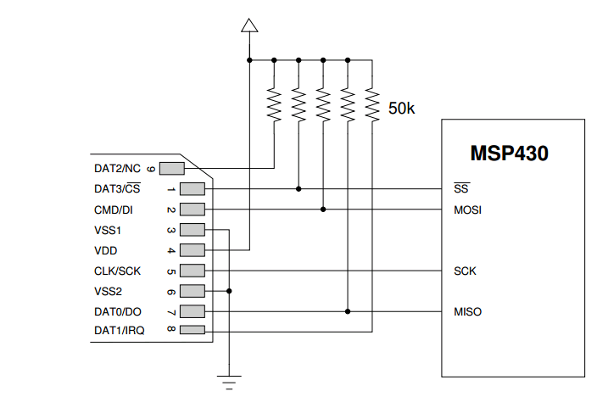The AliExpress shield simply has 10kOhm pullups on its MOSI, MISO, and SCK lines as well as on the SD card’s DAT1 and DAT2 pins. Since our MCU operates at 3.3V, the schematic below is all we should theoretically require. A decoupling capacitor (C19) is also included for the SD card.

### Component List

The following BOM has repeated Part # entries since the components are organized by subsystem such that their function can be described more accurately.

|  |  |  |  |  |
| --- | --- | --- | --- | --- |
|  | Part # | QTY | Purpose | Comment |
| HYDRA | PRT-12790 | 2 | Inter-board header | Standard components for all Hydra boards. |
| TSM-105-01-T-DV | 1 | JTAG header | Generic 2.54mm-pitch programming header |
| MCU + MCU power delivery | ATSAME51J18A-MFT | 1 | MCU | Contains a plethora of data transfer interfaces including two CAN buses which we require as well as a wealth of ADC-enabled pins. |
| NR6028T100M | 2 | 10uH power inductors for MCU supply rails | These components decouple various MCU power rails from the board-wide 3V3 rail. All chosen as per datasheet recommendation. |
| 1206ZD106KAT2A | 1 | 10uF decoupling capacitor |
| C0402C104K8PACTU | 6 | 100nF decoupling capacitors |
| GRM155R60J475ME47D | 1 | 4.7uF decoupling capacitor |
| ERA-3AEB102V | 1 | 1kOhm SWCLK pullup resistor | Used to pull up SWCLK pin of JTAG header as per datasheet recommendation |
| RC1206FR-0710KL | 2 | 10kOhm I2C pullup resistor | Pullup resistors are required at an I2C end point, included in case the logic board acts as an end point. |
| Clock crystals | ABM8-48.000MHZ-B2-T | 1 | 48MHz clock crystal | Chosen as per datasheet recommendation. |
| 08051A6R8CAT2A | 2 | 6.8pF decoupling capacitors |
| ECS-.327-12.5-1210-TR | 1 | 32.7680kHz clock crystal |
| C0805C180J5GACTU | 2 | 18pF decoupling capacitors |
| CAN | MCP2544FD-E/SN | 1 | CAN transceiver | Used to communicate with other HYDRA boards within the avionics stack. |
| C0402C104K8PACTU | 1 | 100nF decoupling capacitor | Decouples CAN transceiver from board-wide 5V rail. |
| CRCW12061K00FKEA | 1 | 1kOhm resistor | Voltage divider for CAN_RX line to reduce voltage to the 3.3V that the MCU can accept. |
| CRCW12062K20FKEA | 1 | 2.2kOhm resistor |
| Status LEDs | LTST-C190GKT | 1 | Green status LED |  |
| TLMS1000-GS08 | 1 | Red status LED |  |
| LTST-C191TBKT | 1 | Blue power status LED | Turns on if board has power. |
| ERA8AEB331V | 3 | 330Ohm current limiting resistors for LEDs |  |
| Buzzer + amplifier | PS1240P02BT | 1 | Buzzer | Chosen for high sound output. Sole component connected to battery voltage on this board. |
| STD5N20LT4 | 1 | Buzzer amplifier MOSFET | MOSFET for amplifying a signal from the MCU to higher levels for the board’s buzzer. |
| CRCW12061K00FKEA | 2 | 1K current limiting and buzzer discharge resistors | R2 discharges LS1 (buzzer) when Q1 (amplifier) turns off, since LS1 acts as capacitive load. R14 limits gate current of Q1 from MCU pin (PA18). |
| RC1206FR-07100KL | 1 | 100K pull-down resistor | Ensures MOSFET is in cutoff region unless PA18 is providing voltage |
| SD card | 47219-2001 | 1 | SD card holder | Chosen for its hinged design that should hold the SD card more firmly than a traditional SD card holder. |
| CRCW12062K20FKEA | 3 | 2.1kOhm resistor | Act as voltage divider to lower SPI levels from MCU to lower signal voltages for the SD card. Used as per the DFRobot SD card shield schematic. |
| CRCW12061K00FKEA | 3 | 1kOhm resistor |
| ERJ3EKF1002V | 4 | 10kOhm pullup resistors | Used as per the AliExpress SD card shield schematic |
| C0402C104K8PACTU | 1 | Decoupling capacitor | Decouples SD card supply from board-wide 3V3 rail. |
| SBG + UART to RS-232 converter | SBG Ellipse2-N-G4A3-B1 | 1 | SBG sensor package | Provided by sponsor, contains accelerometer, barometer, gyroscope, magnetometer, and GPS as well as a common filter to ensure accurate sensor data. |
| MAX3232EUE+T | 1 | UART to RS-232 converter | Required since SBG uses RS-232 whereas MCU is only capable of UART. |
| C0402C104K8PACTU | 1 | Decoupling capacitor | Decouples MAX3232 from board-wide 5V rail. |
| GRM31CR71H475KA12L | 1 | 4.7uF capacitor | All four of these capacitors were chosen as per the MAX3232’s datasheet. |
| 12061C334KAZ2A | 3 | 330nF capacitor |
| Reset switch | A6H-2102 | 1 | Reset switch | Dip switch chosen instead of momentary to prevent accidental actuation on impact or from acceleration. |
| ERJ3EKF1002V | 1 | 10kOhm pullup resistor | Pulls up RESETN pin of MCU until dip switch closes at which point it limits current flow from the 3V3 rail to GND to 0.33mA. |
| C0402C104K8PACTU | 1 | 100nF filter capacitor | RC filter to prevent noise on the RESETN net. Capacitor also limits helps dampen current flow when SW1 closes and RESETN is pulled low. |
| ERJ-3EKF3300V | 1 | 330Ohm filter capacitor |

### Layout Considerations

The SBG needs to be along the rocket’s axis meaning that it had to be placed in the center of the board. The remaining components were molded around the SBG with the MCU being fitted in a relatively central location to allow as much access as possible to its pins. Each subsystem was built individually after which the subassemblies of components were aggregated together, as close as possible to the MCU. The MCU has a GND pad included below it because the VQFN package has a large ground plane to promote heat dissipation. The pad here serves the same purpose by promoting heat transfer with the board-wide GND plane.

The two exceptions to this rule are the SD slot and the buzzer that were mounted farther from the MCU. The SD slot was mounted farther to not interfere with the SBG’s footprint whereas the buzzer was mounted close to the V_BATT pins of the right header since it is the sole component that requires V_BATT.

The board has 4 layers to simplify the design process and allow more possibilities for future expansion as more features are added. The two intermediary layers are power planes for GND and 3V3 seeing as these are in high demand throughout the design. 5V is routed on the bottom layer through a thicker trace with the SBG’s connector being placed close to the left header since it draws the most power on this board. 5V power is then routed to the MAX3232 and the CAN transceiver.

The crystal layouts were kept close to the MCU such that the crystal’s traces remained as short as possible. Beyond this, the power and ground planes were removed below each crystal and the ground traces going to the capacitors were extended such that they reach a via just outside of the plane cutouts.

### Schematics

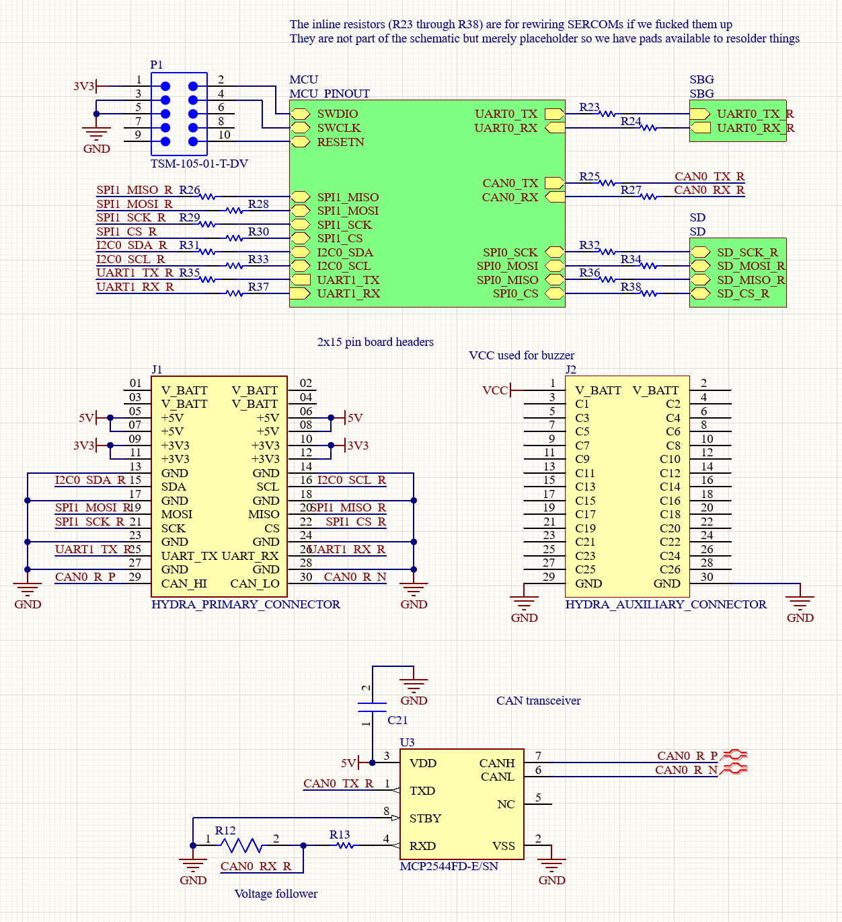

Figure 1‑3. Hydra V1 logic board hierarchy schematic

The schematic above includes the rough hierarchy for the MCU’s operation as well as the HYDRA board connectors and CAN transceiver. From the top right of the MCU and going clockwise, the MCU communicates with the SBG sub-schematic through UART, with the CAN transceiver using its onboard CAN controller, with the SD card using SPI, and with the UART, I2C, and SPI buses of the left header using their respective protocols. Finally, a SWD JTAG header is linked directly to the MCU’s pins as well as the board’s 3V3 and GND rails as per the standardized 10-pin JTAG pinout.

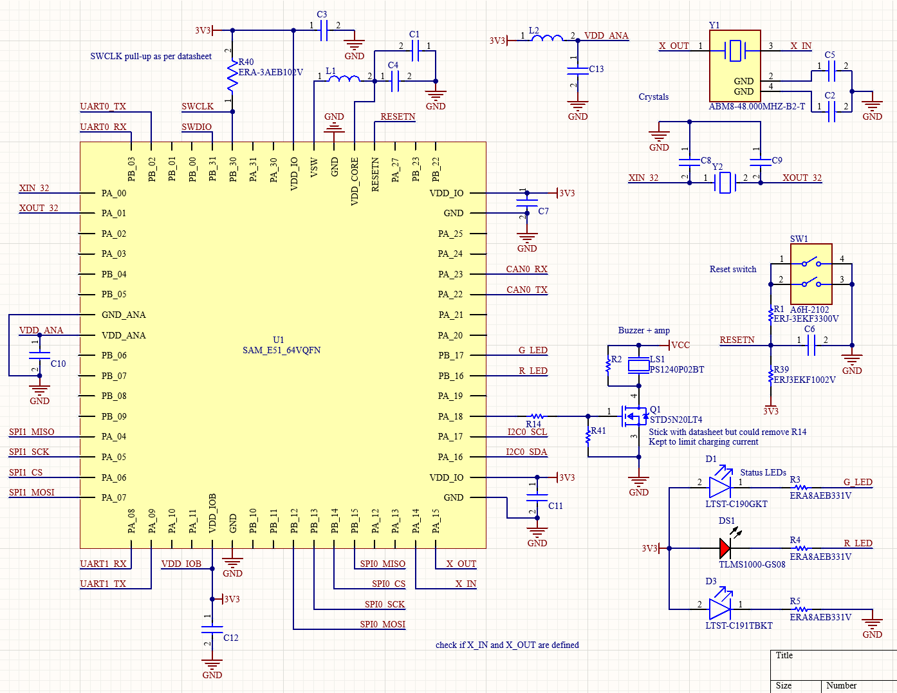

Figure 1‑4. Hydra V1 logic board MCU pinout

The schematic above depicts the ATSAME51 to the left alongside its related power components with the exception of L2 and C13 which are included separately off to the top right of the MCU. The two crystals and reset switch are included next to the L2/C13 assembly. The status LEDs and RESET switch are included below the two crystals.

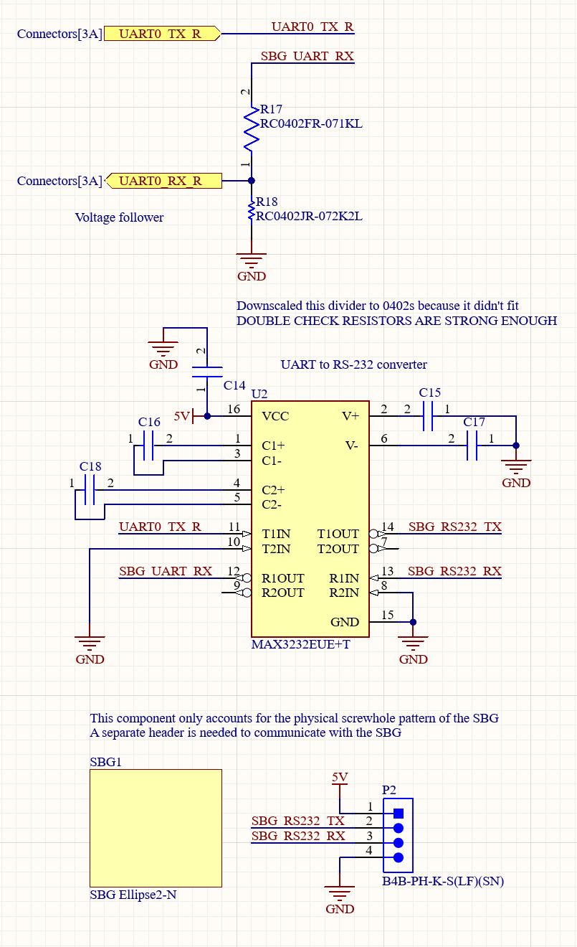

Figure 1‑5. Hydra V1 logic board SBG pinout

The schematic above depicts the SBG alongside its UART to RS-232 converter that runs off of the board’s 5V rail. C15 through C18 were chosen as per the datasheet as depicted below for 4.5 < Vcc < 5.5 whereas C14 is a decoupling capacitor.

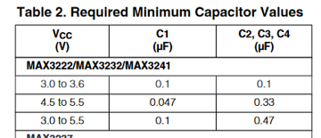

Figure 1‑6. MAX3232EUE+T datasheet recommended capacitor values

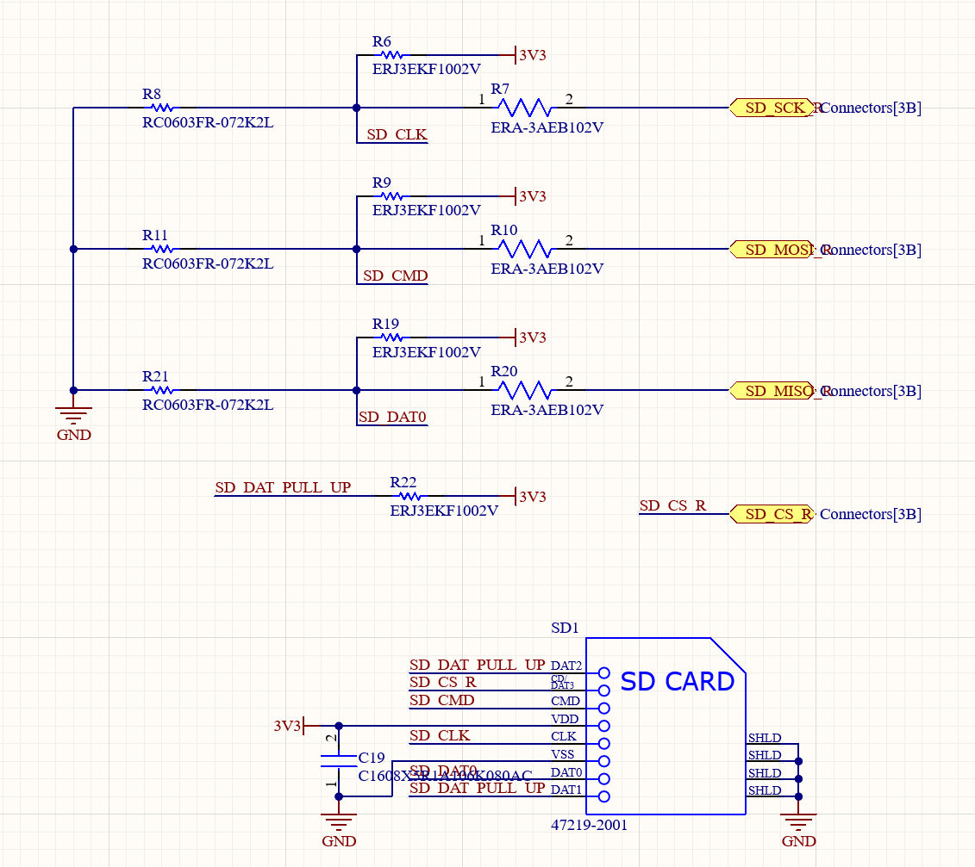

Figure 1‑7. Hydra V1 logic board SD card schematic

The SD card schematic includes three voltage divider pairs (R8/R7, R11/R10, R21/R20) alongside four pullup resistors (R6, R9, R19, R22) and a decoupling capacitor (C19).

### PCB

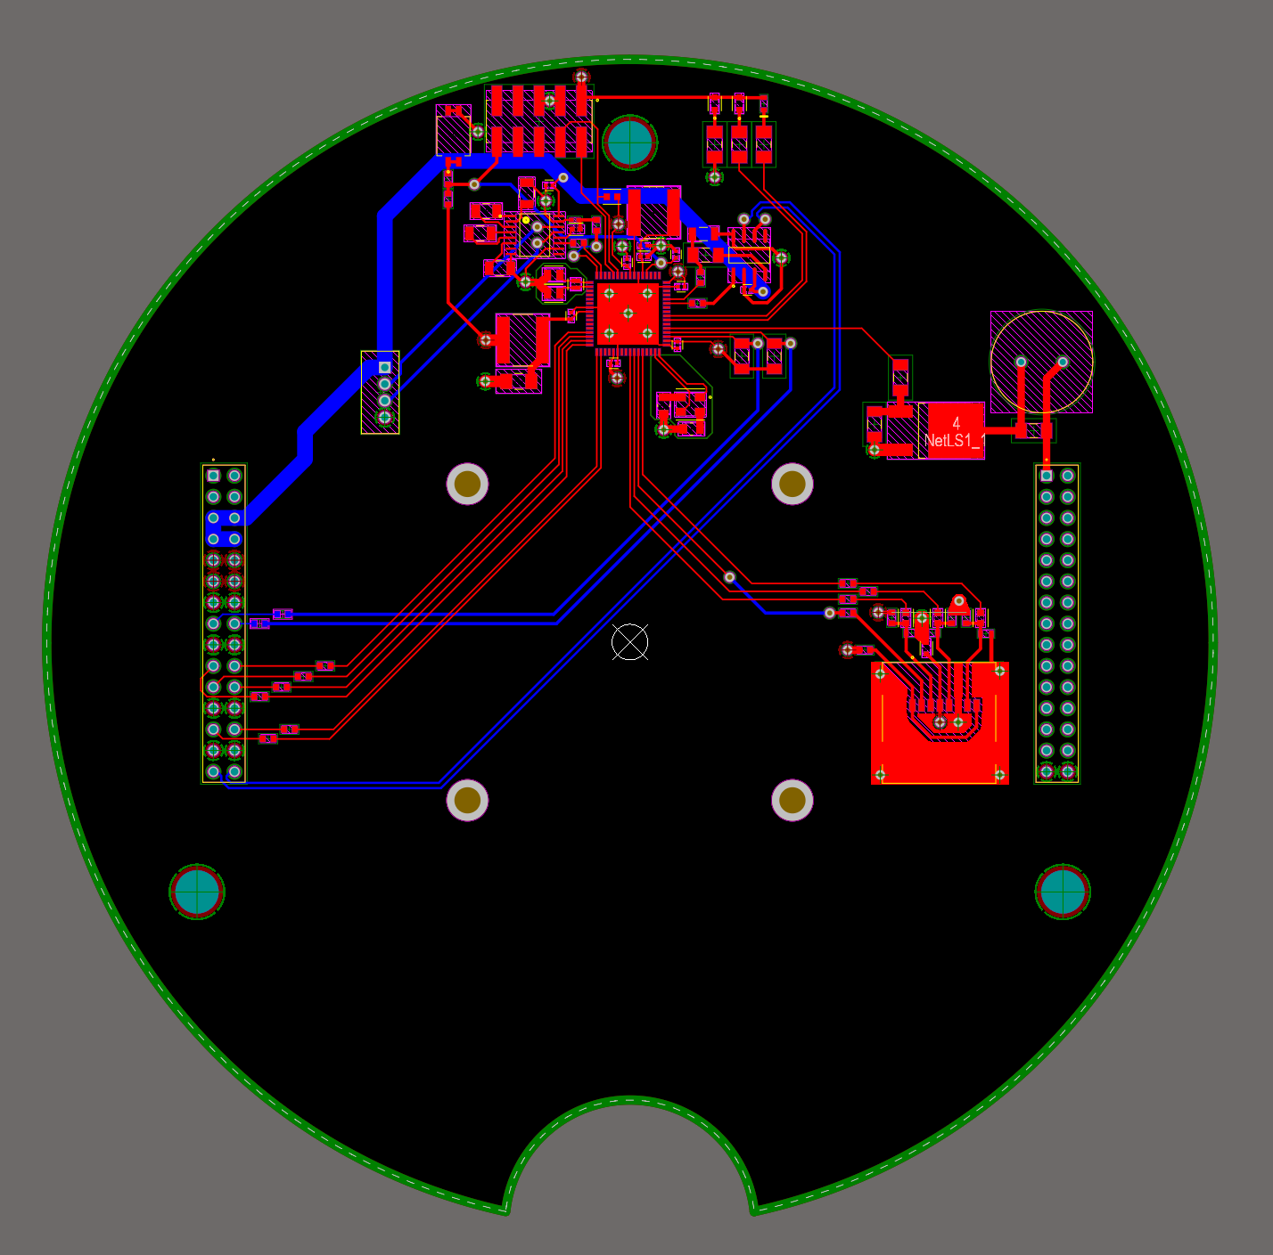

Figure 1‑8. Hydra V1 logic PCB trace layout

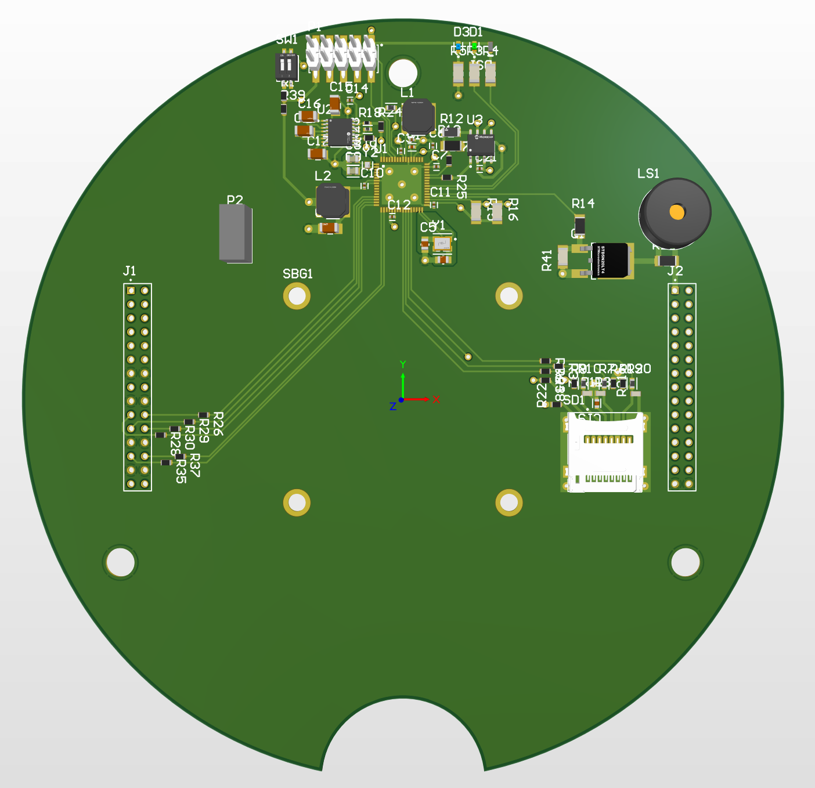

Figure 1‑9. Hydra V1 logic board 3D view

### Reflection

The following is a list of issues that should be fixed in the next iteration:

* Place reset switch RC filter closer to MCU
* Clear ground pad below MCU of silk screen (add to MCU part in Altium cloud?)
  + Ensure VIAs connecting this pad don’t have thermal reliefs
* Clean up SD card circuit
* Remove rewiring resistors where not needed
* Make whole top layer a ground pour
* Fix silkscreen
  + Make it readable
  + Omit certain component IDs but try to retain most
  + Add SBG outline to component
  + Add identifying text (place Altium project name and credits on PCB)
  + Add SBG logo (for picture I intend to send to SBG – Serban)
  + Label programming interface and each of the 3 status LEDs
* Make all components 0603s except decoupling capacitors which are 0402s
* Make buzzer MOSFET adequately sized à smaller
* Change SBG connector to something more sensible (not JST but maybe JST-SM?)
  + Molex might be best since we do have extras
    - Might not want this connector to be the same as ejection or power connectors to ensure the board is retard-proof
  + Also pay attention to vertical clearance, use right angled connector if possible pointing backwards towards rear wire channel of PCB stack
* Spread out components on PCB
  + Organize by system
  + Move MAX3232 and CAN transceiver away from MCU but keep power circuitry and crystals closeby
    - Not sure how long the traces can be between MCU and these ICs but it should be ok. Check with Simon or Seb or someone who knows what they’re doing before making these changes
  + Maybe at labelling text or some cool design on the board
* Move buzzer to PA19
* Change programming header to smaller size and fix programming pinout
* Add thermal pad to MCU footprint

## Power Board (HYDRA_V1_POWER)

### Overview

The first iteration of the power board is as barebones as possible and only includes a 3V3 regulator alongside a 5V regulator. Both of the power regulators receive power through a set of safety switches which interact with a rod protruding from the rocket’s body. This mechanism is redundant for Hydra V1 since the flight computer is not in charge of any flight functionality however it will be required with future Hydra versions.

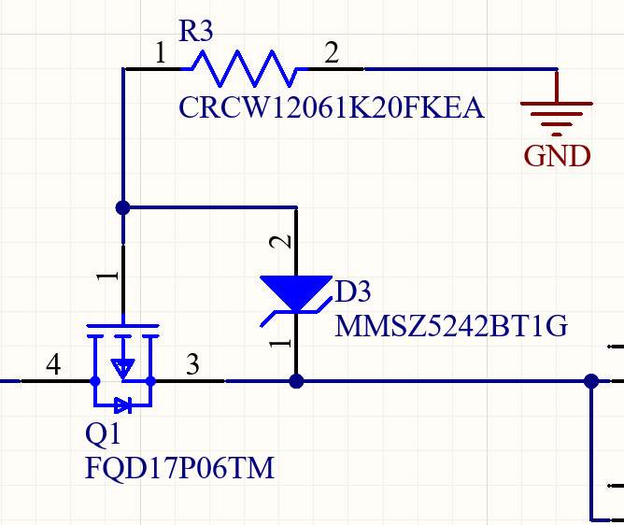The only circuit requiring explanation in this rendition of the power board is the reverse polarity protection included at the input. This circuit allows current to flow through Q1 when the polarity is correct since the GND power port will be ground and the MOSFETs drain (pin 4 of Q1) will be positive. In this configuration, the MOSFET’s body diode conducts current from the drain to the source (pin 3 of Q1). Additionally, R3 connects the ground power port to the MOSFET’s gate which pulls it low and excites the MOSFET such that it can conduct current in both directions. During a reverse polarity event, the MOSFET’s drain becomes negative whereas the GND power port becomes positive. This results in the gate (pin 1 of Q1) potential being higher than the source potential therefore shutting off the MOSFET and preventing current flow in both directions. The body diode will not conduct since it is oriented the wrong way and the MOSFET will prevent current flow in the other direction. The Zener diode (D3) prevents the voltage difference between the gate and source from ever exceeding 12V, during an overvoltage event for example, which could damage the MOSFET.

### Component List

Table 2. Hydra V1 Power Board Component List

|  |  |  |  |
| --- | --- | --- | --- |
| Part # | QTY | Purpose | Comment |
| C0805C103J5RACTU | 2 | 10nF 50V boost capacitor | Value based on datasheet[2]. Shared between both regulators since their datasheet both require identical values here. |
| B540C-13-F | 2 | 40V 5A Schottky Diode | Value based on datasheet[2]. |
| HSMG-C190 | 2 | Indicator LED | One used per regulator, these are arbitrarily chosen. |
| LM2677S-5.0/NOPB | 1 | 5V regulator | Chosen for simplicity of application circuit and high output current of 5A which is excessive for the Hydra V1. |
| 16TQC15M | 3 | 15uF 16V input surge capacitor | Number and value of capacitors used is based on datasheet[2]. |
| ANY | 1 | 470nF >15V 1812(4532) capacitor | Value based on datasheet[2]. |
| SRP6060FA-220M | 1 | 22uH 5A output inductor | Value based on datasheet[2]. |
| 25SVPF180M | 2 | 180uF output surge capacitor | Number and value of capacitors used is based on datasheet[2]. |
| CRCW1206140RFKEA | 1 | 140Ohm 1206(3216) LED resistor | Based on forward current[3]. |
| LM2678S-3.3/NOPB | 1 | 3V3 regulator | Chosen for simplicity of application circuit and high output current of 5A which is excessive for the Hydra V1. |
| EEHZA1V680XP | 2 | 65uF 35V input surge capacitor | Number and value of capacitors used is based on datasheet[2]. |
| 74477110 | 1 | 10uH 5.5A output inductor | Value based on datasheet[2]. |
| 16SVPC120M | 1 | 120uF output surge capacitor | Value based on datasheet[2]. |
| CRCW120660R4FKEA | 1 | 60Ohm 1206(3216) LED resistor | Based on forward current[3]. |
| 43045-0402 | 1 | Battery connector | Chosen for locking ability and high current capacity (5A per pin at 250VDC). It has 4 pins so each battery terminal uses two for a combined 10A current capacity. |
| FQD17P06TM | 1 | 60V 12A P-Channel reverse polarity protection MOSFET | Chosen since surface mount and enough current capacity for our purposes however may be switched due to availability issues at the time of this writing. |
| MMSZ5242BT1G | 1 | 12V Zener 0.5W diode to regulate reverse voltage for P-Channel MOSFET | Zener voltage was chosen to match nominal battery voltage. Current limiting resistor tabulated below ensures power through Zener does not exceed 0.5W. |
| CRCW12061K20FKEA | 1 | 1.2k 1206(3216) current limiting resistor for Zener | Maintains max current through Zener as $I=\frac{V}{R}=\frac{12}{1200}=10mA$ |
| SS-5GL2D | 2 | 5A safety disconnect switch | Two are used in parallel since they are rated for 5A each and we need 10A. |
| EEEFK1H101P | 1 | 100uF 50V input surge capacitor | Acts as an input surge capacitor for the board as a whole. |
| PRT-12790 | 2 | Inter-board header | Standard component for all Hydra Boards |

|  |  |
| --- | --- |
|  | Common components |
|  | 5V regulator components |
|  | 3V3 regulator components |

### Layout Considerations

The current power board layout is concentrated to leave space for future power board upgrades and keep the traces as short as possible. The layout for each regulator is compacted to ensure the capacitors and inductors remain as close as possible to the regulation IC as per recommendation from the datasheet.

Additionally, this is a 4 layer board containing GND and VCC planes within the stack to simplify the board’s trace layout. This is not entirely necessary for the time being however it will be necessary with future power board versions that will integrate significantly more functionality. As such, 4 layers are kept to simplify the process of designing future boards as the power regulator layout will not need to be changed and we will have tested the layout prior to ordering a second board with more functionality.

### Schematics

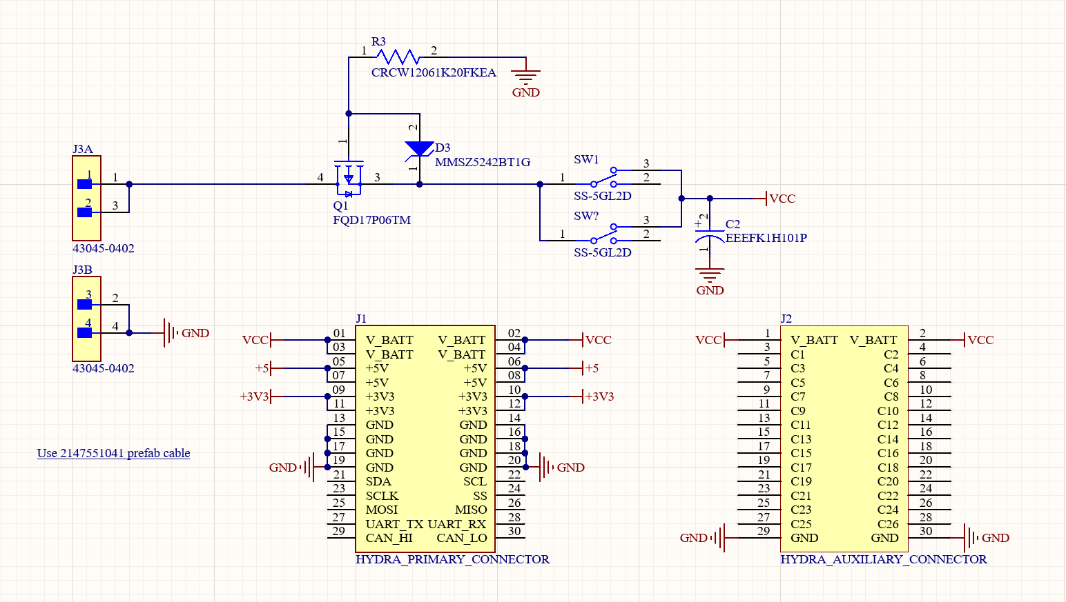

Figure 1‑10. Connectors and reverse polarity protection schematic

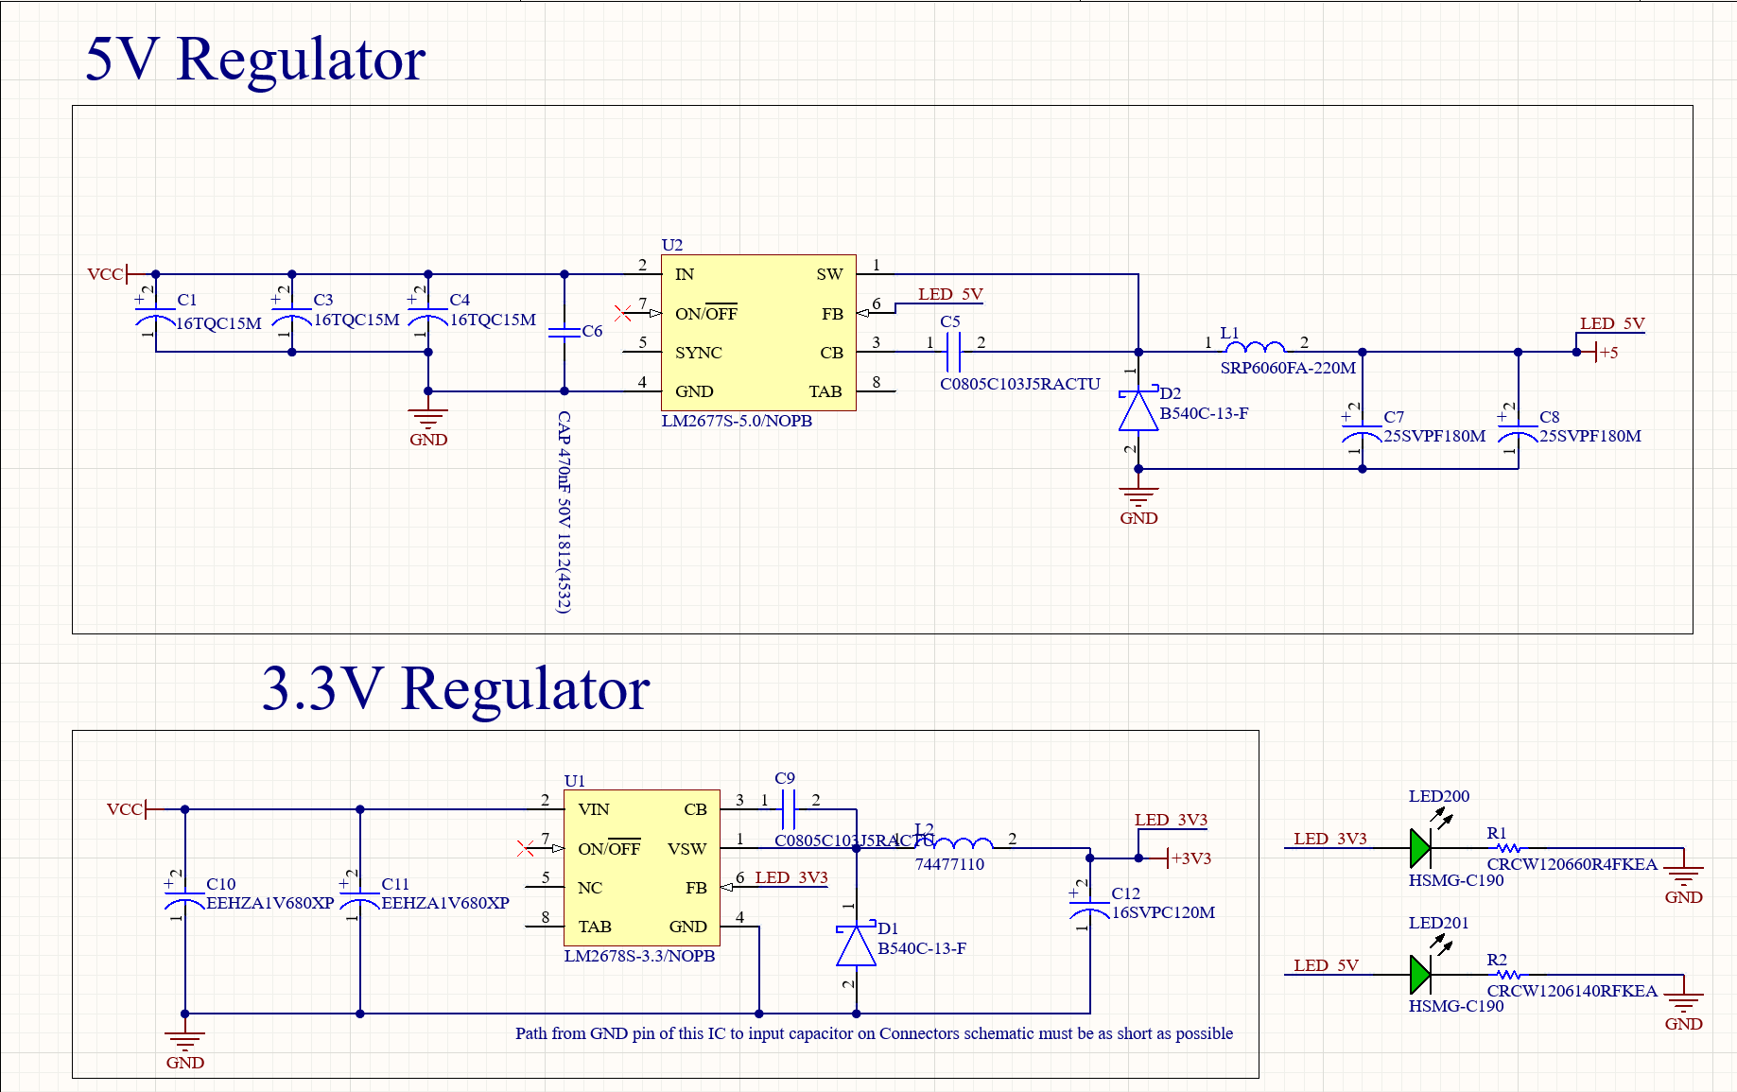

Figure 1‑11. 5V and 3V3 regulator schematic w/ LEDs

### PCB

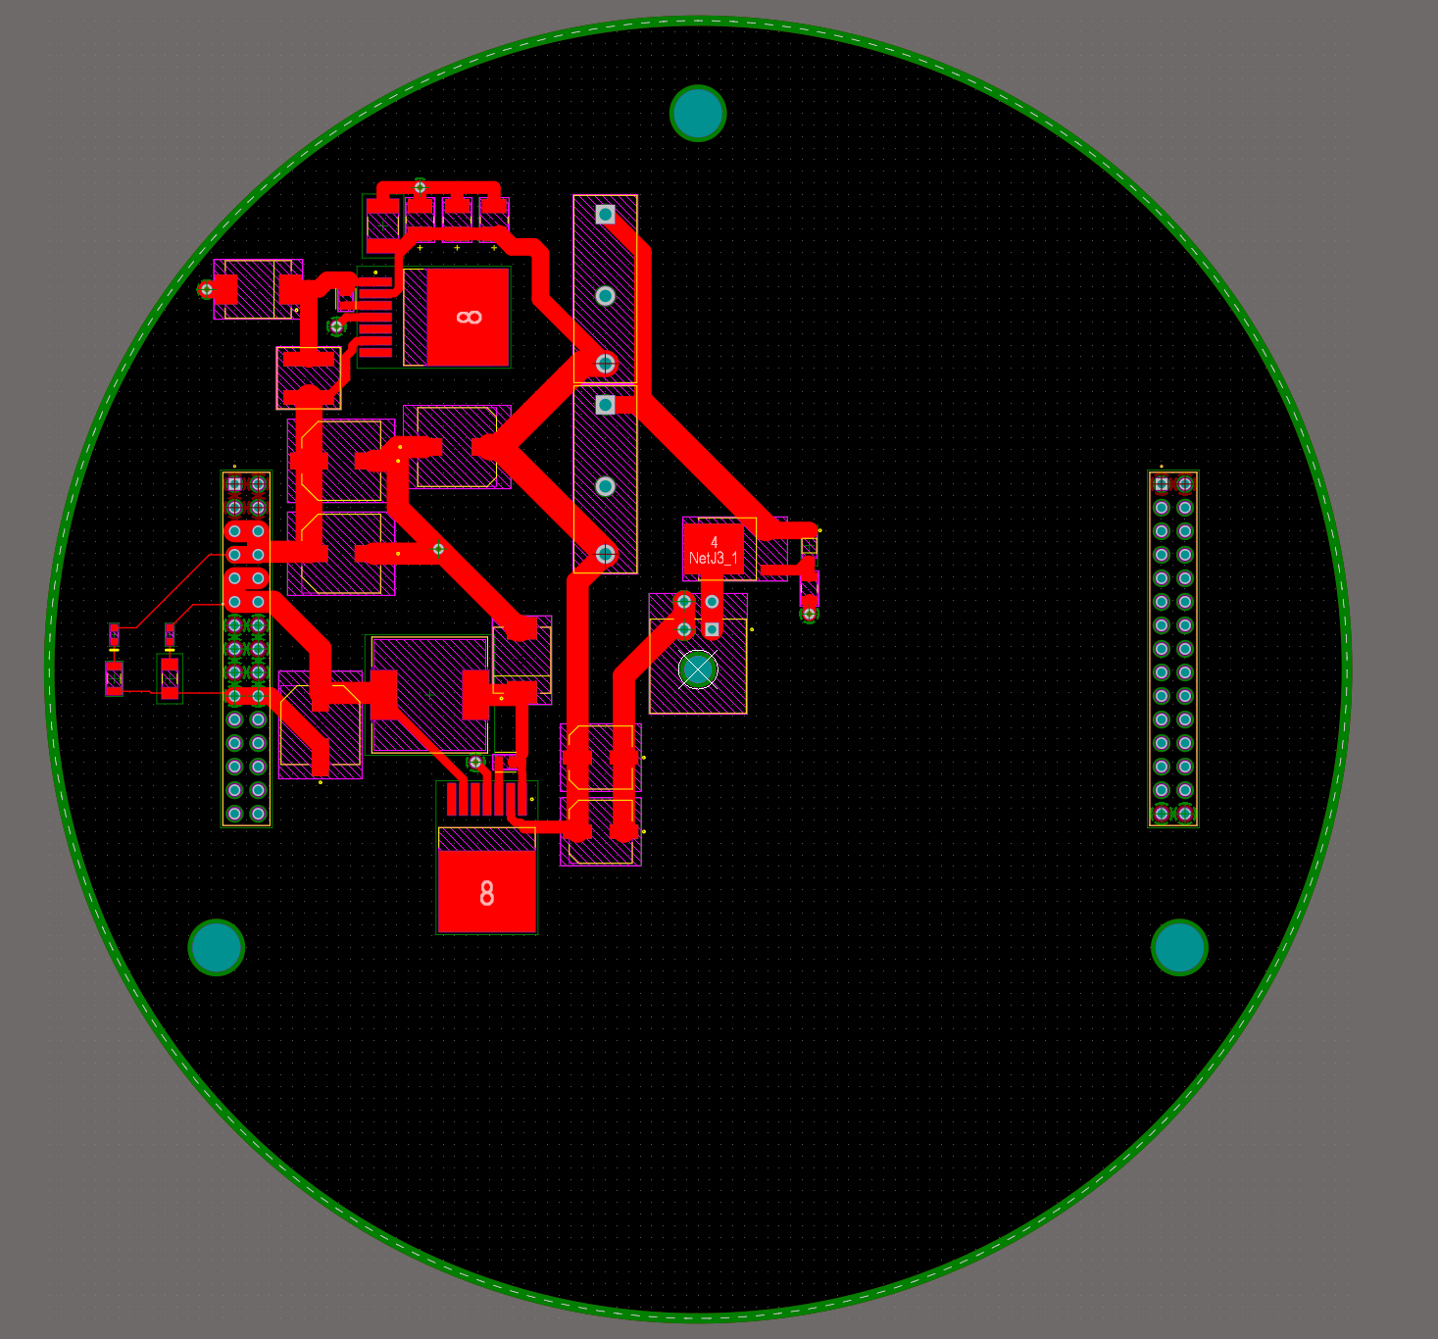

Figure 1‑12. Hydra V1 Power Board PCB Layout (PWR and GND planes omitted)

### Reflection

* Add VIAs to regulator back tabs to dissipate heat into ground plane

## MCU Pinout (HYDRA_V1_MCU_PINOUT)

### Overview

The MCU pinout project is a barebones MCU schematic that includes MCU-specific power components, clock crystals, status LEDs, a reset switch, a CAN transceiver, and a 10-pin JTAG interface. Sections 1.5.2 and 1.5.3 are not included since the information can be found in Sections 1.3.2 and 1.3.3, respectively. Section 1.3.1.3 may be relevant with regard to the crystal and reset switch circuits. Additionally, Section 1.3.3 may be relevant when considering the PCB layout though the HYDRA_Vx_LOGIC (where ‘x’ is the most recent version) project should ideally be used for reference.

The remainder of this section covers the requirements to implement the MCU_PINOUT schematic in another project. The following nets must be connected in order for the pinout to work:

|  |  |  |
| --- | --- | --- |
| Net name | Net type | Purpose |
| 5V | Power port | Supply 5V to CAN transceiver |
| 3V3 | Power port | Supply 3V3 to MCU |
| GND | Power port | Provide GND to board |
| CAN0_P | Differential pair | CAN high (P) and CAN low (N) differential pair |
| CAN0_N |

#### Power Requirements

The MCU_PINOUT project does not incorporate any internal regulators since Hydra boards rely on the power board for 5V and 3.3V. In the case of a board that does not have access to regulated voltage rails, a separate regulator must be integrated. TALK ABOUT MCU PWR CONSUMPTION 5V should be provided to a power port object labelled “5V” whereas 3.3V should be provided to a power port object labelled “3V3”. No external components should be attached to the MCU’s internal power nets (VDD_ANA or VDD_IOB) and should instead use another supply such as the aforementioned 5V or 3V3 power port objects.

#### CAN Requirements

The CAN transceiver is the sole component within the MCU pinout that operates at 5V and, as such, its RxD pin has a voltage divider (R5/R7) to reduce the 5V to 3V3 before it reaches the MCU. Additionally, the CANH and CANL pins are marked as a differential pair such that Altium automatically matches the lengths of each trace and maintains constant spacing between the two. This differential pair must be connected to the left header or some other end spoint.

### Component List

See relevant components in Section 1.3.2.

### Layout Considerations

See relevant considerations in Section 1.3.3.

### Schematics

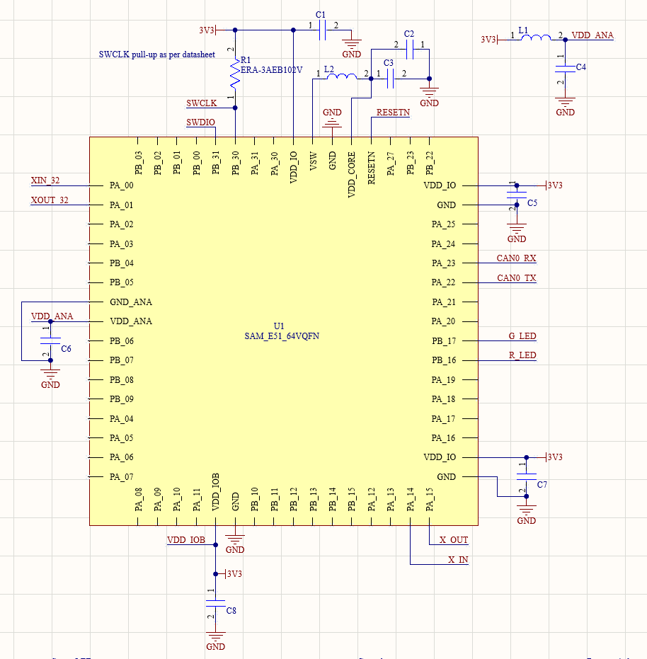

Figure 13. MCU_PINOUT MCU pinout including power components and SWCLK pullup

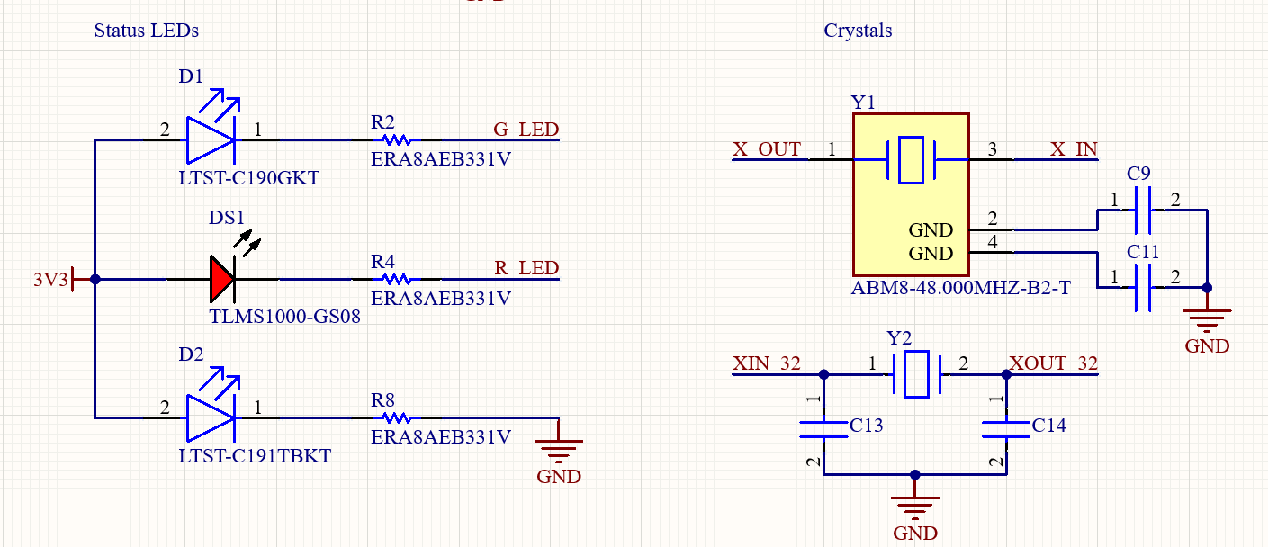

Figure 14. MCU_PINOUT status LED and crystal schematics

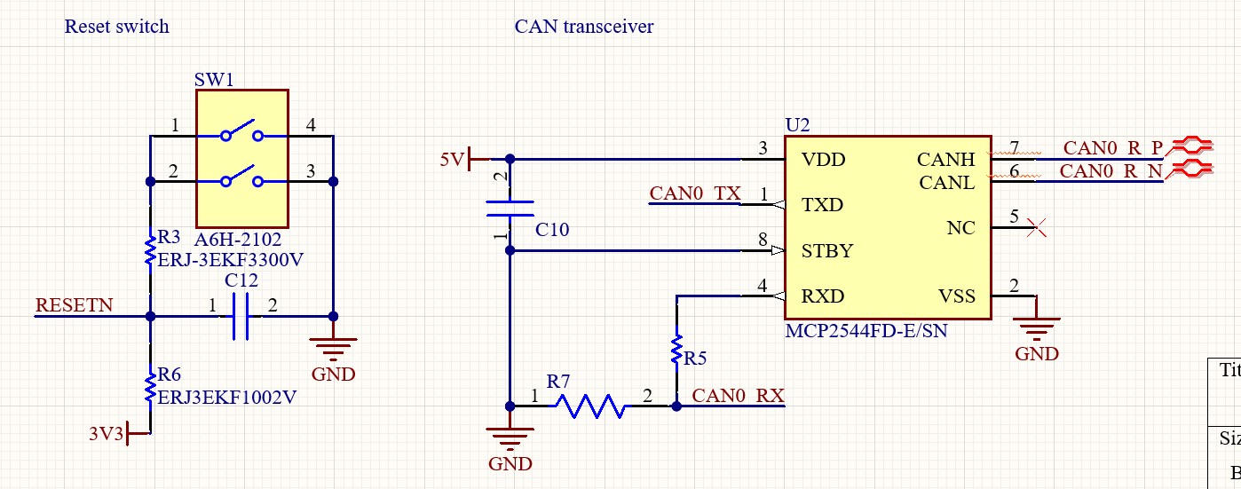

Figure 15. MCU_PINOUT reset switch and CAN transceiver schematics

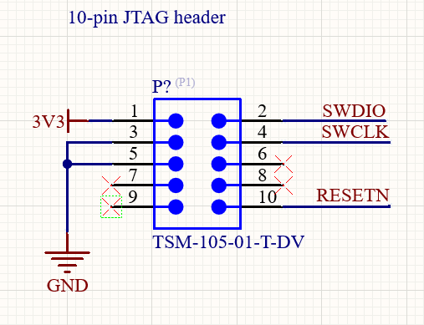

Figure 16. MCU_PINOUT 10-pin JTAG header schematic

# Hydra V2

## Recovery Board (HYDRA_V2_RECOVERY)

### Overview

The Hydra V2 recovery board contains SRAD ejection circuitry in parallel with an RRC3 recovery device for redundancy. This version of the board uses a SAME51 MCU though this will be updated in the future since functions that rely on the ADC are unusable due to an issue with the chip’s clocks on the software side. The SRAD circuitry also contains a barometer and IMU that can be utilized in the event that no navigational data is available on the avionics CAN bus.

### Layout Considerations

The layout of this board went through a couple iterations prior to the version pictured below. The RRC3 (U3) is kept on the left since the Hydra V2 aesthetic tends to have the status LEDs on the top right of the board meaning that it makes more sense to have the MCU there as well. The arming rod traverses the board immediately to the right of the RRC3 thereby leaving most of the right side of the board open for SRAD circuitry. Lastly, the RRC3 has a dedicated power connector to the **right** of the arming rod passthrough to prevent any wires from needing to cross the arming rod area. This was important to ensure that this board could remain stackable.

Beyond this, there are few significant layout considerations. The MCU is located on the top right with the backup sensor package (BARO + IMU) immediately below it. This is to ensure the data lines between the two remain as short as possible. The actual pyro switches are placed near the recovery connectors which are on the bottom right of the board, near the wire channel that is at the bottom of the PCB. This connector placement facilitates wiring recovery charges to the board and provides space for a uORocketry logo to be placed between the pyro switches and the MCU.

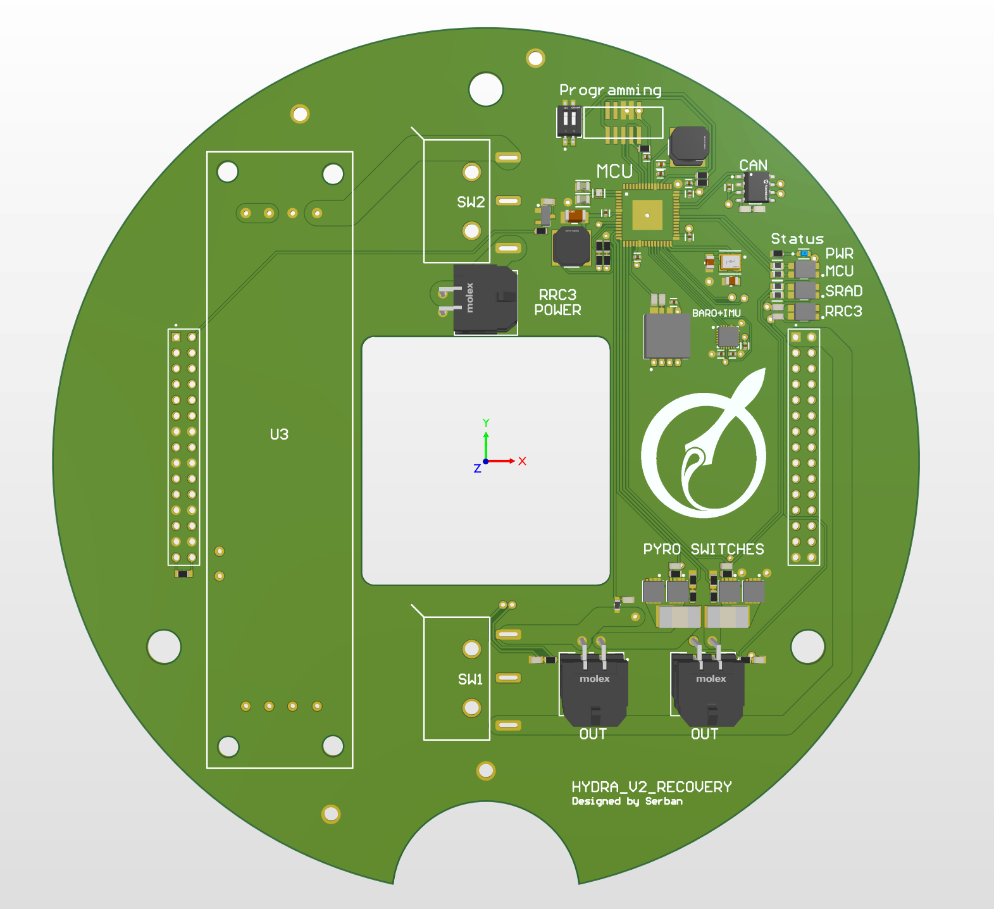

Figure . HYDRA_V2_RECOVERY PCB

### Schematics

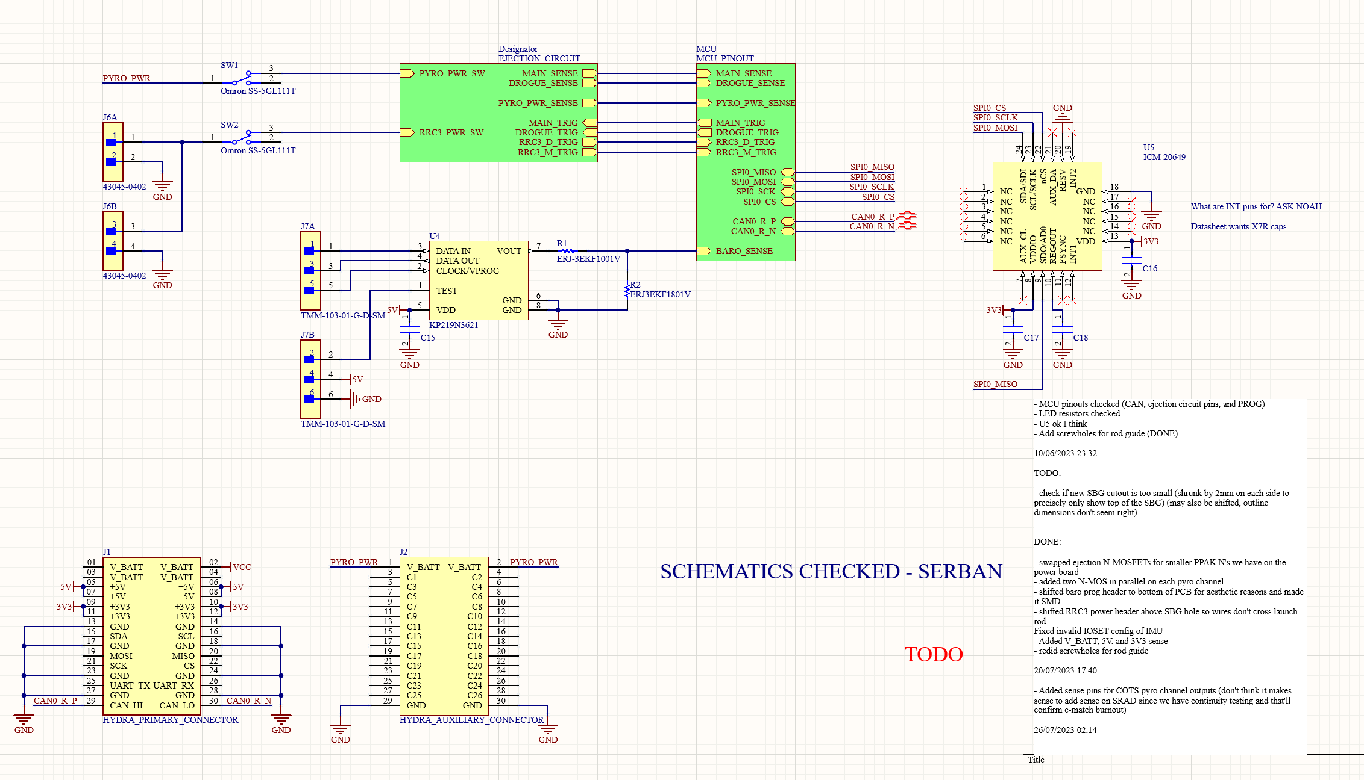

Figure . HYDRA_V2_RECOVERY Overarching Schematic

This schematic displays the overall functionality of the V2 recovery board. Firstly, power comes in at the top left and there are two ‘arming’ switches: one for the RRC3 and one for the SRAD circuit. The ejection circuit follows and contains both the RRC3 and SRAD system. The MCU schematic interacts with the ejection circuit as well as an IMU and barometer that were added at the last minute, hence why they are on this sheet. The IMU and barometer integration was not finalized in time for competition **and should be fixed in the future.** The INT pins of the IMU are used to notify the MCU of new data and should be integrated since we use direct memory access in our code so this would not slow down the MCU by a noticeable amount. Additionally, **Noah mentioned the barometer may not be good for our application** so that chip may need to be swapped.

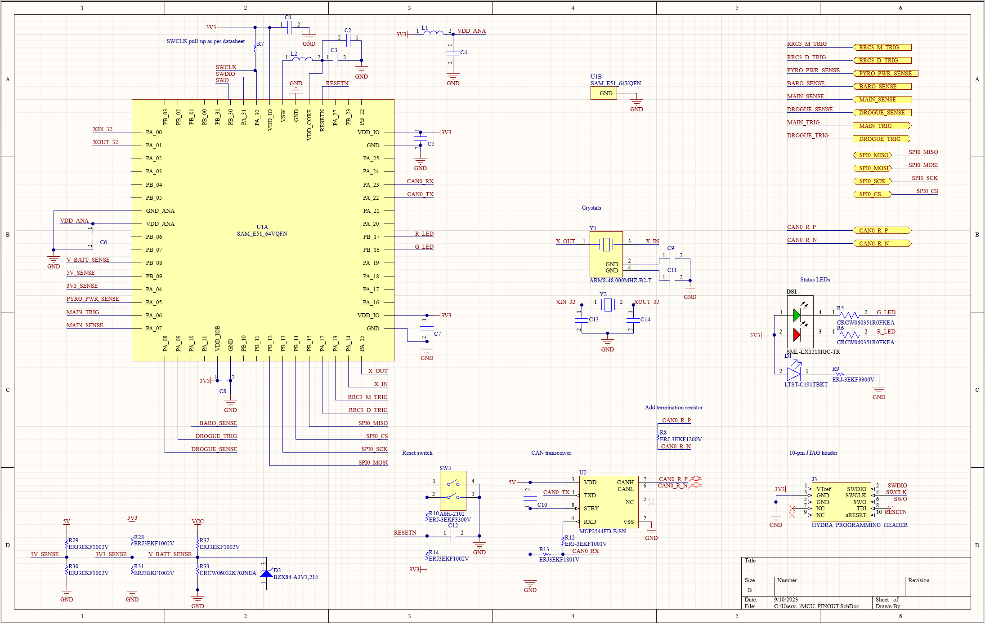

Figure . HYDRA_V2_RECOVERY MCU Schematic

Nothing awfully exciting here. This board has some added voltage sensing at the bottom left and all the I/O being used by the board is pinned out on the top right side of the schematic.

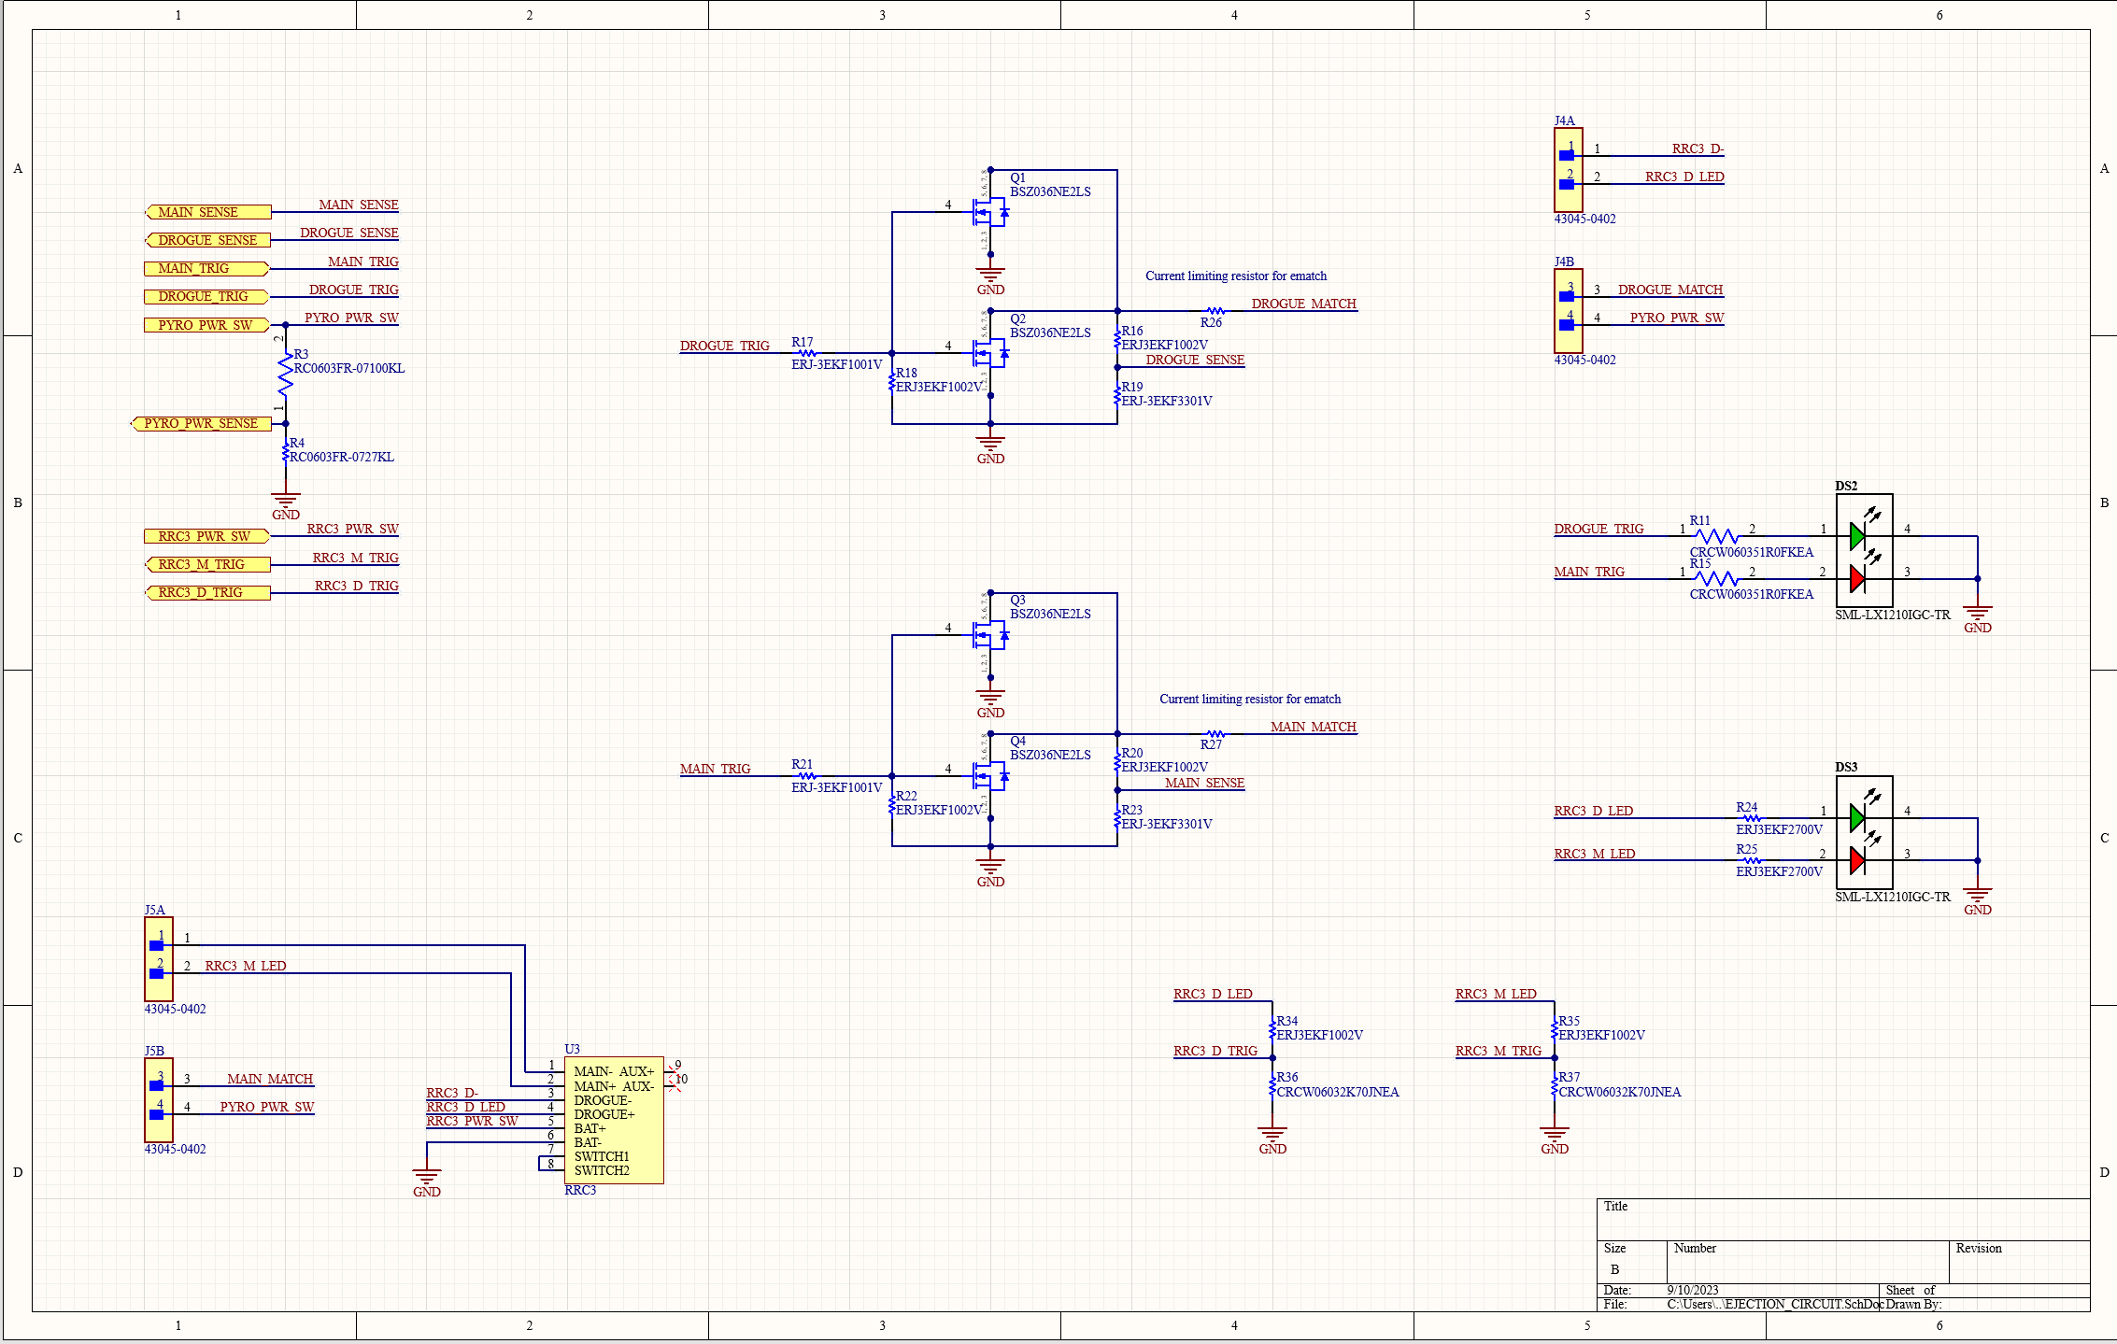

Figure . HYDRA_V2_RECOVERY Ejection Schematic

A voltage divider is included on the pyrotechnics power rail here (**after the arming switch**) such that the board can detect when the pyrotechnics system is armed. Further sensing exists to determine continuity across the SRAD main and drogue pyrotechnics channels as well as the RRC3’s main and drogue pyrotechnics channels. Unfortunately, the RRC3 has continuity checking meaning that **sensing voltage does not give information about whether those channels fire**. This only provides information about whether there is continuity along the RRC3 pyrotechnics channels. **We should switch to a current-based solution in the future so we can sense both continuity and ignition.**

### PCB



Figure . HYDRA_V2_RECOVERY PCB Front

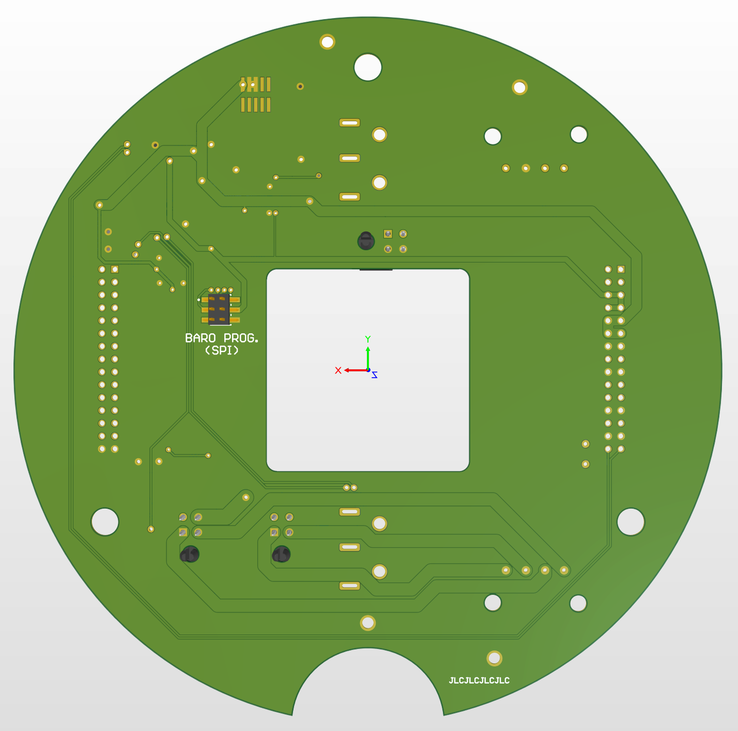

Figure . HYDRA_V2_RECOVERY PCB Back

### Reflection

In summary, the following things need to change about this PCB:

* Add current-based ignition/continuity detection on RRC3 **in addition to** voltage-based continuity detection
  + Also fix RRC3 status LEDs since they’re always on at the moment
* Swap MCUs so we can actually use the ADC pins and get continuity testing and whatnot of SRAD system
  + Maybe swap to current-based ignition/continuity detection for SRAD as well since we currently only have continuity
* Redo sensor package and place the IMU at the center of the PCB this time
* Move away from current arming switches
  + Probably go to MOSFET-based arming system
* Add pyrotechnics voltage sense prior to switch as well as after switch
* Maybe add buzzer to notify launch pad team of pyrotechnics status (RRC3 has this, we could as well)

## Communication Board (HYDRA_V3_COMMUNICATION)

### Overview

The purpose of this board is to act as a black box with respect to all content going across the avionics CAN network, and to provide a radio link between Hydra and the ground station. It also has redundant internal regulators which can power the board from the pyrotechnics power channel in case the main avionics power rails fail. This allows us to potentially maintain telemetry with the rocket during a power failure event and diagnose/fix the issue remotely.

### Layout Considerations

The primary difference between this board and other Hydra boards is the MCU’s location which is on the bottom of the PCB, below the RFD900+’s mounting location. This was done since the RFD900+ took up too much room and we did not want to cram the top side of the PCB.

The redundant regulator logic is placed close to the right Hydra header whereas the actual regulators are placed close to the left header of the PCB. This is because the rail cutoff switches were also placed next to the left header, along with the bulk capacitors for the 5V and 3V3 rails so it made sense to put the regulators there as well. The 5V bulk capacitors are placed immediately next to the RFD900+’s connector since the RFD900+ is the only significant device on the board’s 5V rail.

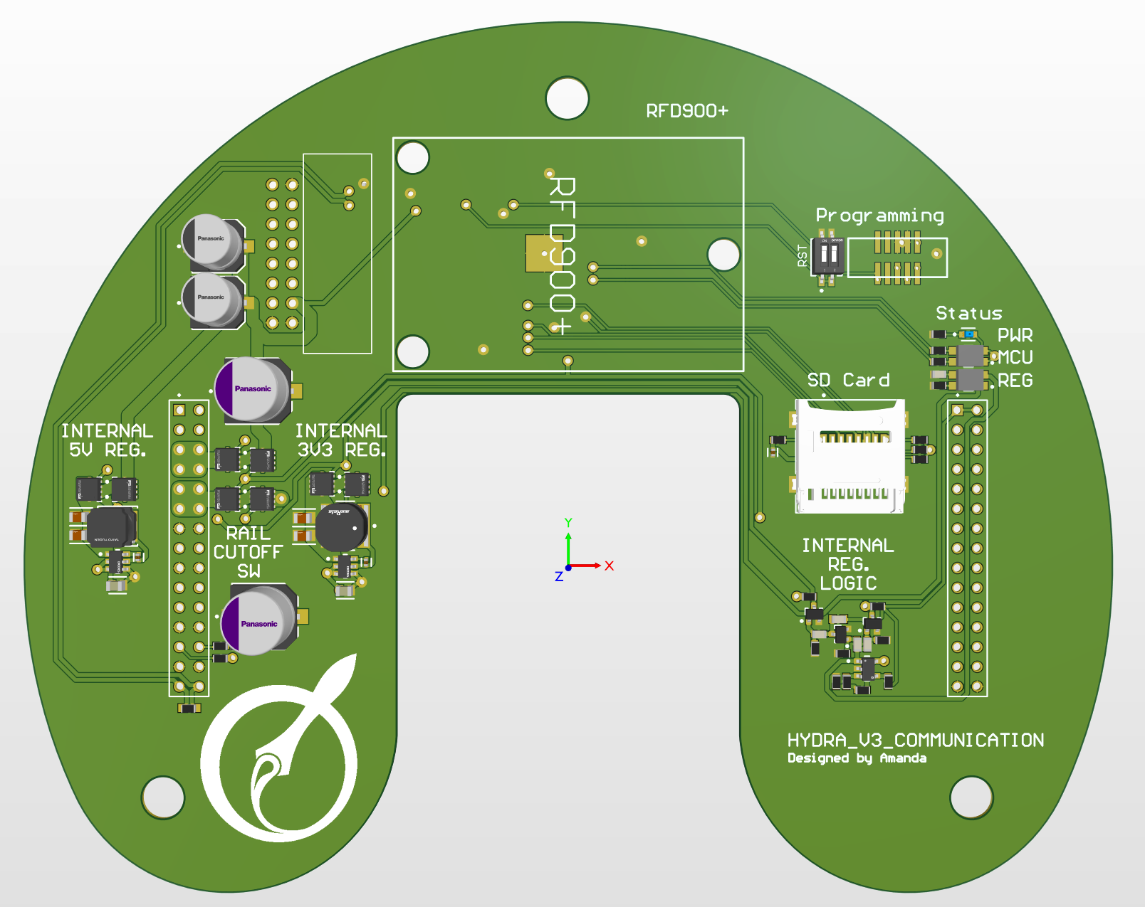

Figure . HYDRA_V3_COMMUNICATION PCB

### Schematics

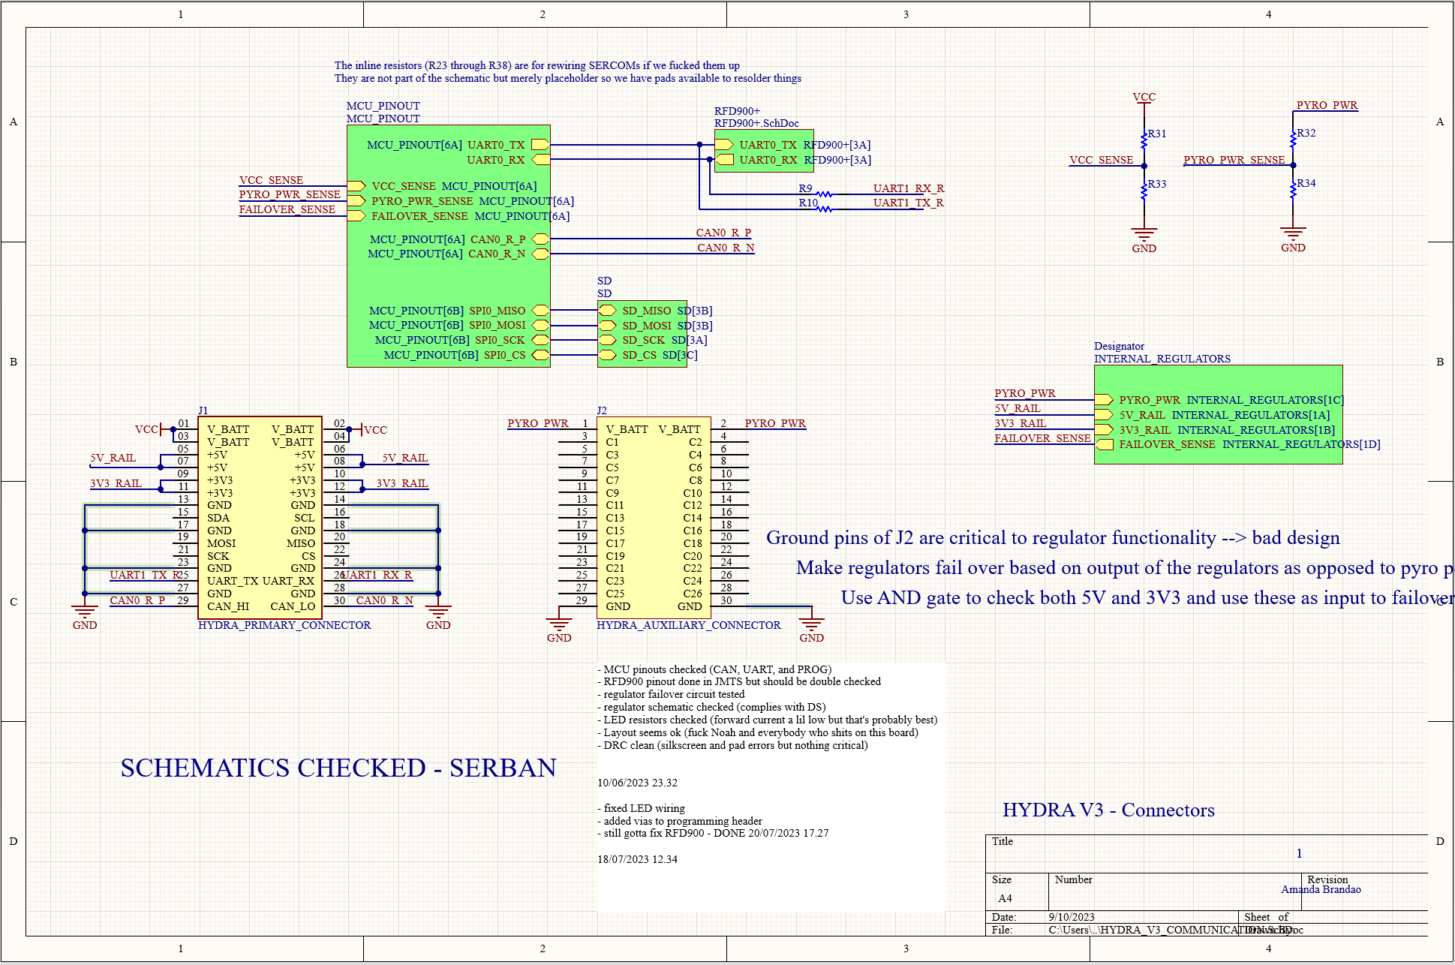

Figure . HYDRA_V3_COMMUNICATION Overarching Schematic

The MCU schematic is at the top left of Figure 22 and interacts with the regulator failover logic to its left as well as the RFD900, avionics CAN bus, and SD card to its right. The top right of Figure 22 has a couple voltage sensors **which should have zeners!!!** Lastly, the internal regulator schematic is halfway up on the right side of the schematic. The text below the internal regulator schematic effectively states that the current hardware logic for the internal regulators is dog water and should be changed. Currently, the board will stick to its internal regulators as long as there is pyrotechnics power and only fallback to the hydra power rails if pyrotechnics power is lost. We ideally want the opposite of this and we’d also want the hardware logic to look at the status of the 5V and 3V3 rails as opposed to the pyrotechnics power rail. This is because the current logic cannot detect a failed regulator and this led to a few hiccups during testing since the current 5V regulator likes to fail randomly (we should also get a beefier one of these for this board).

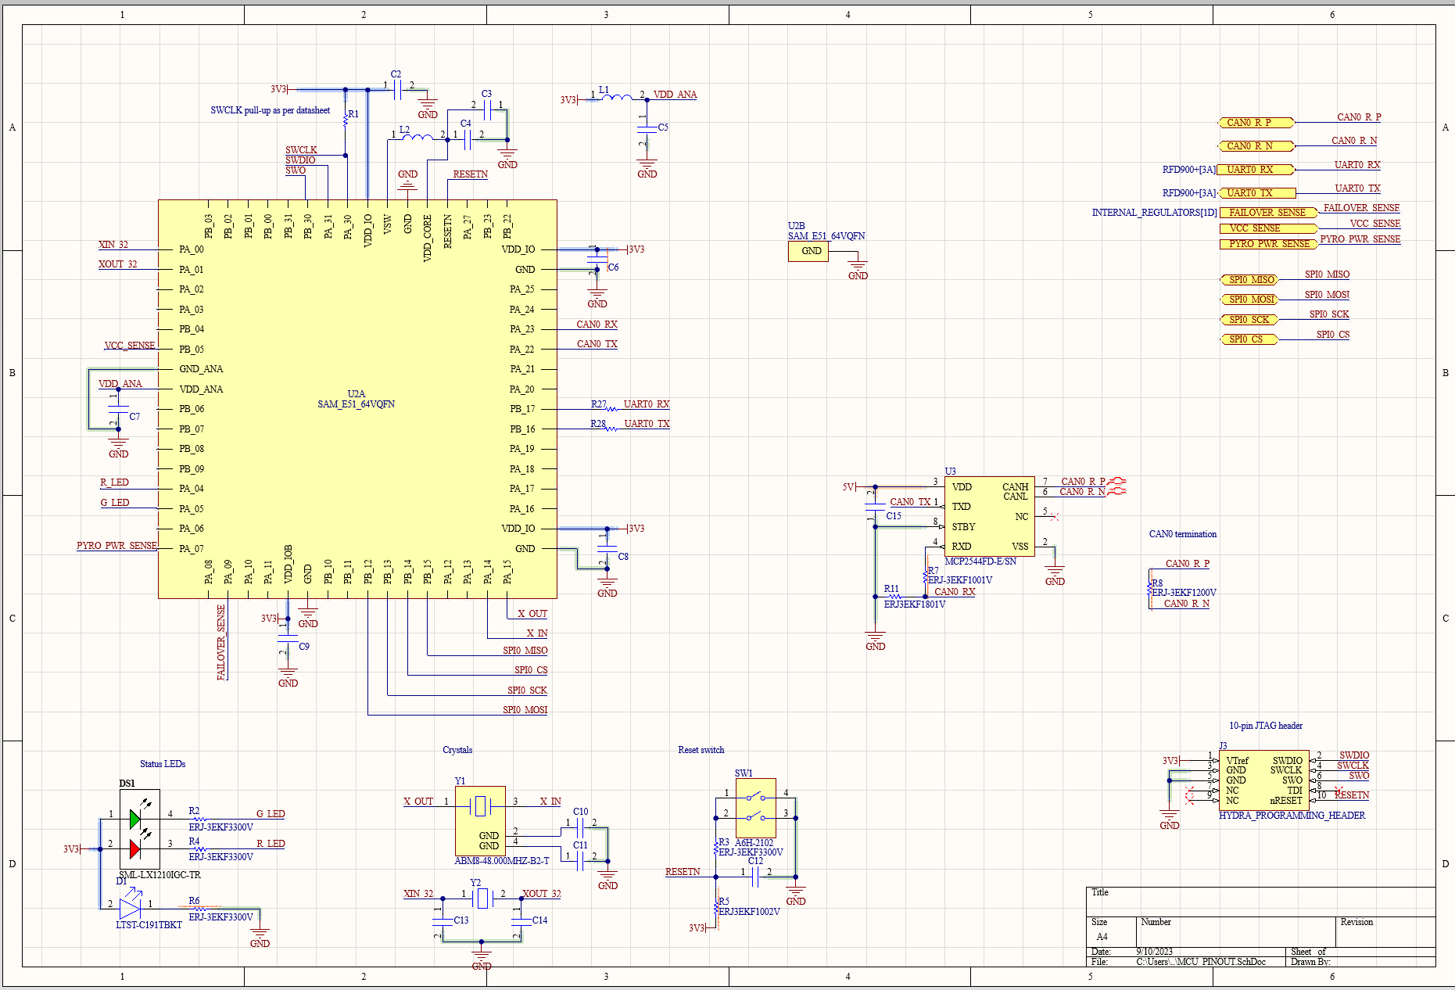

Figure . HYDRA_V3_COMMUNICATION MCU Pinout Schematic

This schematic is more or less copied from the MCU_PINOUT project. Only notable changes are the I/O modifications to the top right of the schematic.

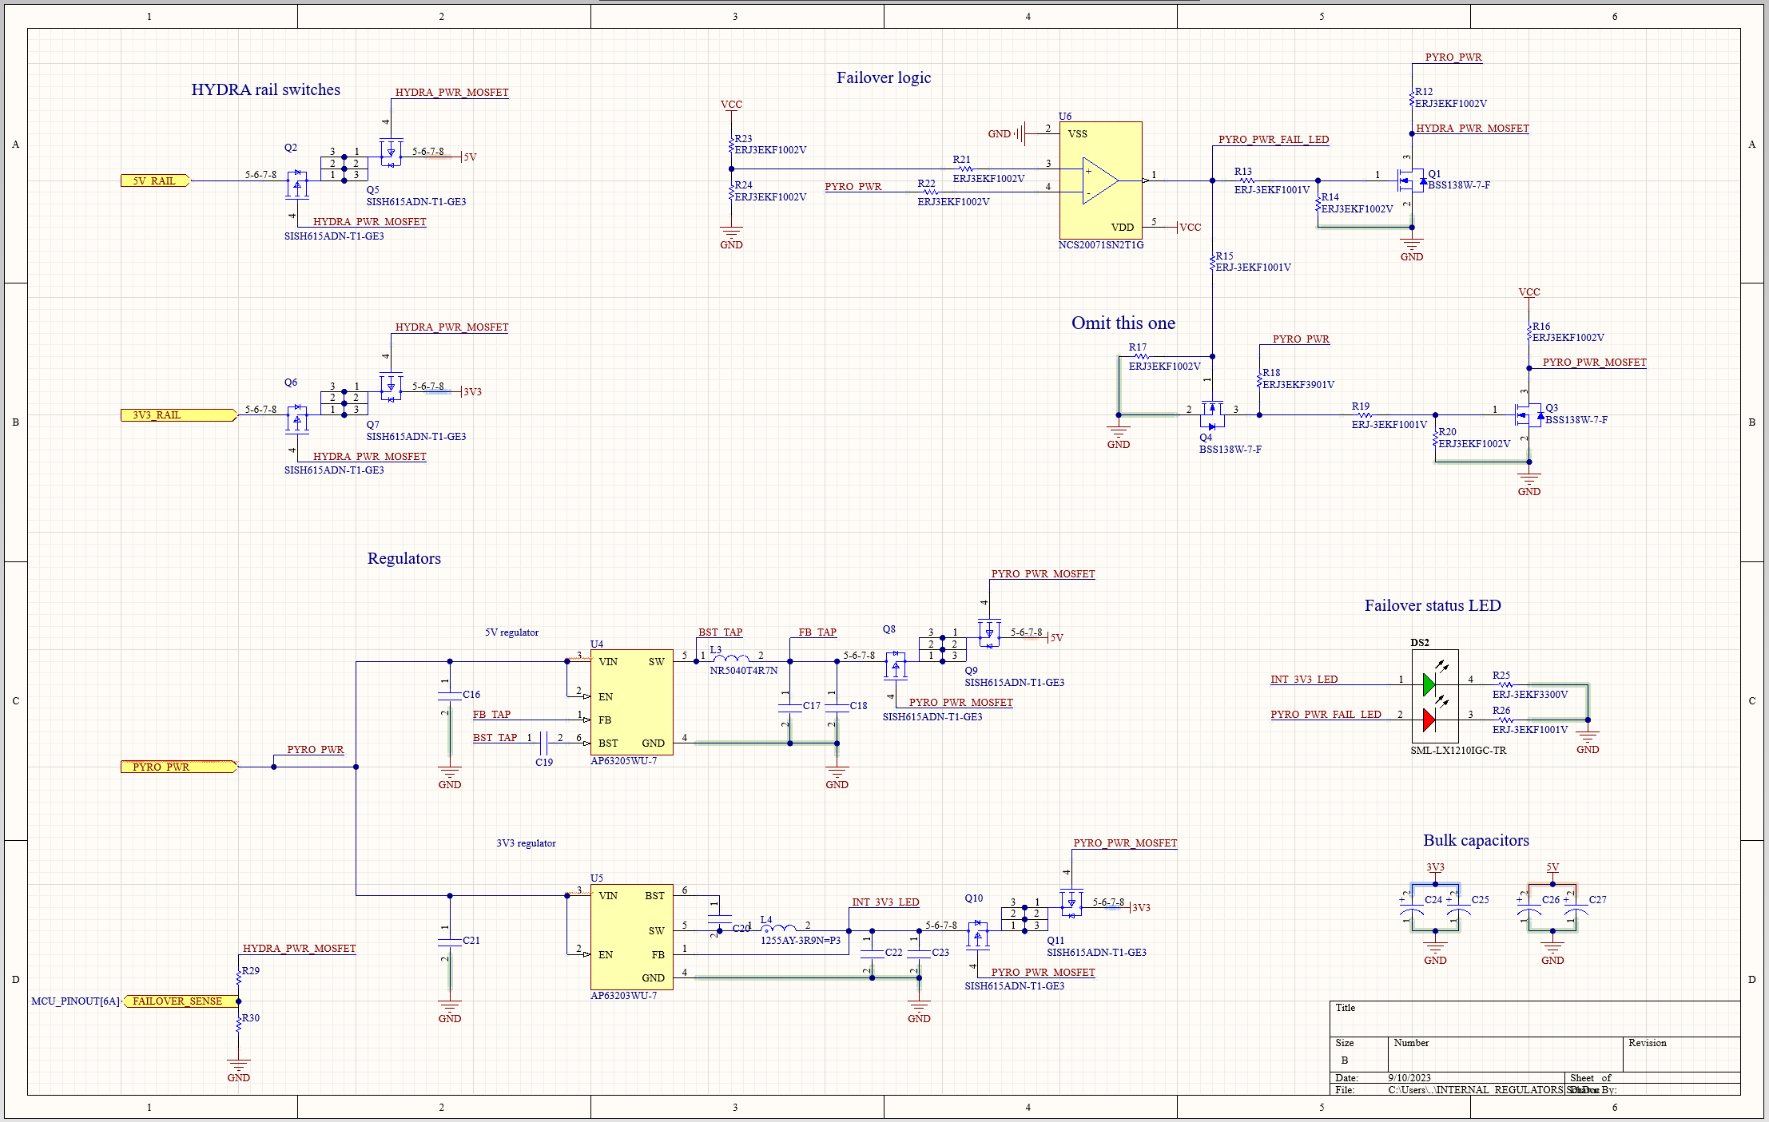

Figure . HYDRA_V3_COMMUNICATION Internal Regualtor Schematic

The schematic above houses the internal regulators for the V3 communication board as well as the hardware that enables them to supplement power in the event that the regulated hydra power rails fail. The top left of the schematic houses MOSFET-based rail switches that are driven by the failover logic located on the top right of the schematic above. All MOSFET-based switches consist of two back-to-back MOSFETs to nullify the body diodes of each MOSFET and prevent current flow in either direction when the switch is off. An additional set of MOSFET-based rail switches is included at the output of the internal regulators whose schematic is on the bottom left of the figure above. The voltage divider at the bottom left serves to provide the MCU with feedback regarding whether or not the chip is using its internal regulators. Lastly, a bi-colour status LED and bulk capacitors are included in the bottom right of the schematic. The LED’s green colour will turn on if the board has 3V3 power and the red colour will turn on if the board has lost pyrotechnics power. **Due to the unreliable nature of the 5V regulator, the failover functionality was disabled on all communication boards for Launch Canada 2023.**

As previously stated, this circuit currently uses the internal regulators as long as pyrotechnics power is available and this should be swapped in the future since it cannot tell if both of its internal regulators are in fact working. Furthermore, the internal 5v regulator should be swapped for a beefier one.

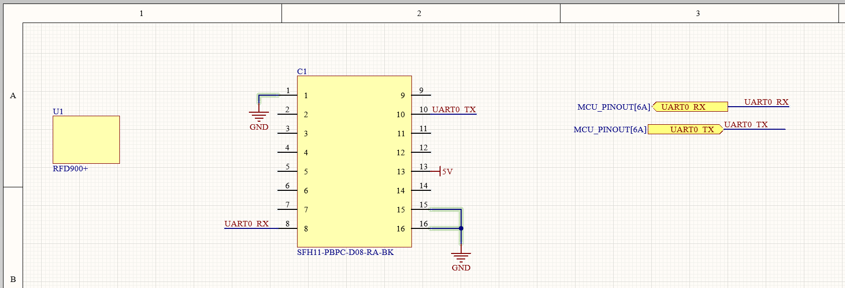

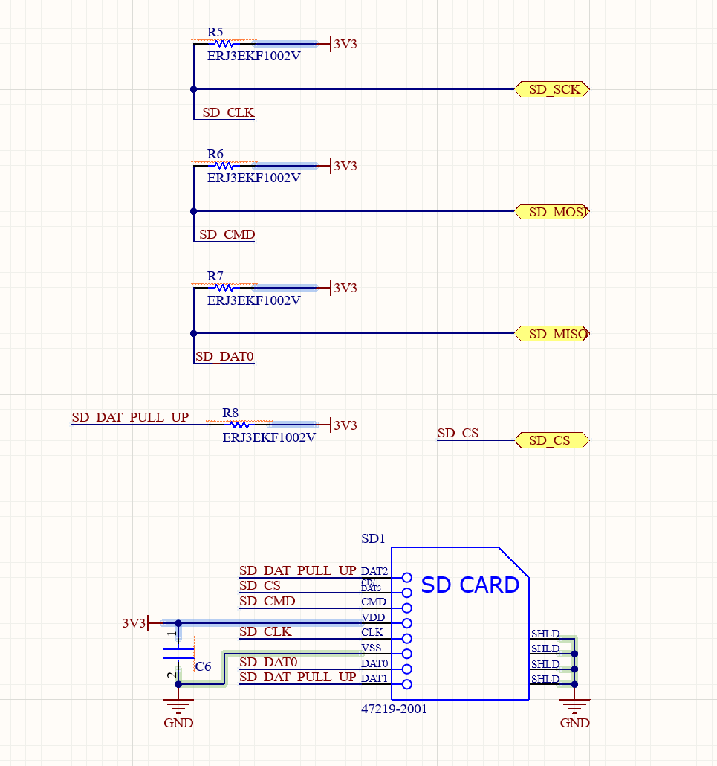

Figure . HYDRA_V3_COMMUNICATION RFD900 and SD Card Schematics

The RFD900 schematic contains two components because the one to the left (U1) only accounts for the physical footprint of the RFD900 (screwholes and outline) whereas C1 is the header that is used to connect to the RFD900. The SD card schematic was copied from a SPI-based SD card breakout from AliExpress.

### PCB



Figure . HYDRA_V3_COMMUNICATION PCB Top

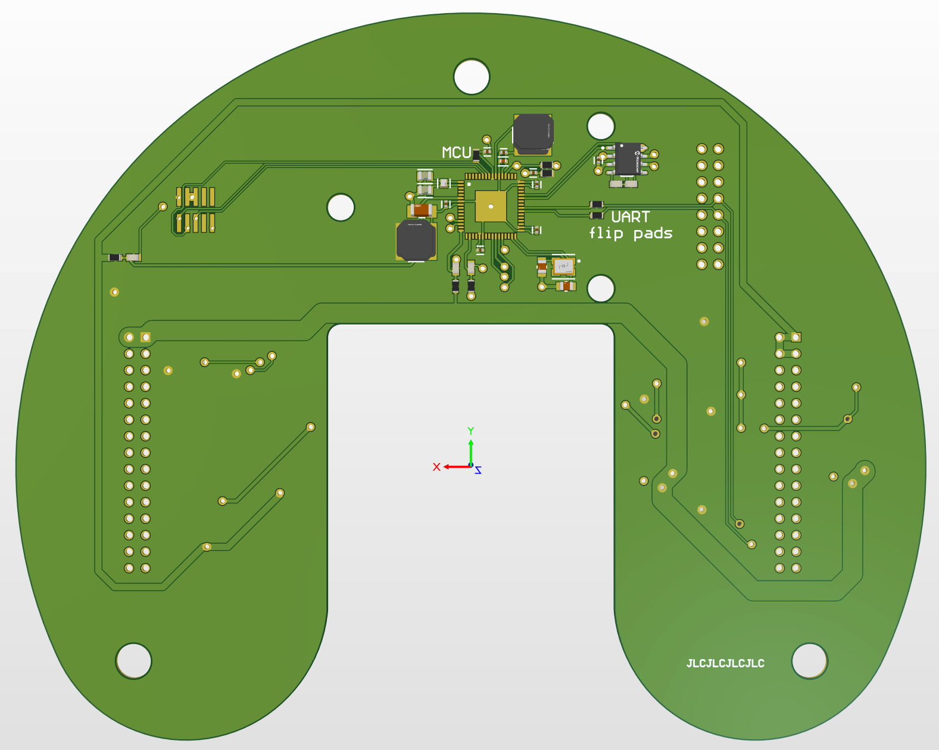

Figure . HYDRA_V3_COMMUNICATION PCB Bottom

The MCU was included on the bottom of this PCB to provide room for the RFD900.

### Reflection

The following things need to be fixed with this PCB:

* Fix regulator logic
  + We should be using HYDRA rails by default, not internal regulators
  + Swap 5V regulator for a beefier one because it has failed us twice now
  + Use hardware to determine if either 5V or 3V3 rails have failed and **only** **swap corresponding rail to internal regulators**
    - Board currently senses pyrotechnics power so it cannot detect a failed internal regulator
* Fix RFD900+ footprint

## Logic Board (HYDRA_V2_LOGIC)

### Overview

This board is relatively identical to the V1 logic board with the exception of some added voltage sensing, a new MOSFET switch to turn the SBG on/off, and a secondary CAN network which enables us to interface with CAN devices without exposing the flight-critical avionics CAN network. Its purpose is to interface with the SBG, log data from the SBG to an onboard SD card and publish navigational data to the avionics CAN bus. This board is also intended for future use in a hybrid vehicle where it could interact with satellite PCBs throughout the vehicle to receive sensor data or control actuators.

### Layout Considerations

Not many layout considerations were made for this board given its large size and small component count. The board itself is a 4-layer PCB to make the overall aesthetic cleaner though this decision was not necessary. The SBG mounting point is centered on the PCB and the transceiver is placed to the left of the SBG which allows the SBG’s cable to coil around the sensor before reaching the plug. This provides some strain relief and reduces the need for any sharp bends in the cable since the PCB’s connector is relatively far from the SBG’s connector.

The CAN_1 output was placed at the rear of the board to be as close as possible to the wire passthrough of the Hydra stack though it should realistically be placed closer to the back of the board such that it can easily be unplugged without invasive access to the stack. The buzzer was placed above the SD card on the right of the SBG since it would be closer to the pyrotechnics power rail which it is driven by. The SD card was placed below this solely for symmetry.

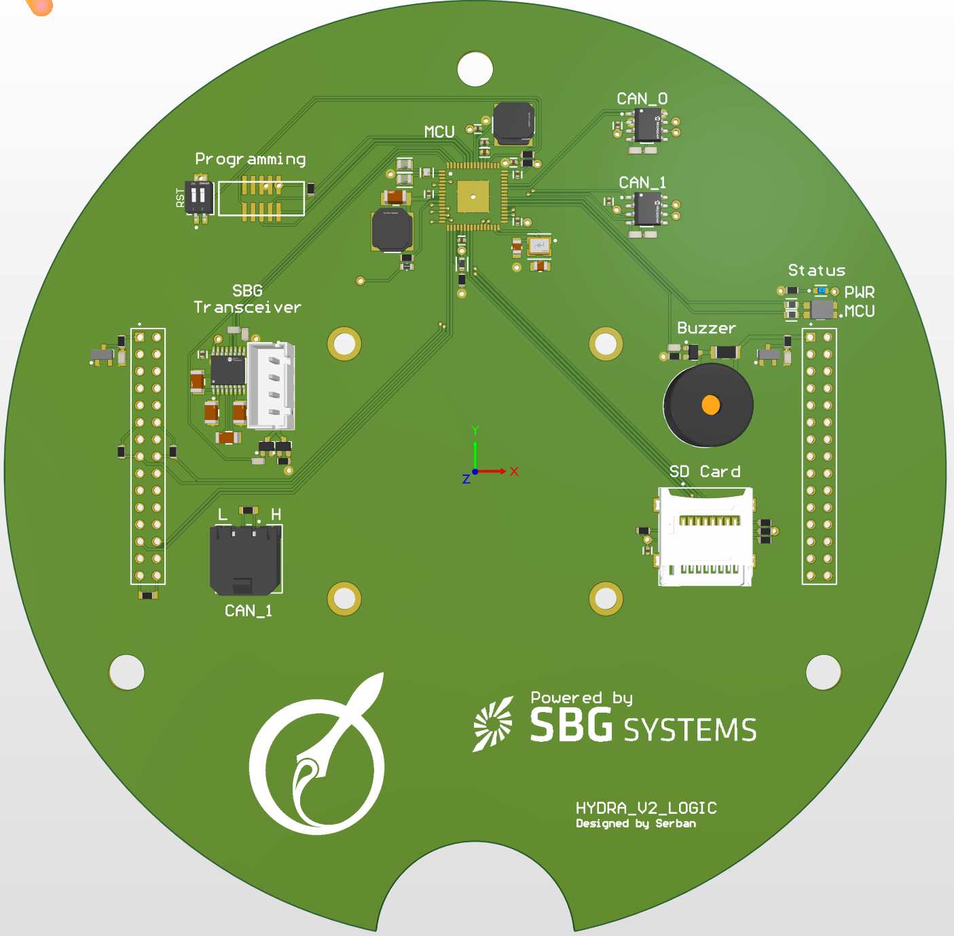

Figure . HYDRA_V2_LOGIC PCB

### Schematics

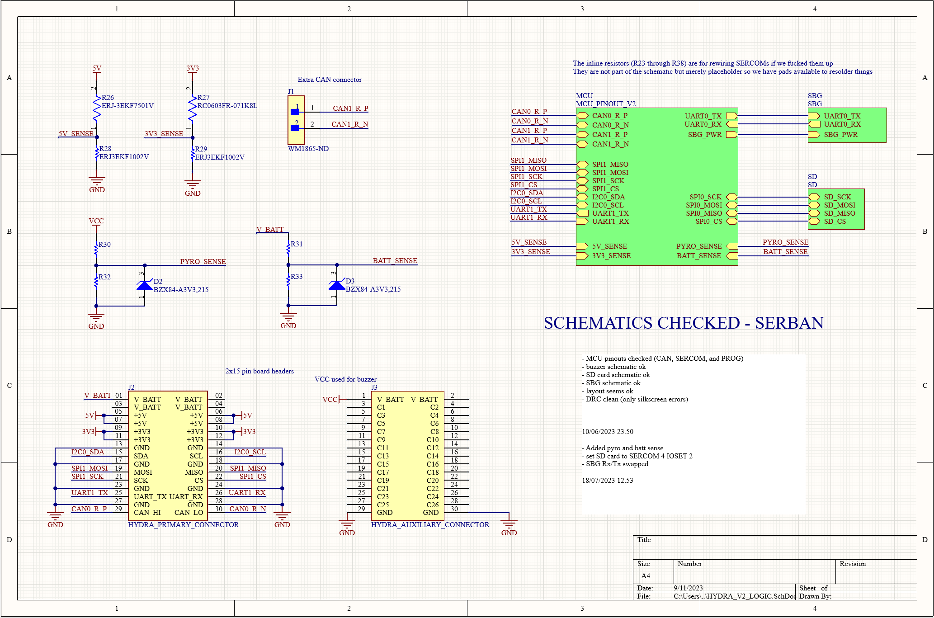

Figure . HYDRA_V2_LOGIC Overarching Schematic

The top left of the schematic contains voltage dividers that provide feedback on all hydra power rails. Zeners are included on the VCC and pyrotechnics power channels since these may go high enough for the voltage divider to output more than 3.3V which may damage the MCU. The MCU pinout is included on the top right of the schematic and interfaces with the SBG, SD card, voltage sense dividers, and a variety of other I/O pins on the hydra headers.

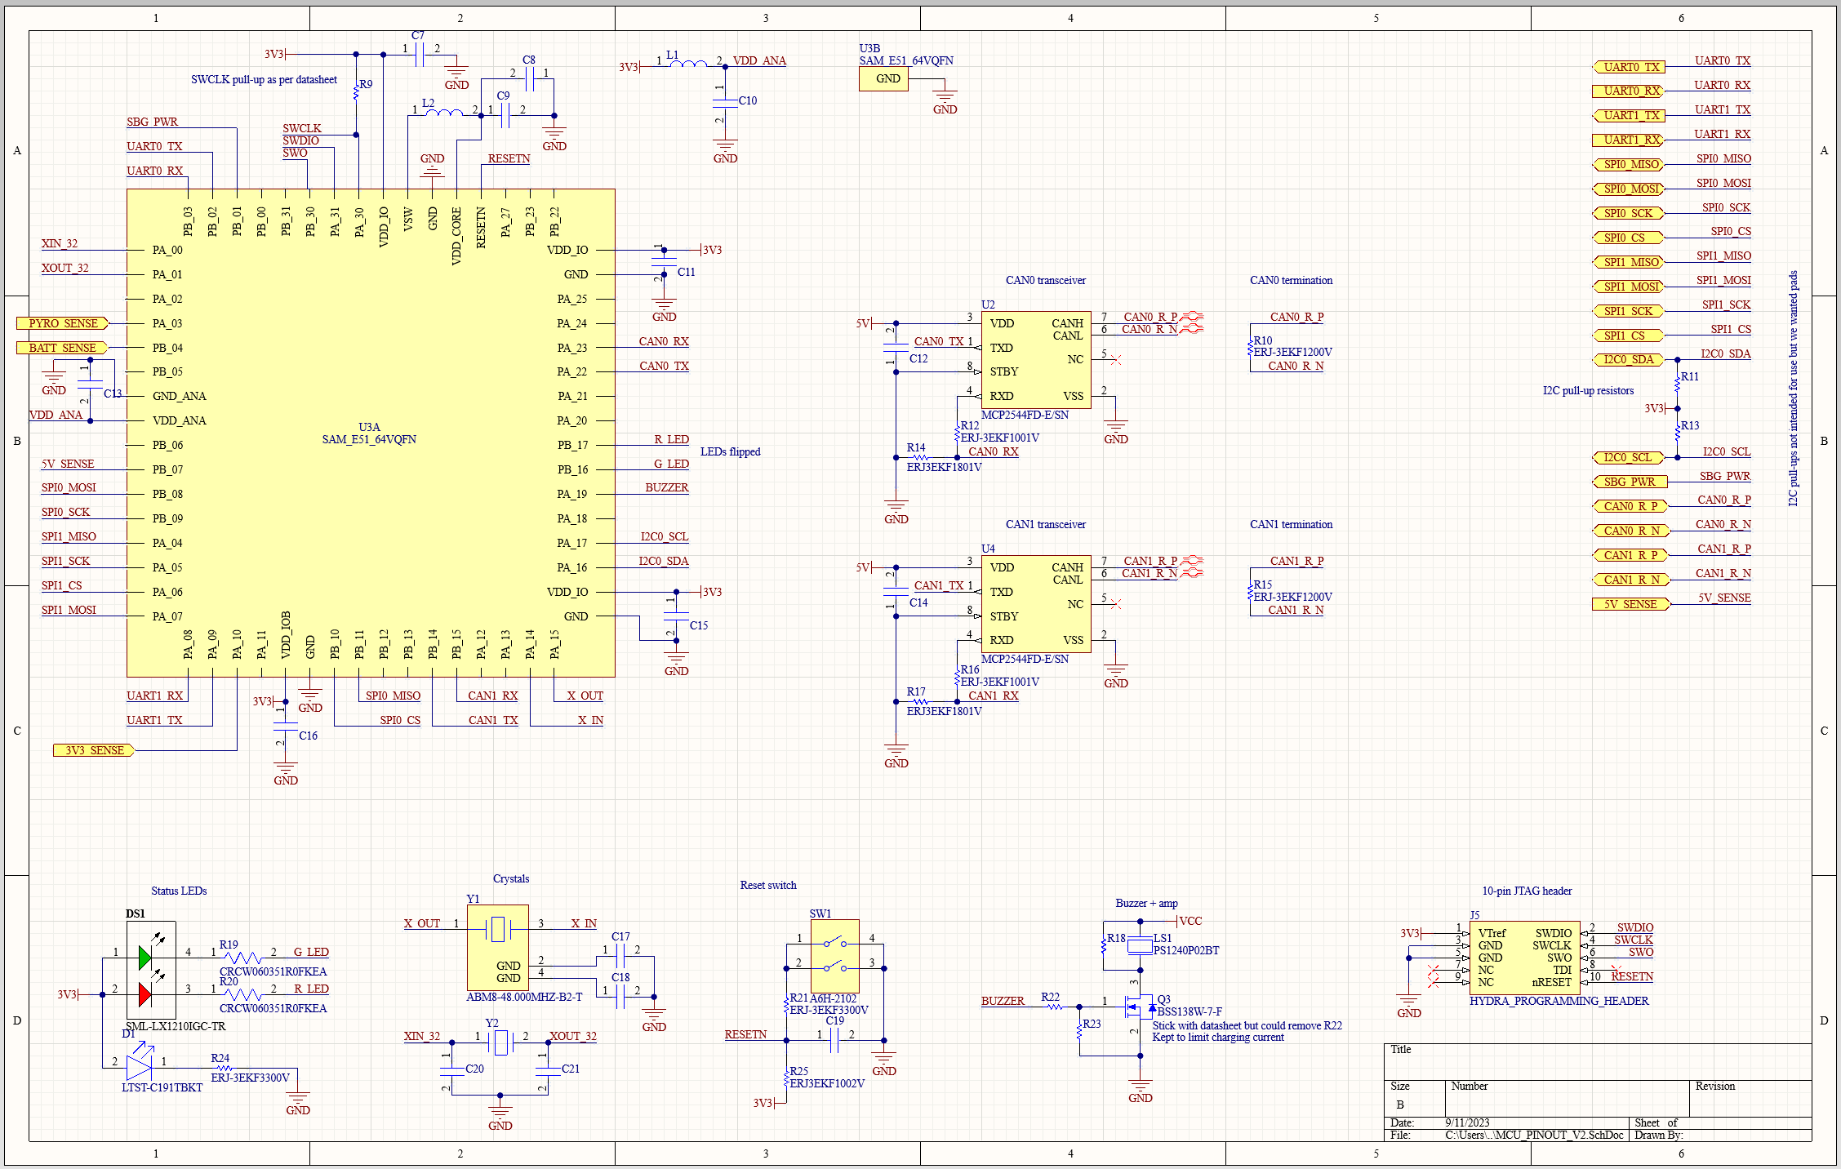

Figure . HYDRA_V2_LOGIC MCU Pinout Schematic

This MCU schematic contains an added buzzer (bottom right, second circuit from the right) and an added CAN transceiver to provide two CAN interfaces. Beyond this, all the I/O used is noted on the top right of the schematic except for some voltage sense I/O that is connected directly to the MCU from the port symbol on the left side of the schematic.

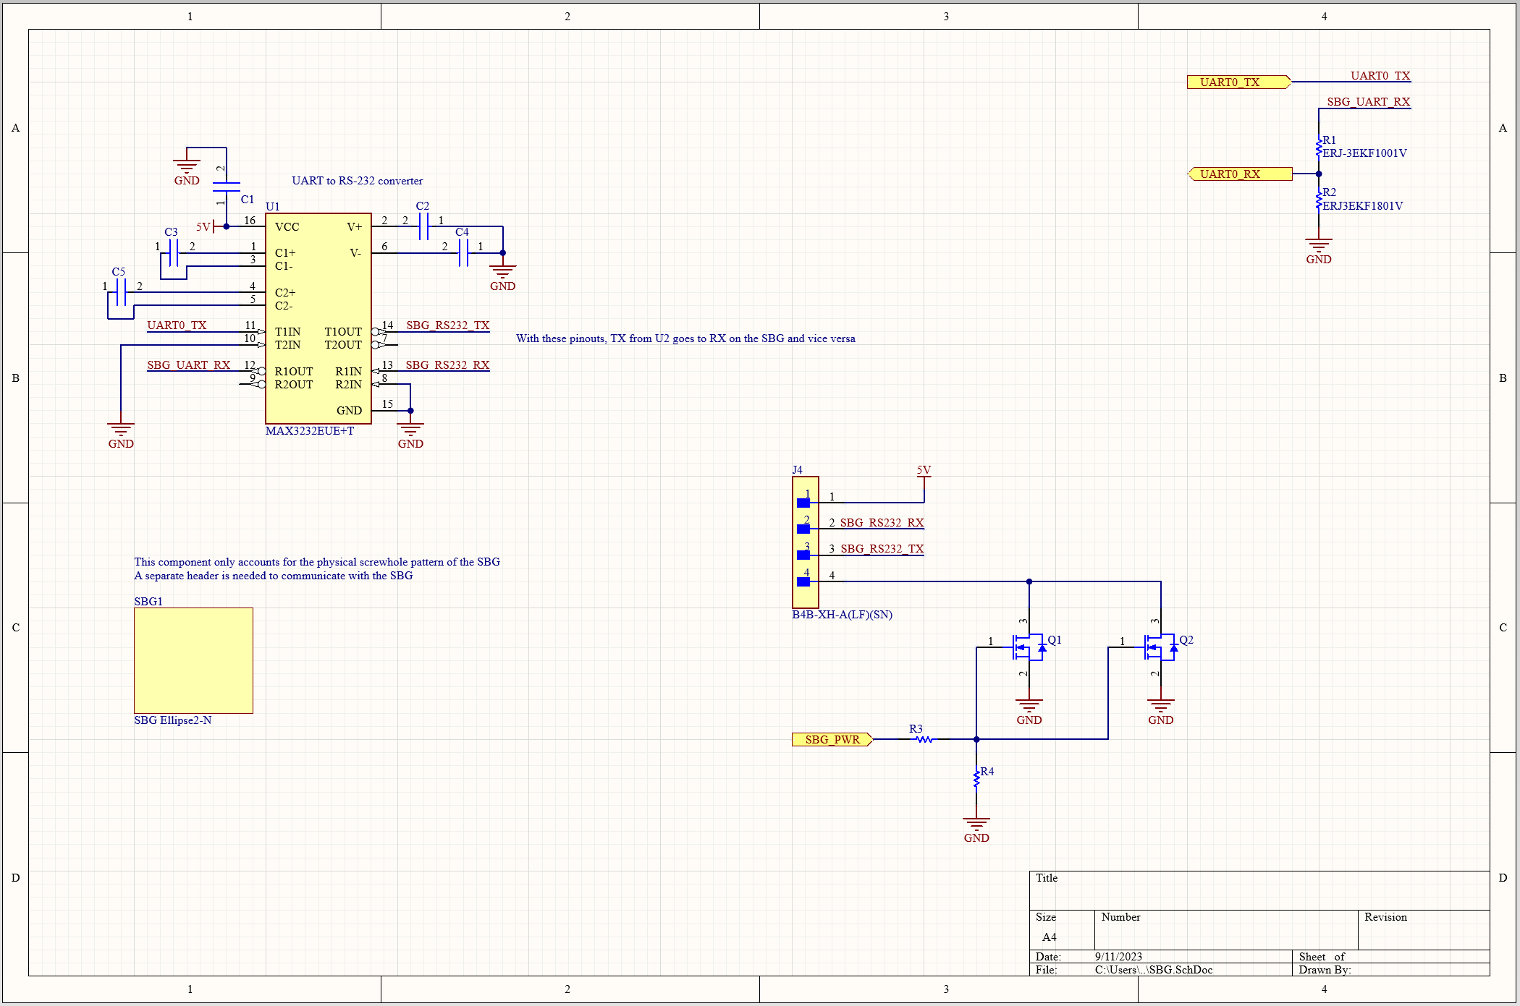

Figure . HYDRA_V2_LOGIC SBG Schematic

This schematic includes the MAX3232EUE+T RS-232 to UART transceiver (U1) used by the MCU to communicate with the SBG as well as the MOSFET switch to toggle SBG power. The SBG component towards the bottom left of the schematic solely accounts for the SBG’s mounting holes and the voltage divider in the top right of the schematic is only included on the RX pin of U1. This is because U1 operates at 5V logic levels and the MCU will not work if it receives 5V on any pin (we accidentally tested this). That being said, neither will the MCU die so it’s ok.

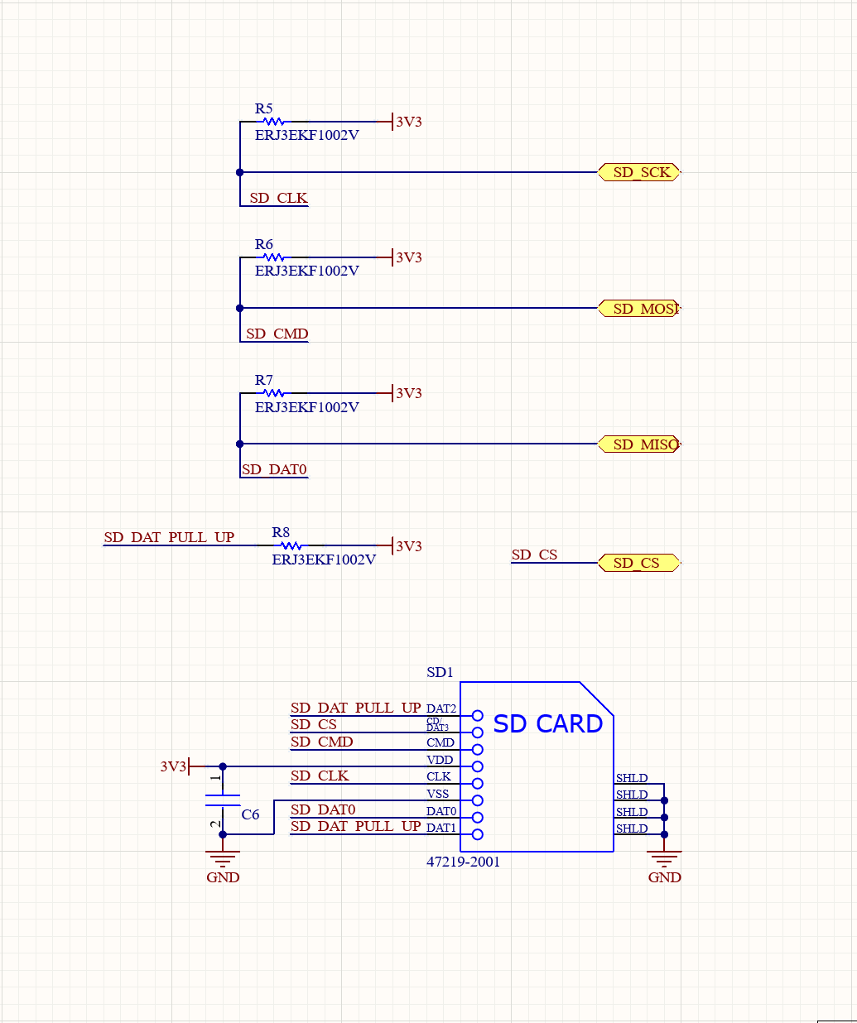

Figure . HYDRA_V2_LOGIC SD Card Schematic

Generic SD card schematic, copied from a generic AliExpress SPI-based SD card shield.

### PCB



Figure . HYDRA_V2_LOGIC PCB Top

The general layout of the V1 logic board was maintained though things were spaced out more to facilitate assembly and improve aesthetics. This is a 4-layer board mostly to simplify routing since it would entirely be possible to make it a 2-layer board instead.

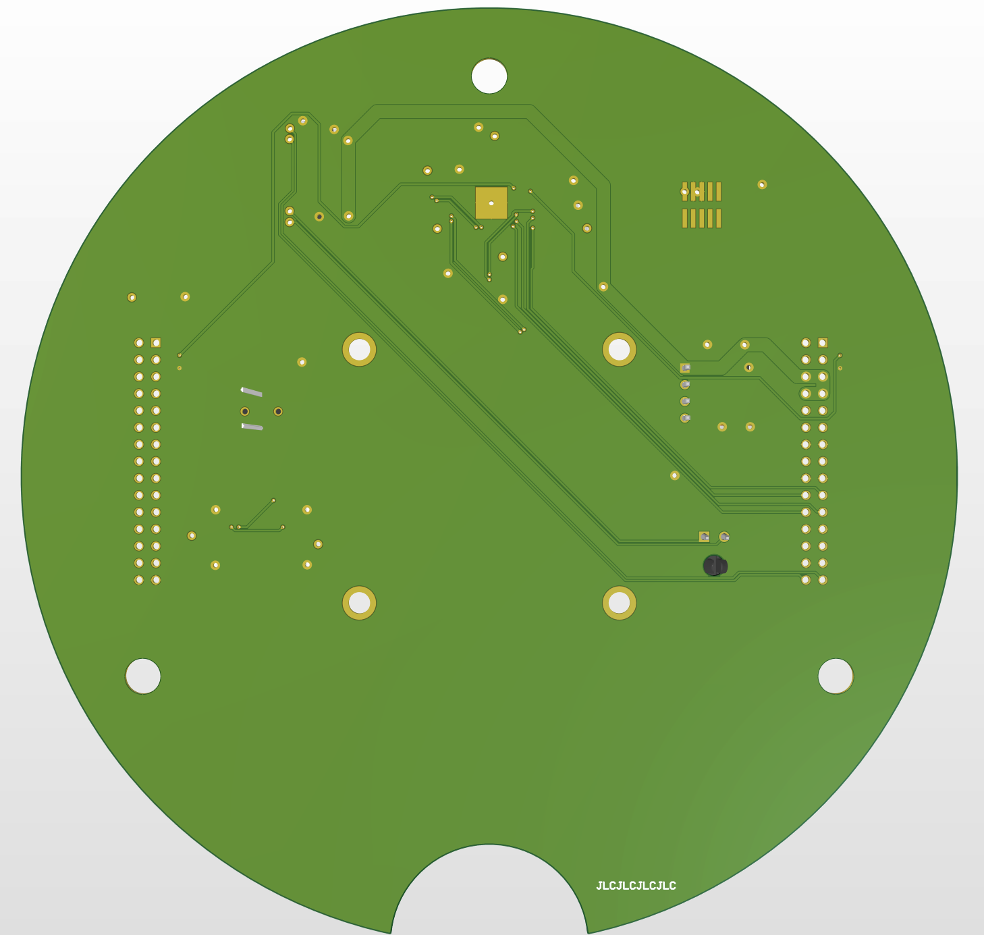

Figure . HYDRA_V2_LOGIC PCB Bottom

### Reflection

* We should swap the MCU because the current one cannot keep up with the SBG’s data rate
* We should also probably swap the SBG because we maxed out every one of its sensors
* Should swap cheap JST connector for SBG as it may cause issues in high vibration events
* Shift from SD card to solder-on-memory since the SD card may have shifted in flight causing data errors
* Maybe remove buzzer? I don’t think we’ll ever use it
  + Also change name since this board is now the sensor board and not the logic board

## Power Board (HYDRA_V2_POWER)

### Overview

The V2 power board uses identical regulators to the V1 power board albeit in parallel for redundancy. Each power rail (5V and 3V3) has two regulators whose outputs go through a load-sharing circuit based on the LTC4353IDE#PBF load-sharing controller. This ensures we have 5A of redundant current delivery per rail with a possibility of peaking up to 10A.

From a macroscopic perspective, the power is received and passed through two cutoff switches before entering the global power protection circuit. This circuit handles reverse polarity protection as well as overcurrent and overvoltage protection (in this order). Finally, the power protection circuit provides the MCU with input voltage and current data. Following the protection circuit, power passes through two similar regulator circuits which power the 5V and 3V3 rails of the avionics stack. Both circuits consist of two identical regulators who largely share input and output capacitors and are combined using a load-sharing circuit. Finally, an MCU is included to manage the board and communicate with the remainder of the avionics. The MCU has its own internal regulators such that it remains online even in the case of a power failure on the main hydra power rails.

### Layout Considerations

This board went through many iterations before arriving at this state. It was designed around the arming rod passthrough’s position which ended up being located slightly to the right of the board’s vertical center line. All the power circuitry is housed to the left of the arming rod, near the left Hydra header, and all of the logic/power protection circuitry is housed to the right of the arming rod.

Power enters through the bottom molex connectors, enders the ground power switch, and then reaches the arming switches (there are electrolytic bulk capacitors here which is stupid since no reverse polarity protection has happened yet). These switches then forward power to the power protection circuitry which dumps the resulting power into one of the board’s two internal layers. This is a four layer PCB with the two internal layers being power and ground; the power layer is split into two (pictured below): a 3V3 plane below the MCU and a VCC plane along the remainder of the PCB.

The regulators are grouped in two sets of two: one for 5V and one for 3V3. These sets are placed far apart from each other and have thermistors on the bottom layer of the PCB immediately below each regulator to provide thermal feedback to the MCU.

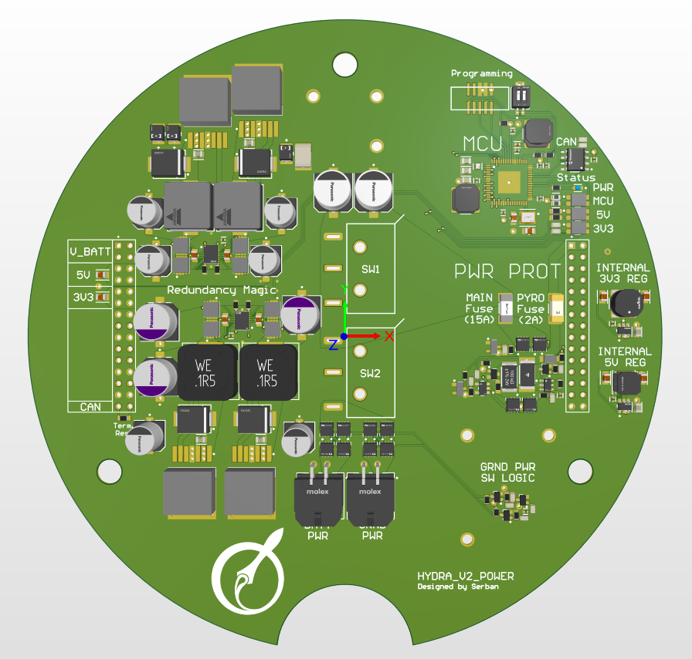

Figure . HYDRA_V2_POWER PCB

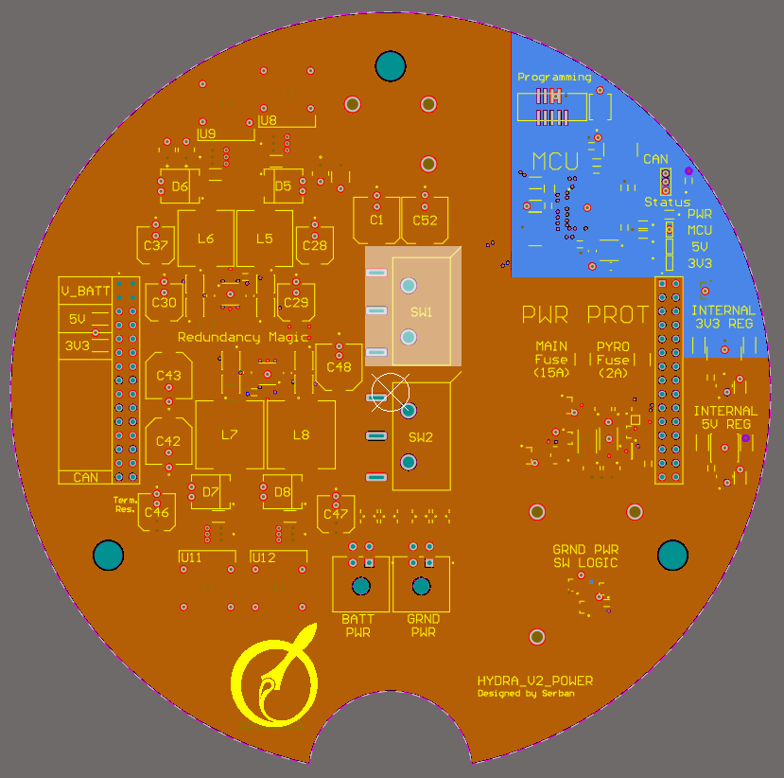

Figure . HYDRA_V2_POWER Power Planes

### Schematics

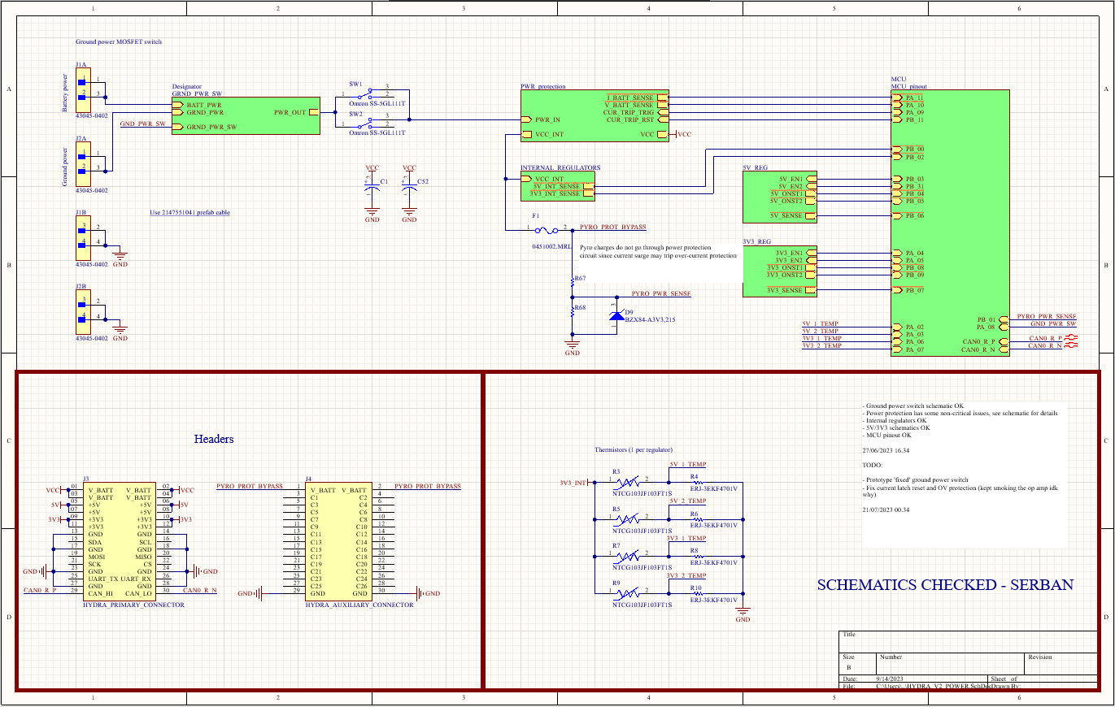

Figure . HYDAR_V2_POWER Parent Schematic

Power enters through J1 and J2 (top left) and immediately enters the ground power switch before reaching the safety switches and then entering the power protection stage. The power protection stage provides two outputs: VCC_INT and VCC. VCC_INT only contains reverse polarity protection and is used for the board’s internal regulators as well as the pyrotechnics power rail. The VCC rail maintains reverse polarity protection but also has resettable over-current and over-voltage protection. Both rails pass through a 15A fuse within the power protection circuit though the pyrotechnics rail has an additional 2A fuse of its own.

This arrangement was done since the sudden spike in current draw from igniting e-matches may risk tripping the over-current protection circuit and turning off the hydra power rails so the e-matches do not go through the over-current circuit. Additionally, reverse polarity protection was maintained on the pyrotechnics channels since the recovery board uses MOSFET-based switches whose body diode would ignite the e-matches in a reverse polarity event.

Both the 5V_REG and 3V3_REG schematics draw from the VCC rail and interface with the MCU to provide telemetry data. The thermistor circuits on the bottom right serve to provide temperature telemetry on each of the four main regulators of the board. Lastly, two bulk capacitors are included below the safety switches (C1 and C52).

#### **Power Protection Considerations (PWR_protection.SchDoc)**

The power protection schematic has three components: reverse polarity protection, overcurrent/overvoltage protection, and current sensing. Battery voltage sense and the board’s internal Vcc rail are pulled prior to the over-current/over-voltage protection circuit since we want both of these to be active at all times. Voltage sense should always provide information and VCC_INT is used for the pyrotechnics channels of the recovery board and most importantly for the power board’s internal regulators which ensure its MCU remains online regardless of what is happening on the hydra power rails.

The reverse polarity protection works identically to that of the V1 power board (see Section 1.4.1). The overcurrent/overvoltage protection is based on [this](https://www.ti.com/lit/an/snoaa39/snoaa39.pdf?ts=1681756702248)[4] paper from Texas Instruments using a TLV1805 op-amp. Fundamentally, this circuit is an op amp comparator which compares the voltage drop across a shunt with a fixed value provided by a carefully selected voltage divider. The schematic shown below is taken from the aforementioned paper and depicts the overcurrent circuit. For the purposes of this explanation, I will refer to the non-inverting input of the op amp as VP (since it’s denoted by a plus sign) and the inverting input as VN (since it’s denoted by a negative sign).

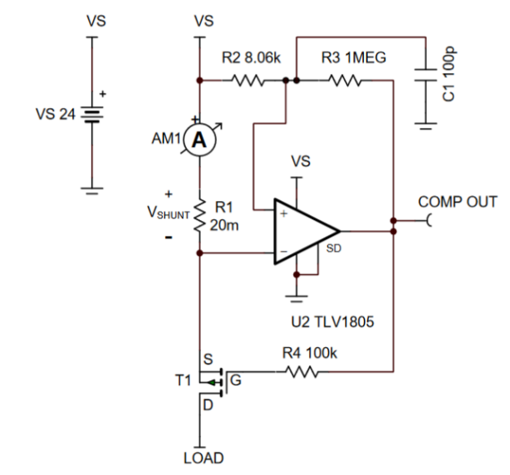The power is passed from the top left, from the V­S power object, through a shunt (R1), and finally though a P-channel MOSFET before reaching the load at the bottom left. The voltage post-shunt, VN, will be marginally less than the supply voltage VS. The voltage divider (R2/R3) is selected such that it produces a voltage analogous to the drop that would occur across R1 at the maximum allowable current flow. Initially, the current draw is below the limit and so the voltage drop across the shunt is small and therefore the post-shunt voltage is higher than the voltage generated by the divider. Since VN is higher V­P, the op amp’s output will be low (op amp output ~ V­P – VN). This output does two things: firstly, it pulls the gate of the P-channel MOSFET low thereby turning it on, and secondly it maintains the right side of the R2/R3 voltage divider low. Once an overcurrent condition is reached and the voltage drop across the shunt causes VN to be less than VP, the op amp’s output will go high. This high output cuts off the MOSFET but also effectively sets both sides of the R2/R3 voltage divider high so VP will now be effectively equal to VS. In this manner, VP = VN and the op-amp will be stuck in its hysteresis zone where there is not enough of a difference between VP and VN for the output to change state. The capacitor (C1) is included to pull the output of the R2/R3 divider low on boot; this ensures that VP is less than VN at boot and the circuit does not trip prematurely.

Figure . TI Over-current Protection Schematic

The overvoltage protection works by using a comparator, voltage divider, and zener reference to figure out if the board’s input voltage exceeds the maximum allowable input voltage of 18V (chosen based on the maximum value for U5, our current sense IC). Once the input voltage increases past the maximum allowable input voltage, the comparator’s output will swing high and set the output of the overcurrent circuit’s op amp high thereby forcing the over-current protection to trip.

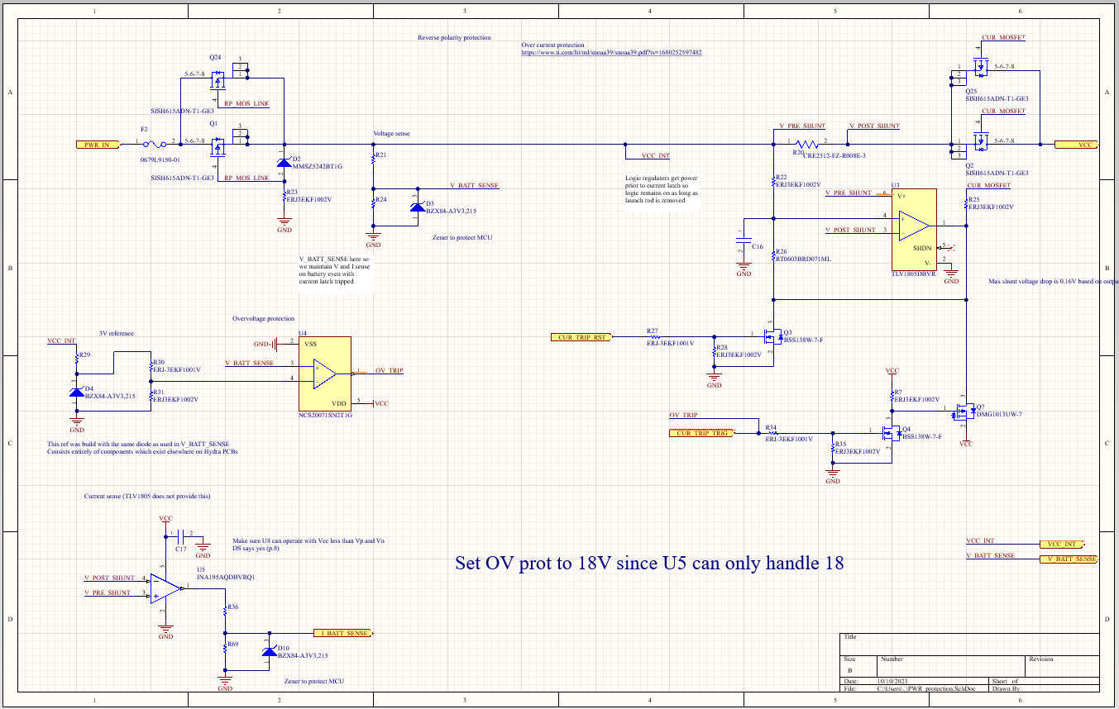

Figure . HYDRA_V2_POWER Power Protection Schematic

Aside from protection, this schematic provides the MCU with information about battery voltage and current draw using a voltage divider as well as a dedicated shunt IC. Voltage sense is provided by a voltage divider and zener (R21/R24 and D3) prior to the over-current protection such that it always remains active. The zener serves to protect the MCU in case the voltage divider’s output ever exceeds 3V3. Current sense is provided by a dedicated current sense IC (U5) whose schematic is designed as per its datasheet and also includes a zener on the output to once again protect the MCU.

#### **Redundant Regulator Considerations (5V_regulators.SchDoc and 3V3_regulators.SchDoc)**

The explanation here will use part designators from the 5V schematic though both 5V and 3V3 schematics are very similar with the only difference being that voltage dividers are used to decrease the logic voltage to 3V3 in the 5V schematic.

**Parallel Regulator Arrangement**

Two regulators are included in parallel (U1 and U2) and share input/output capacitors. A picture of the regulators for the 5V rail is included below where U1 and U2 are the 5V regulators used for the avionics stack. The purpose of redundant regulators is to reduce the load on each individual regulator and somewhat mitigate the risk of regulators overheating from exposure to the elements. Back-to-back MOSFETs are used in conjunction with the LTC4353IDE#PBF load-sharing controller though only one MOSFET is used in practice, as per the schematics provided on the load-sharing controller’s datasheet. A status LED is included for each rail where each LED represents the status of one regulator meaning that the status LEDs should optimally be yellow (both red and green on). This probably isn’t ideal.

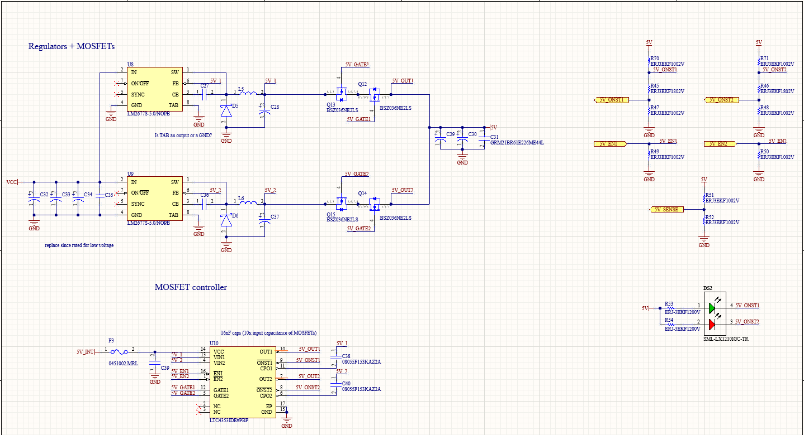

Figure . HYDRA_V2_POWER 5V Redundant Regulator Schematic

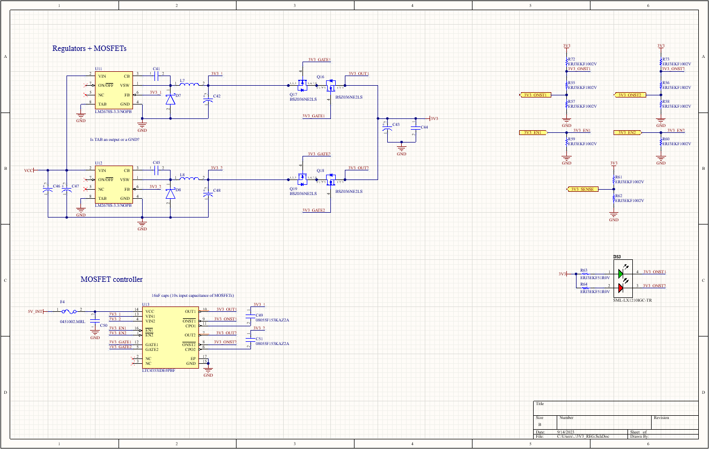

Figure . HYDRA_V2_POWER 3V3 Redundant Regulator Schematic

#### Internal Regulators (INTERNAL_REGULATORS.SchDoc)

Nothing special here, both regulators were designed as per their datasheet and voltage dividers are included to provide telemetry about the internal rail voltages.

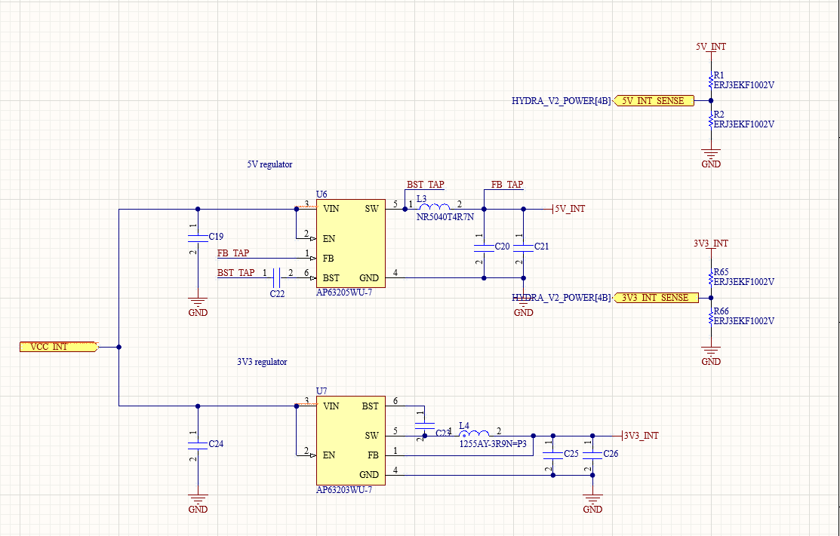

Figure . HYDRA_V2_POWER Internal Regulator Schematic

#### Ground Power Switch (GRND_PWR_SW.SchDoc)

This does not work and will be scrapped in V3. Ignore.

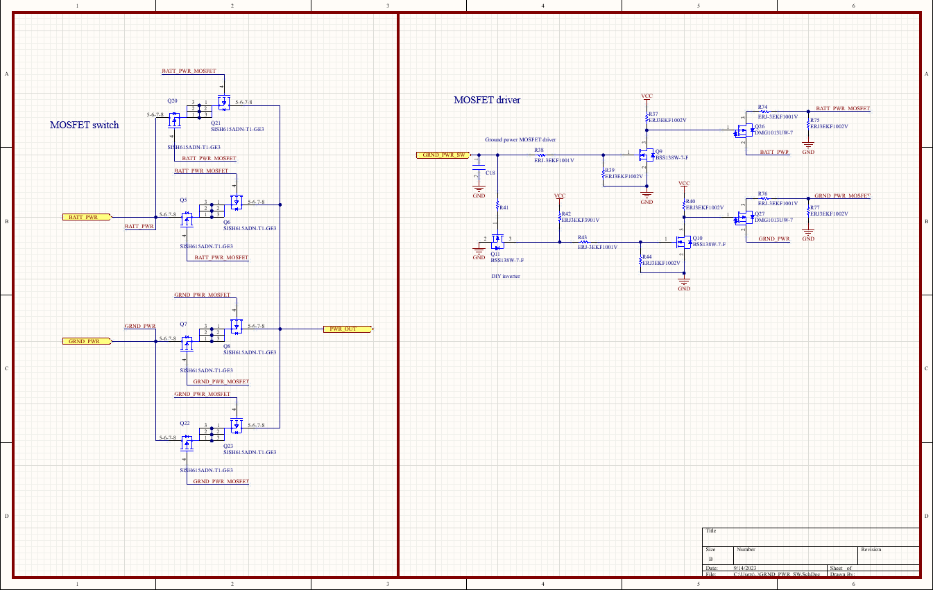

Figure . HYDRA_V2_POWER Ground Power Switch Schematic

#### MCU Considerations (MCU_PINOUT.SchDoc)

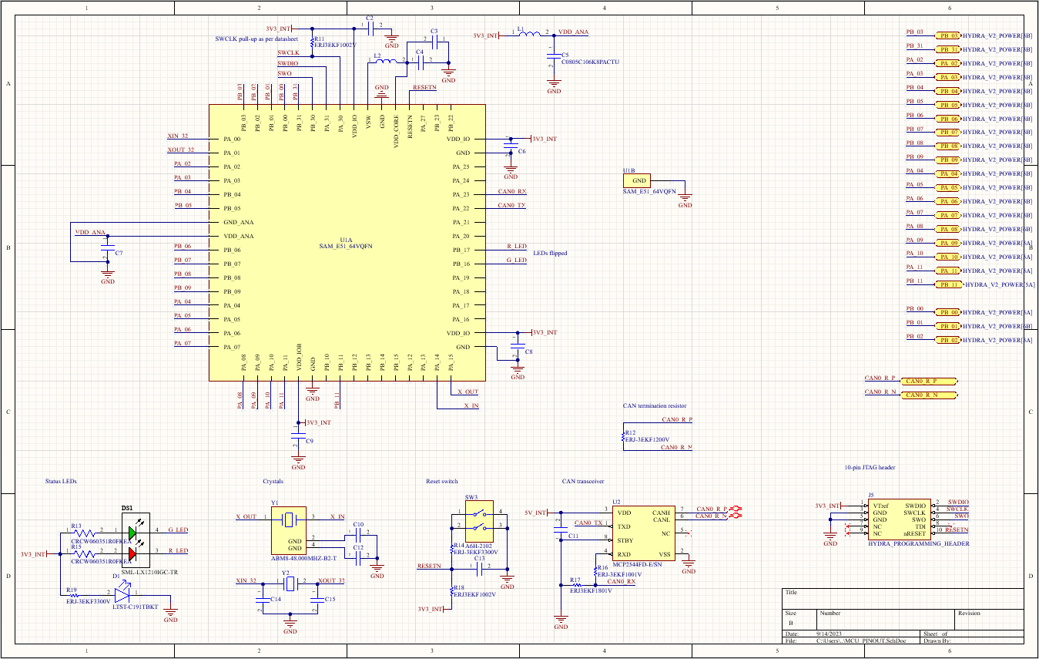

Figure . HYDRA_V2_POWER MCU Pinout Schematic

A lot of the pins interface on the left of the MCU since the MCU is located at the top right of the board and because the ADC pins are located along the left side, the left half of the bottom, and a bit to the top left of the MCU. All the I/O is pinned out on the top right of the schematic.

### PCB



Figure . HYDRA_V2_POWER PCB Top

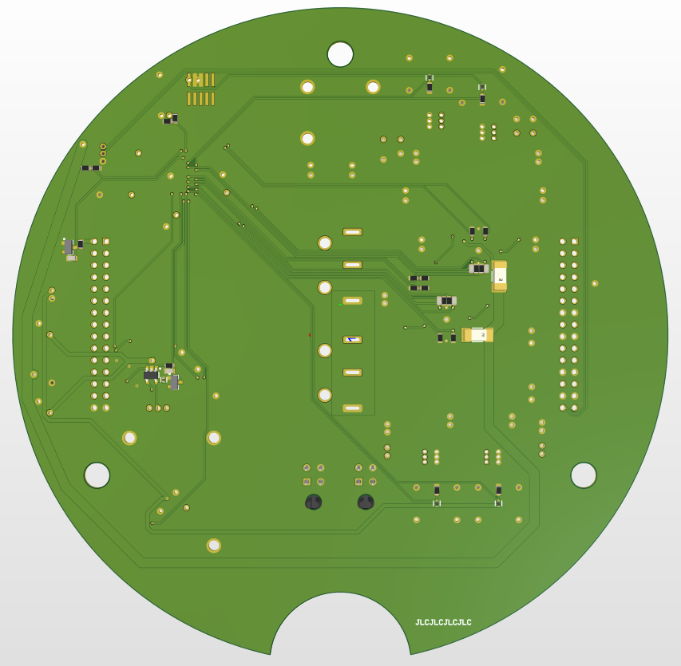

Figure . HYDRA_V2_POWER PCB Bottom

The two fuses visible to the right of the PCB’s center point are not actually meant to be included. These pads can be short circuitted to provide 5V to the load sharing controllers though they were not used in practice since the load sharing controllers are meant to function as long as either one of their inputs is above 2.9V.

### Reflection

* We’re scrapping most of this
* Power protection circuitry is good and should likely be maintained with slight improvements
  + Over-current latch is being forced off correctly but resetting the over-current protection should be done by setting pin 1 of U3 high. Schematics were fixed but actual board just short circuitted everything in hopes of turning things off (probably did this as a joke and forgot to change it before production)
* There’s a voltage leak into the MCU’s 3V3 rail on one of the manufactured power boards (but not the other since the other one programmed and that MCU works)
* Move away from two regulators per board
  + Move to one regulator per board and using multiple power boards together for redundancy
* Move away form current arming switches to MOSFET-based arming mechanism
* Drop ground power switch and add fuse/RP protection as the first thing on the PCB.

# Hydra V3

## SAME51 Stackable PCB Template Project (HYDRA_V3_SAME51_TEMPLATE)

### Overview

This project is an interim Hydra V3 template for the first round of Hydra V3 PCBs utilizing the SAME51 MCU such that the first round of PCBs can be designed in parallel with the new MCU’s pinout/supporting circuitry. The project contains a sample PCB layout with circuitry that is common to all Hydra V3 stackable PCBs: the MCU, over-current protection, stacking headers, status LEDs and I/O connectors, as well as common silkscreen markings.

#### V3 vs. V2

A few changes are included in this project that differ from Hydra V2 boards:

* The size was adjusted to fit the design requirements specified in the Hydra Framework design notebook.
  + Connectors were also changes to match the design requirements specified in the Hydra Framework design notebook.
* The reset switch was swapped with a smaller and cheaper momentary switch as opposed to the two-channel dipswitch used in V2. This is because we seldom had a legitimate use for the MCU’s reset switch and there is therefore no need to budget as much PCB space/component cost for this feature.
* The bi-color status LEDs were swapped to smaller and cheaper parts and a 5V status LED was added to the MCU pinout, so the boards natively provide visual information about the 5V rail’s status in addition to the 3V3 rail’s status.
* Voltage sensing was added on all rails as part of the MCU schematic since all Hydra boards should have this feature to help diagnose any erroneous power rail behaviour.
* Programming interface connector was swapped for a smaller connector due to space constraints on these new PCBs.
* Over-current protection was added to 5V and 3V3 rails
* Two CAN networks were added as per Section 2.3.2.2 of the Hydra Framework design notebook
* I got a little trigger happy with test points

### Schematics

#### Parent Schematic

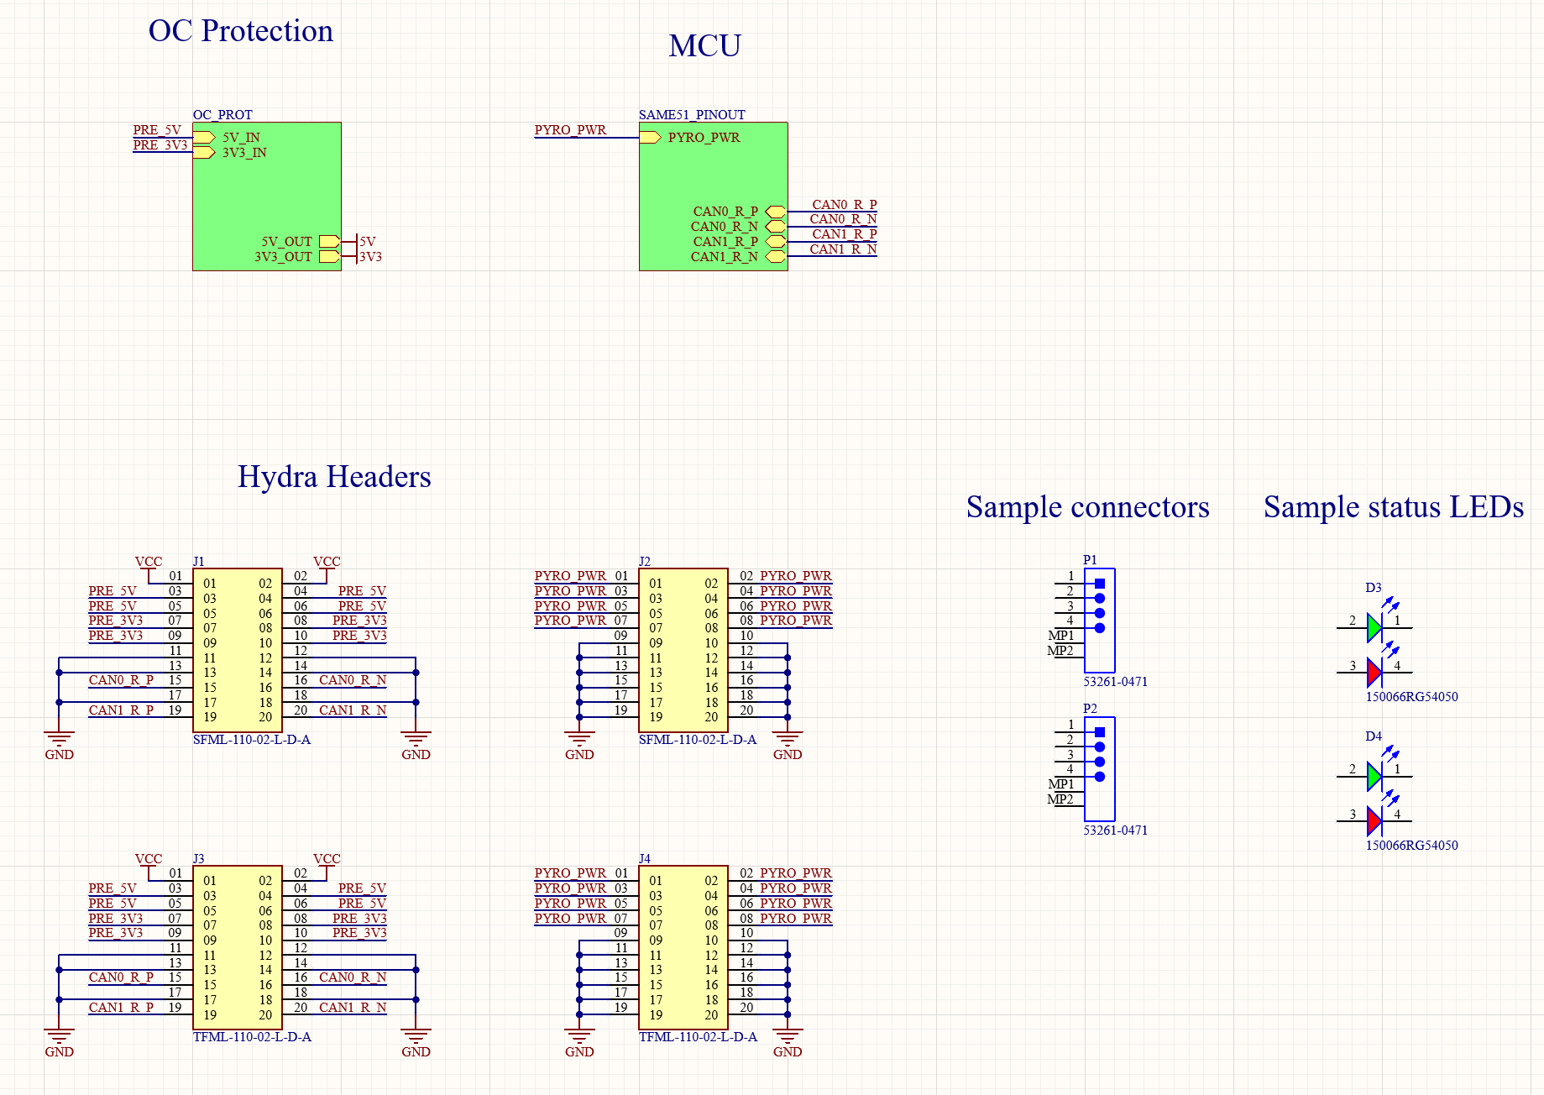

Figure . HYDRA_V3_SAME51_TEMPLATE Parent Schematic

This is a barebones Hydra V3 parent schematic containing the bare minimum components required for stackable V3 boards. The sample connectors/LEDs to the right may be removed if unused but were included to provide an example of how the components should be laid out on the PCB.

The only other modifications that should be done to this circuit are the addition of other I/O pins to the SAME51_PINOUT schematic symbol as required by the PCB being designed. No modification should be made to the header pinout or OC protection schematic.

The main difference between this parent schematic and that of V2 PCBs is the updated header pinout.

#### MCU Schematic

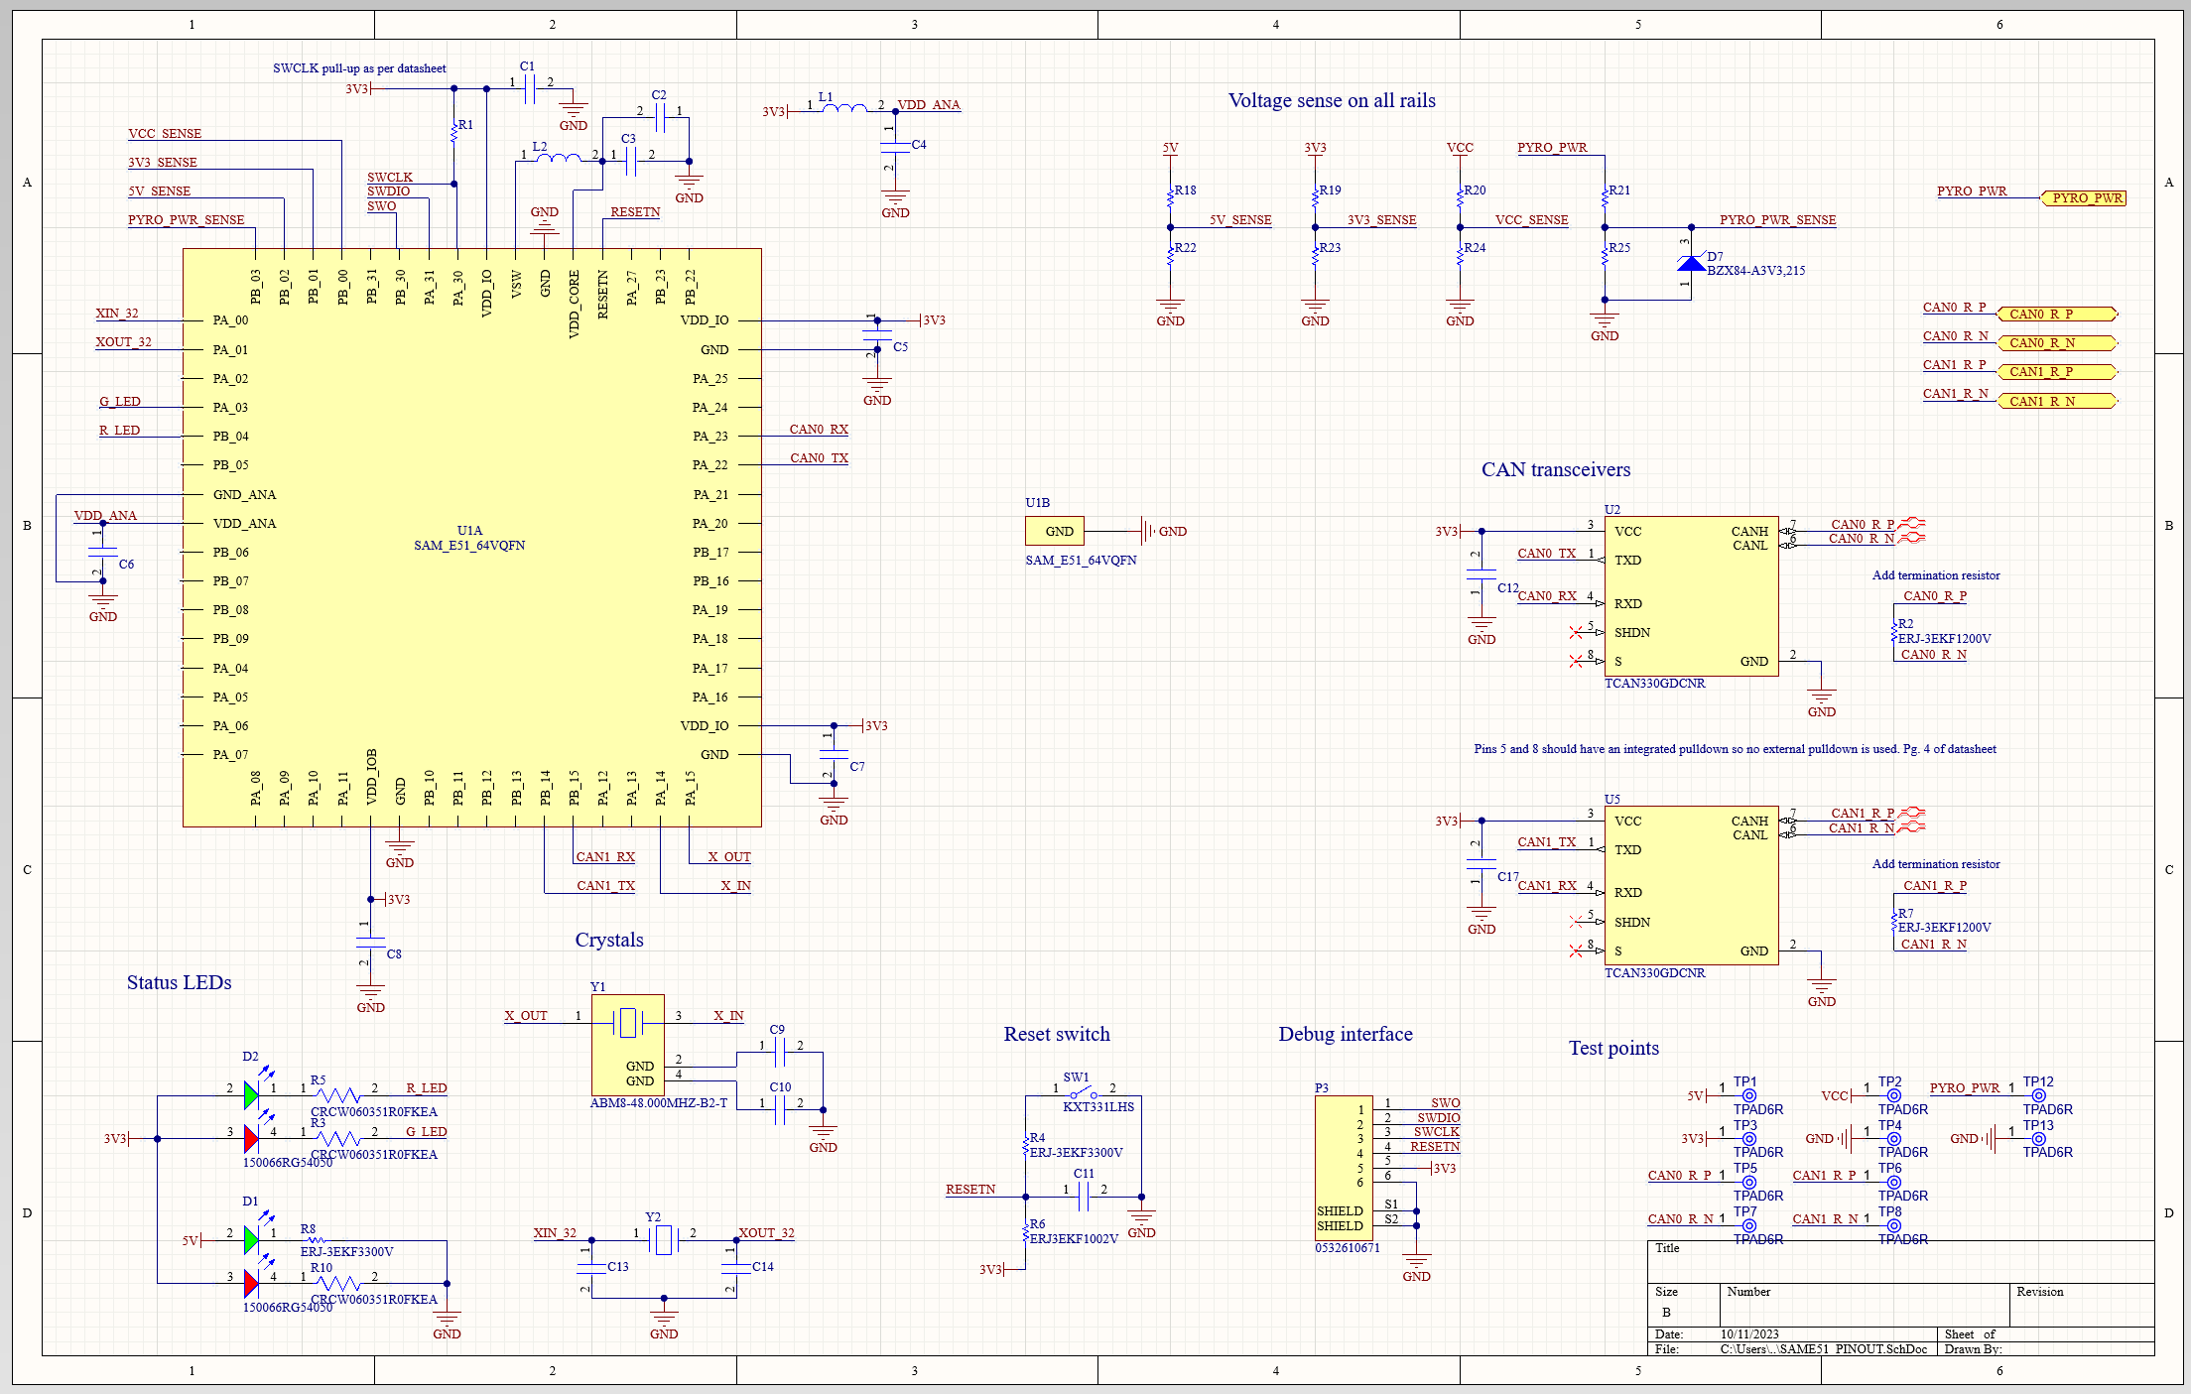

Figure . HYDRA_V3_SAME51_TEMPLATE MCU Pinout Schematic

This MCU pinout schematic is highly similar to that of V2 boards with the exception of a few changes:

* Status LEDs (bottom left) were swapped to a smaller bi-color chip and the power status LED has been upgraded to display 3V3 and 5V power statuses.
* Reset switch was swapped from a dip switch to a momentary switch for size and cost constraints (SW1 – bottom middle of schematic).
* Voltage sense was added to all power rails since all Hydra boards should be able to sense this. A zener is included on the PYRO_PWR rail since it is the only rail without overvoltage protection and may therefore spike high enough to damage the MCU’s ADC.
  + The I/O pins for the voltage sense have already been wired to the MCU but may be changed if it facilitates the routing of a PCB as long as the feature is maintained.
* The debugging connector (bottom right-ish) was swapped to a smaller Molex PicoBlade connector, as per Section 2.3.2.4 of the Hydra Framework design notebook.
* Test points were sprinkled in for easier debugging (bottom right)
* Two CAN transceivers were included as per Section 2.3.2.2 of the Hydra Framework design notebook
  + CAN transceiver IC was also swapped to the TCAN330GDCNR since it runs off of 3V3 as opposed to the old one which runs on 5V. This means the 5V rail is no longer critical for Hydra and PCBs requiring internal regulators for reliability now only require a 3V3 regulator to maintain logic/communication.
    - It is also smaller and slightly slower but software said it’s ok

#### Over-current Protection Schematic

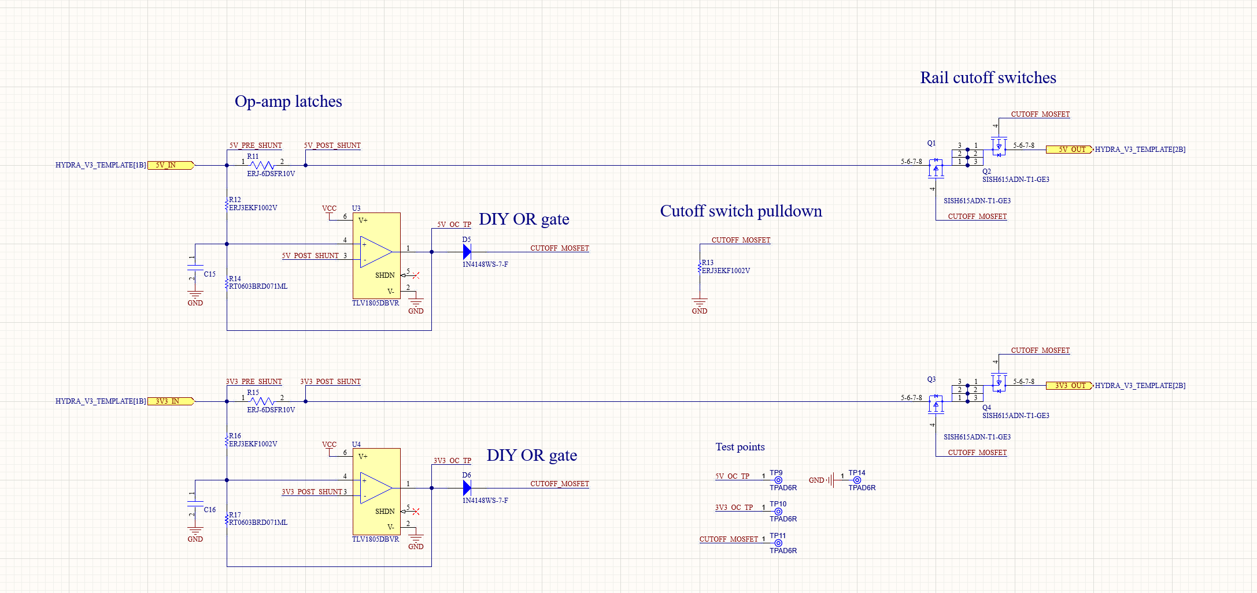

Figure . HYDRA_V3_SAME51_TEMPLATE Over-current Protection Schematic

This schematic uses an op-amp-based overcurrent latch detailed in [this paper](https://www.ti.com/lit/an/snoaa39/snoaa39.pdf?ts=1696273575569) by Texas Instruments. Its goal is to cut off both 5V and 3V3 power to the PCB if either rail draws too much current from the avionics-wide power rails. This function was achieved by modifying Texas Instruments’ over-current protection circuit and adding the two diodes (D5 and D6) at the outputs of the op amps which create a OR-gate such that all the MOSFETs (Q1, Q2, Q3, and Q4) are shut off when either over-current circuit trips. **This feature remains to be prototyped.**

Lastly, back-to-back MOSFETs are used to cut off power to the board such that the effect of the body diode is nullified, and this circuit will prevent bi-directional current flow in an over-current event.

### PCB

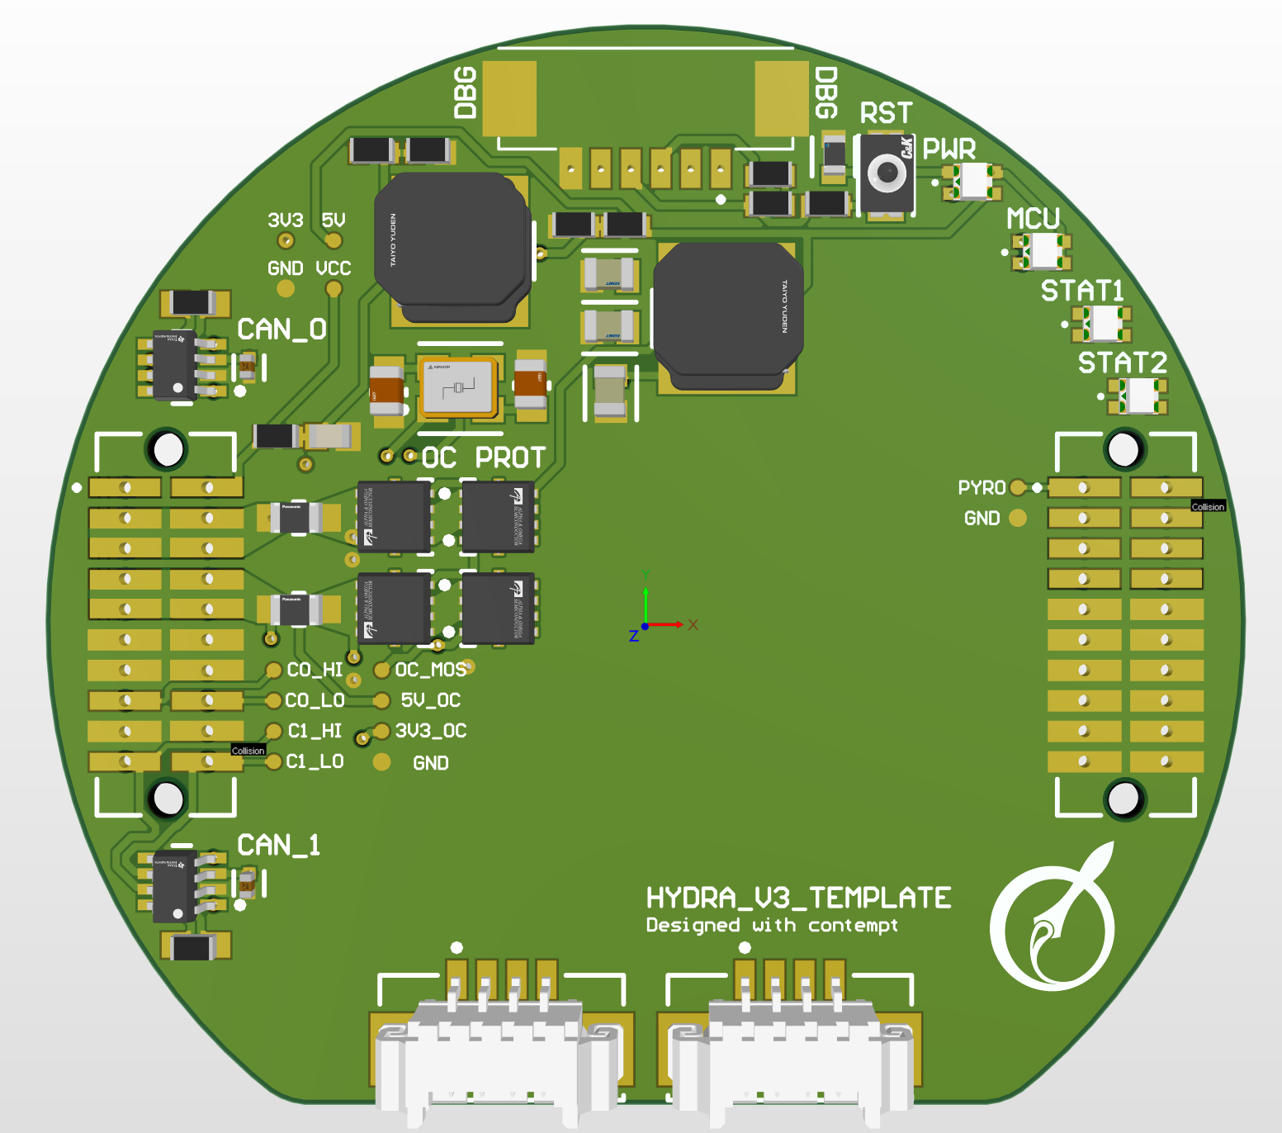

Figure . HYDRA_V3_SAME51_TEMPLATE PCB Top

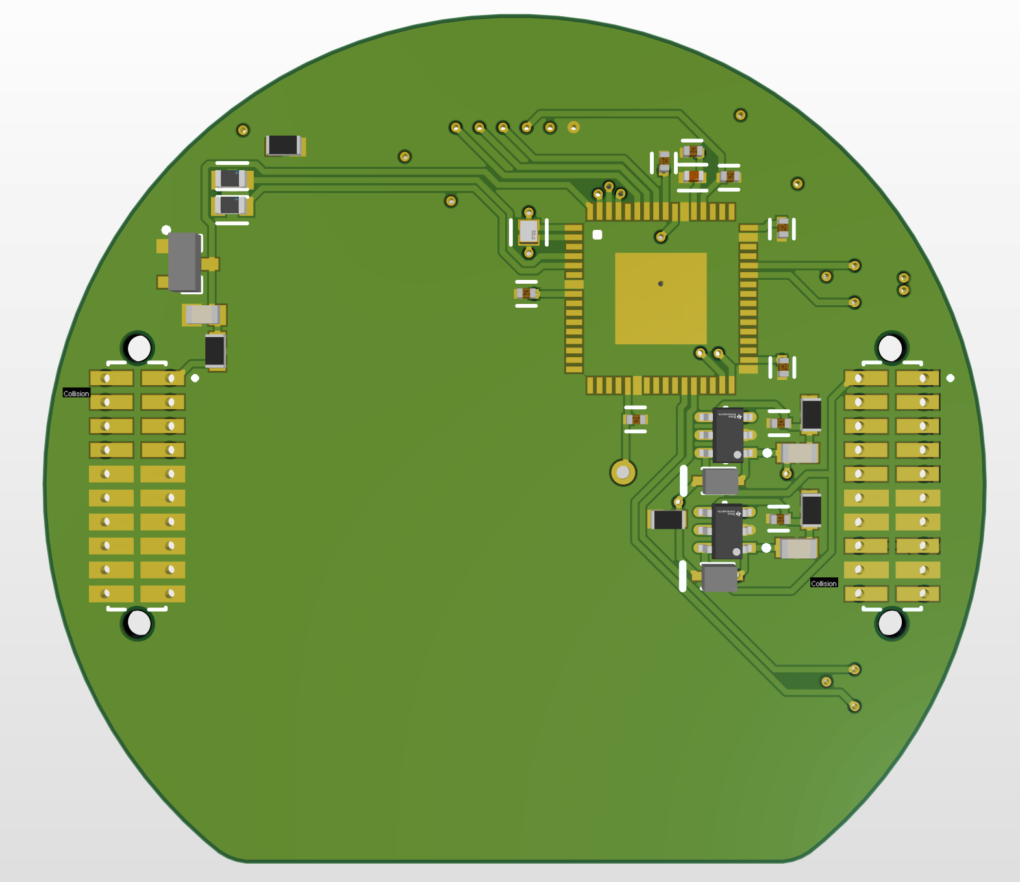

Figure . HYDRA_V3_SAME51_TEMPLATE PCB Bottom

### Layout Considerations

#### General Overview

This PCB was laid out around the MCU. The MCU was placed on the bottom of the board since it is a very slim component and therefore did not need to be on top. The power filtering/clock circuitry was then placed as close as possible to the MCU pins on the opposite side of the PCB. The debugging connector, reset switch, and status LEDs are all placed as per Sections 2.3.2.4 and 2.3.2.5 of the Hydra Framework design notebook.

The overcurrent cutoff MOSFETs were placed in series with the current shunt immediately next to the 5V and 3V3 inputs of the PCB. The 5V MOSFET is only connected to the 5V sensing circuit though boards built on this template will likely use it for other things as well. The 3V3 MOSFET dumps power into the PCBs internal power planes. Overcurrent detection circuitry is placed beneath the shunt/MOSFET complex, on the bottom layer of the PCB.

Initially, only small 0402 decoupling capacitors were present on the bottom side of the PCB but more things eventually ended up on the bottom side of the board. The overcurrent detection circuitry will likely be fine since it will be above the MOSFETs of the lower PCB when stacked and both sets of components are insignificantly tall. Beyond this all components should be very small with the exception of the pyrotechnics power sense zener but this zener is located above the status LEDs which are not tall and will therefore have plenty of clearance.

The CAN transceivers were placed at either end of the left connector since there is not enough space between the stacking connectors and the edge of the PCB to run more than one differential pair. Additionally, the CAN0 output differential pair **breaks the ground plane** which may be bad design but I couldn’t think of another way to route it and it’s probably fine since it does so on the left side of the PCB and the CAN0 traces do not segregate any circuitry on other layers.

#### Individual Layers

The PCB’s layers are pictured below, from top to bottom.

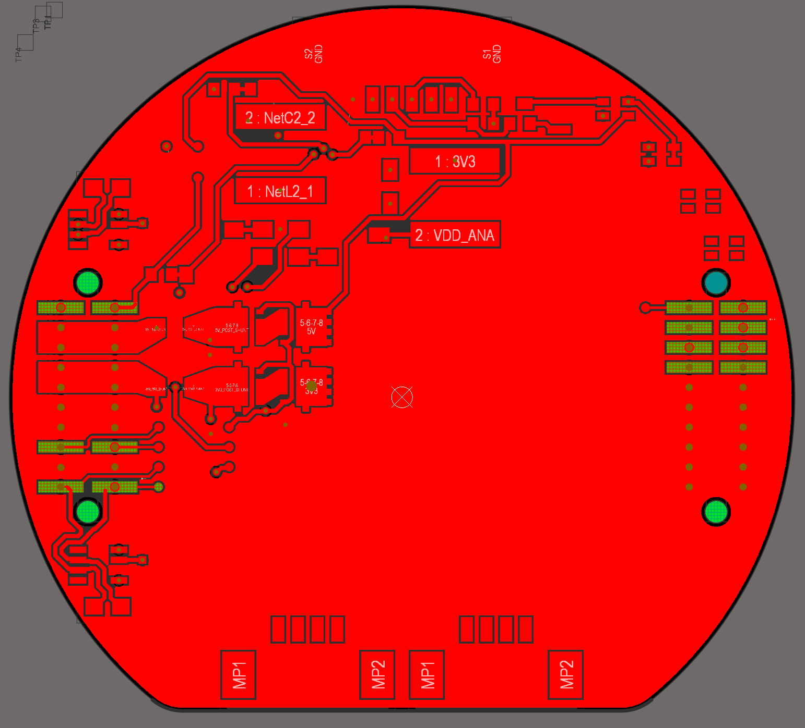

Figure 54. HYDRA_V3_SAME51_TEMPLATE Top Layer

Nothing awfully alarming here, no eccentric design choices were made aside from the two listed below. This layer is also a ground plane.

* CAN test points (on the bottom right of the left header) were connected using 0.2mm traces whereas all other traces are 0.3mm. This is because of the limited clearance between the header’s pads.
* The trace linking the gates of the overcurrent MOSFETs is weirdly routed

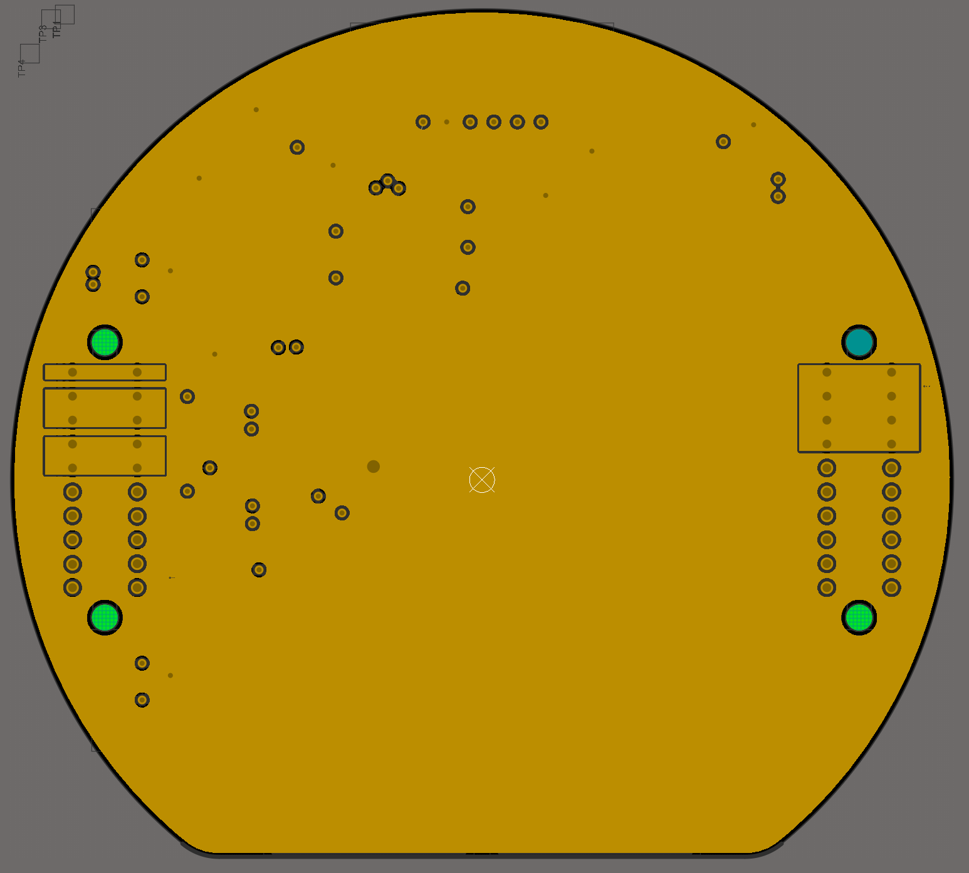

Figure 55. HYDRA_V3_SAME51_TEMPLATE Power Layer

Mostly a homogenous 3V3 plane with the exception of some smaller planes linking common pins on the left and right stacking headers. No planes included for ground pins since we have a ground plane.

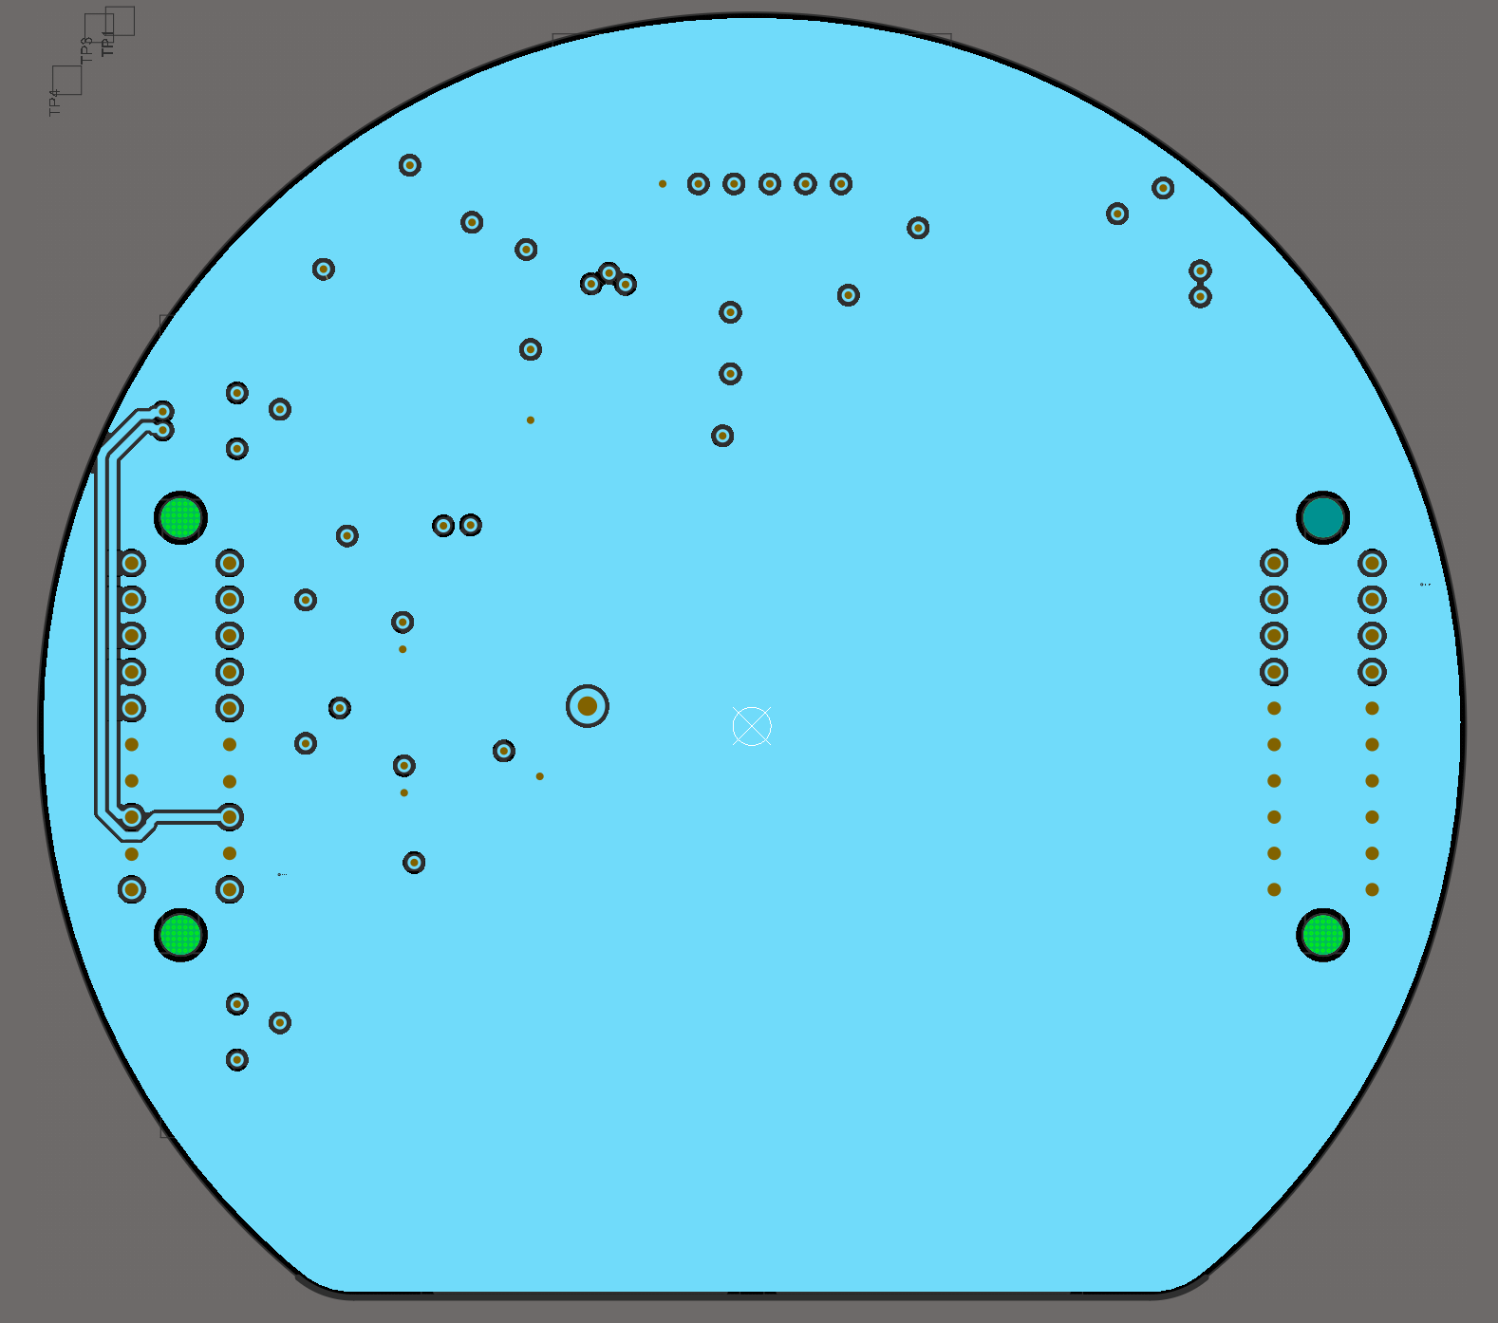

Figure 56. HYDRA_V3_SAME51_TEMPLATE Ground Layer

Mostly homogenous ground plane aside from the CAN0 differential pair routed on the left header. This was routed on an internal layer since the tight clearance between the header’s pads did not allow for 0.3mm traces to fit and this seems like a reasonable solution that does not require thinner traces.

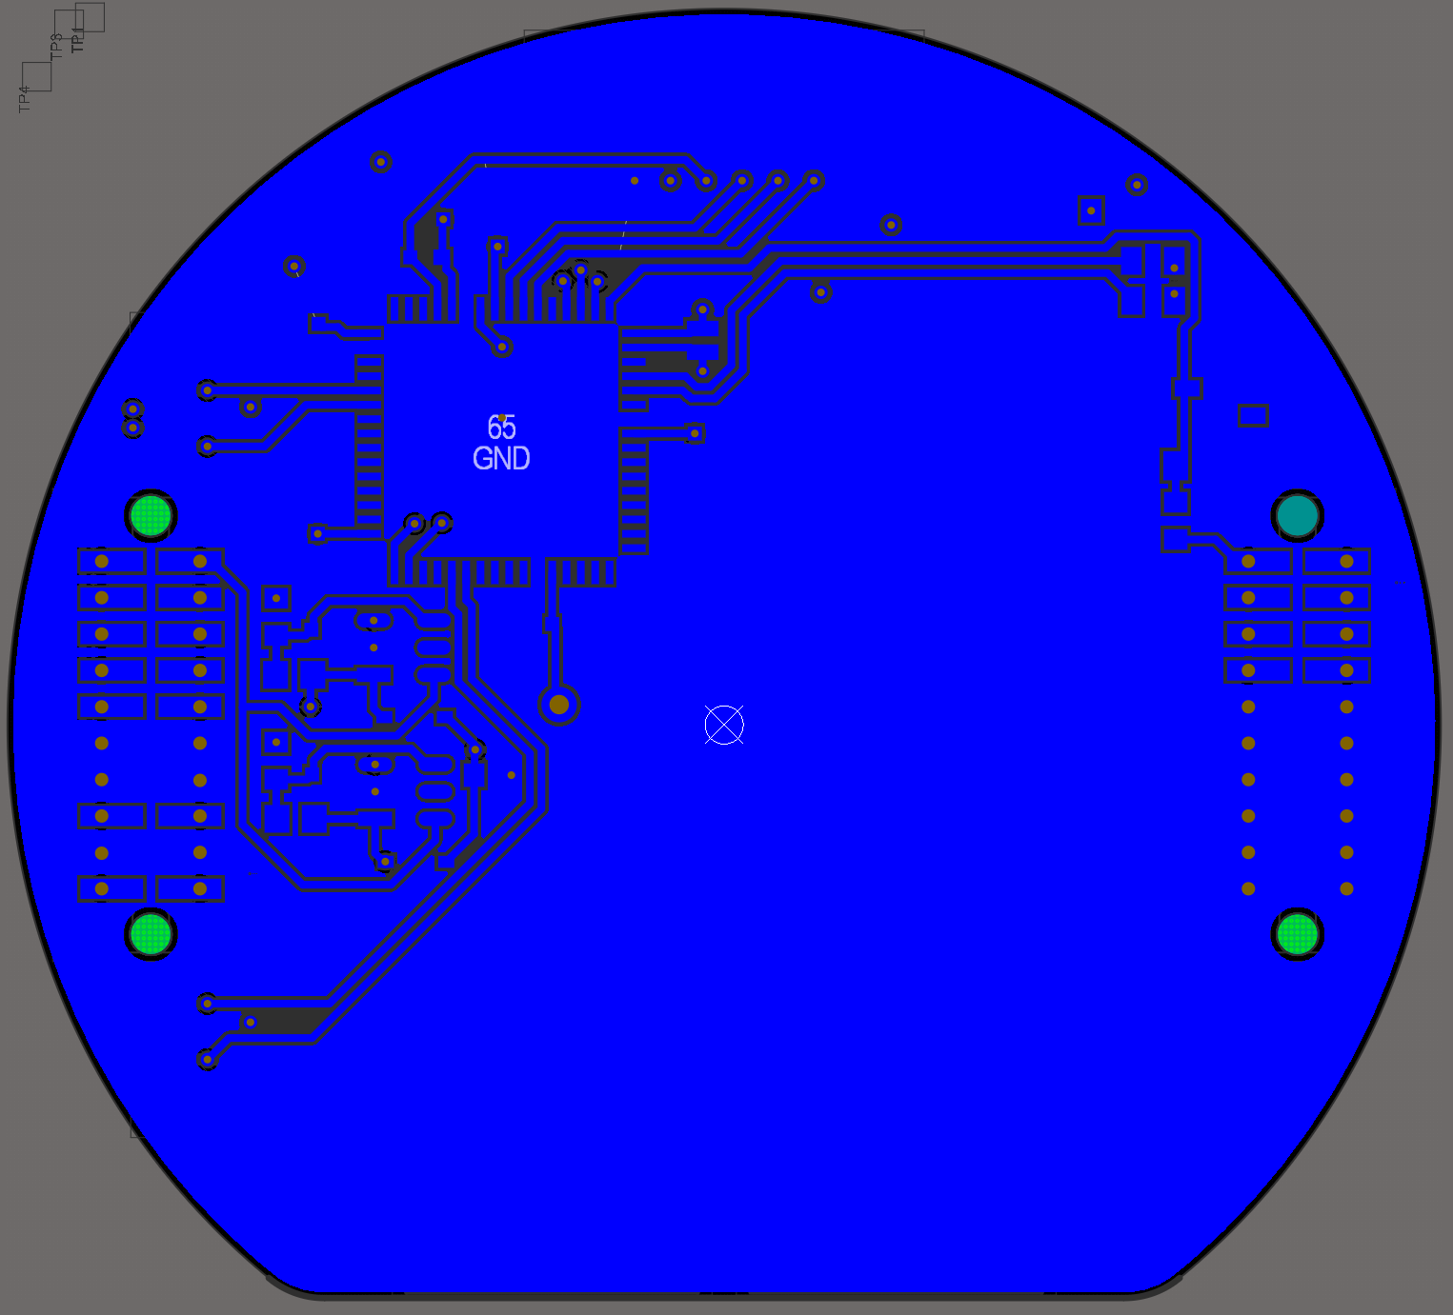

Figure 57. HYDRA_V3_SAME51_TEMPLATE Bottom Layer

This layer is also a ground plane.

### Reflection

TBD

Questions/concerns for Magdalena:

1. Should we/can we have a MOSFET-based cutoff switch for CAN lines?
   1. Transceivers do have internal current limiting on their CAN output but that’s still tied to the duty cycle of their CAN_TX input
2. How bad is current routing of PCB with MCU underneath it?
3. Are there any issues with the common debugging port that V3 uses?
   1. Might add small dedicated debug connector and exchange debugging pins for GNDs so we can send more power through the headers.
   2. Wonky crystal placement
4. Better power rail protection?
   1. Current op-amp-based OC latch ok?
5. Can test points and trace width change
6. Adding multiple traces between two points in Altium
   1. I could and probably should figure this out on my own
7. Weird shunt placement at 5V and 3V3 inputs (copper pad is inefficient)
8. CAN0 breaks ground plane
9. (personal note) add current sense? We have a shunt so we just need a couple op amps

# References (force of habit)

[1] “RRC3 ‘Sport’ Altimeter.” https://www.apogeerockets.com/Electronics-Payloads/Altimeters/RRC3-Sport-Altimeter (accessed Feb. 01, 2023).

[2] “getdatasheetpartid-55536-15112621.pdf.” Accessed: Feb. 01, 2023. [Online]. Available: https://datasheet.ciiva.com/15112/getdatasheetpartid-55536-15112621.pdf?src-supplier=Verical

[3] “LED Series Resistor Calculator | DigiKey Electronics.” https://www.digikey.ca/en/resources/conversion-calculators/conversion-calculator-led-series-resistor (accessed Feb. 01, 2023).

[4] “Overcurrent latch circuit,” 2019.